Planning and Hosting a Seed Exchange Event
Hosting a seed exchange or “seed swap” event can be an impactful community outreach program. These events are a strategy for agents, specialists, and other technical service providers to partner in supporting gardeners, potential commercial growers, and seed entrepreneurs to exchange and learn about plant propagation from seed. Exchange events are generally inexpensive and encourage horticulture engagement, crop biodiversity, food security, and information exchange. Seed kinds frequently offered at exchange events include vegetables (warm and cool season), herbs, flowers (annual and perennial), and natives (flowers and woody plants). These are commonly locally saved seeds, but may include surplus seeds donated by a seed company, local farm or garden center, farmers market vendors, and excess seeds from an individual’s personal stocks. Planning is necessary to develop, promote, and execute a successful seed swap event. This guide is intended to help agriculture professionals prepare for and set up a community-based seed exchange event.

Determine The Target Audience
Generally, seed exchanges are open to anyone in the community interested in seeds or growing plants, although there could be reasons to limit participation. Groups to consider recruiting for events include:
- Prospective gardeners who have never grown anything and are generally curious about community events, growing plants, wellness, and local foods
- Current gardeners and seed savers who are interested in social connection, stewardship, and adding to their seed stocks
- Seed saving enthusiasts who want to learn more about crop diversity, regional adaptation, and food sovereignty
- Entrepreneurs with the objective of connecting with potential buyers and others interested in seed initiatives
Once the target audiences are identified, event objectives can be determined and a theme can be developed with a planning team.

Planning Team Recruitment
Depending on the scale of the event, involving others in planning activities may be necessary to help distribute organizational tasks. Also, having others on-hand during the event who are familiar with the event objectives and logistics will be useful. Groups to consider recruiting or partnering with include:
- Farmers Market Vendors, Staff, and Volunteers
- Master Gardeners
- Garden Clubs
- Non-profit Organizations
- Community and Recovery Gardens
- Food Councils
- Community-based Organizations (i.e. libraries and faith-based groups)
- Student Groups (i.e. FFA, 4H, Junior Master Gardeners, Boy Scout and Girl Scout troops)
- Local Businesses (i.e. garden centers, nurseries, hardware stores)
When choosing collaborators and screening volunteers, keep in mind what kind of help you may need and what skills will be valuable. Clearly articulate the expectations for planning and assignments on the day of the event.

Timing
The best time to host a seed swap is in advance of or at the time when people are planning for the season and making seed purchases. Late winter to early spring (January through March) or in the fall (November) after seed harvest and processing can be good times to schedule an event. Partnering with other organizations can make it much easier to launch and host a seed swap but may limit available dates as will adding a seed swap to an existing event.
Consider if the seed swap is a one-time event or the first in a series of annual events. When selecting a time for an annual or recurring event (i.e. the first weekend of April like the Appalachian Seed Swap in Pikeville (Pike Co) or the first weekend in November like the Annual Heritage Seed Swap hosted by the Sustainable Mountain Agriculture Center in Berea (Madison Co)), consider existing events and holidays to avoid scheduling conflicts that could impact participation.

Location
Local county Extension office meeting spaces (Fig. 1) are often suitable sites for hosting a seed swap when rooms are large enough to accommodate the anticipated crowd and other planned activities like educational sessions or demonstrations. School cafeterias (Fig. 2) or gyms, libraries, or other community spaces may be other logical options. Farmer’s markets, community gardens, recovery gardens, and non-profit organization sites may also be suitable locations. Important considerations when selecting a site are:
- Tables to organize and display seeds
- Space to circulate around tables
- Additional space for educational sessions or demonstrations
- Good parking and accessibility
- Indoor alternative if planned in an outdoor space

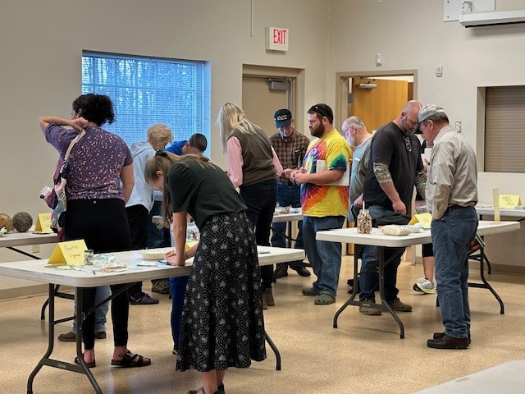
Fig. 1. Madison County 2026 seed swap program at the local Extension office. (Photo credit: Amanda Sears, Madison County Extension Service.)

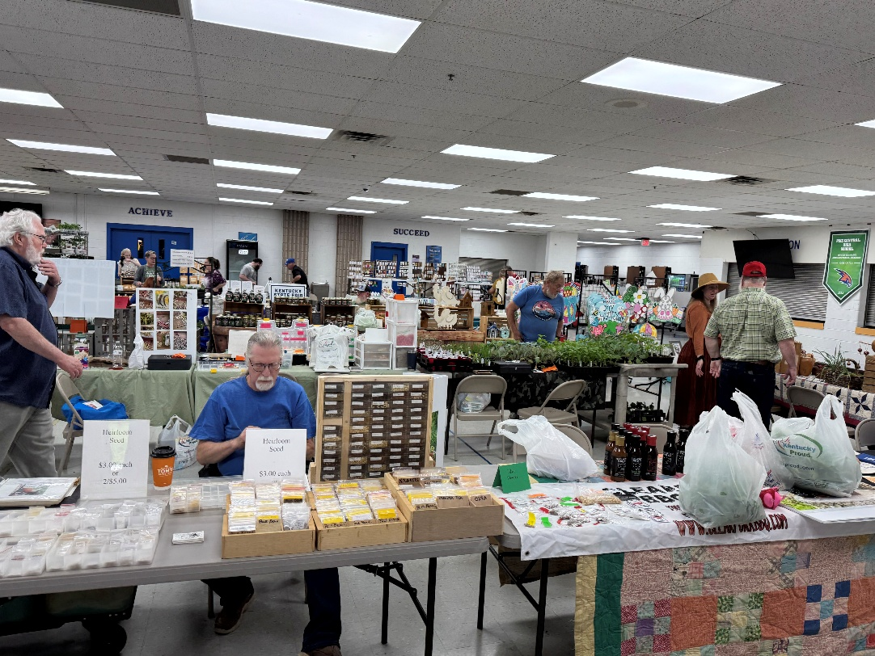
Fig. 2. The annual Appalachian Seed Swap, hosted in 2026 at the Pike County Central High School Cafeteria. (Photo credit: Emily Davis, Pike County Extension Service.)

Establish Seed Event Guidelines
Communicate in advance with individuals who may be bringing seed to the event and specify what kinds of seed and other items (i.e. divisions, bulbs, transplants) are allowed and if sales of seeds and other items will be permitted. Determine if bulk seed is acceptable or if seed will be limited to only pre-packaged seed in envelopes or bags. Include information about what kind of seeds are preferred (i.e. cleaned seed, open-pollinated, locally-grown, excess seed) and what is prohibited (i.e. illegal (Kentucky or Federal), offensive or noxious weeds, patented seed, unknown seed). Suggest (or require) participants bringing seeds to the event have minimum labeling of:
- Seed kind (usually the common name)
- Designation of variety when known and other features of interest like heirloom or organic
- Year grown, collected, or packaged
- Origin or site where seeds were grown
Some growers may decide to include much more information, including seed stories or basic cultural information with their seed.
Some planning teams may decide to allow or encourage vegetative material (i.e. tubers, roots, stolons, cuttings, etc.) for crops like garlic, flowers, and sweet potatoes; craft and handmade items; perennials, shrubs, and trees in containers; prepared foods; and other types of products for sale or distribution.

Educational Programming
Presentations and demonstrations can complement seed exchange activities. Recruit County Agents, Specialists, Master Gardeners, local beekeeper association members, or other experts to speak on a topic. Brief presentations on a timely horticulture or seed-specific topic could include:
- Growing a specific crop or general gardening topics (i.e. soil health, disease management, composting, attracting pollinators, beekeeping)
- Pest identification and management
- Direct seeding a pollinator habitat
- Volunteer opportunities
- Seed propagation (i.e. germination treatments or testing) and seed saving (i.e. general or heirloom seed kinds)
- Techniques for collecting native seed
- Seed storage
When offering lecture-style presentations, ensure audiovisual equipment (i.e. projector, laptop, speakers) is available. Let speakers know how you would like the presentation (in advance on a thumbdrive, for example) and their time limit. Coordinate a session moderator to keep speakers on schedule. For demonstrations, be sure the space can accommodate the type of activity and isn’t too far from the main event.

Event Promotion and Registration
Confirm the date and location as early as possible to begin marketing the event. Promotion – early and often – is critical to reach your target audience and build excitement about the seed exchange. Outlets to promote the event include:
- County-level newsletters and social media channels
- Announcements in local media outlets (i.e. radio station, newspaper) and community boards
- Community-based organizations (i.e. local garden club)
- Partner with local businesses and organizations to distribute flyers and share the event on their social media channels
- Post flyers at local farmers markets, festivals, conferences and other events
Use clear messaging about the target audience (i.e. everyone is welcome, even if they have no seeds to share) and any rules or seed etiquette tips (i.e. properly labeled clean seeds in small packets only).
Requesting registration (call in or online) will help in planning for the event. Knowing who will bring seed (how much and what kinds) and identifying any items they may need (tables, chairs, electric hookup) will help with room set up and layout. An estimate of the number of participants will help to ensure there is an adequate diversity and volume of seed for event attendees and provide contact information in the event of an event change or cancellation.

Hosting the Event
When setting up the room for the event, make sure there is plenty of space to move around the tables where seeds are organized. Some participants may want a dedicated table to hand out and talk about their seed. If presentations are offered, be sure there are chairs available. Have all the tables and chairs in place well before the event starts.
Organizing seeds by category (i.e. vegetables, flowers, herbs, native plants) with clear signage is a great way to help participants navigate the available options (Fig. 3). Spreading seeds out to improve visibility will help people choose the seeds they want; trays or baskets are useful to keep packets organized on tables.
Have participants bringing seeds be on-site at least 15-30 minutes before the event is scheduled to start to ensure seeds are ready and well-organized. If bulk seed will be available, be sure there are small envelopes and pens, pencils or markers to package seed into and label. Spoons or small scoops are useful to dispense seed into small packets.
Post additional signage around the area to help people navigate the event and understand rules and etiquette for the event.
Registration and check-in is an opportunity to welcome attendees, collect contact information, provide nametags, and recognize seed donors. A brief overview of the event may be provided or a handout with instructions about the event.
Make available and highlight Extension publications and services (i.e. soil testing, shared use equipment).
Prepare a statement to remind participants that due to the nature of the event, the host cannot guarantee any quality standards, including correct labeling, purity, germination, disease-free, or other measures.
When explaining event rules, use clear and simple instructions like be careful not to mix seeds, seed viability is not guaranteed, only take or fill 5 packets in the first round or only take what you can plant this season, adjusting final instructions based on the seeds available and the size of the crowd.
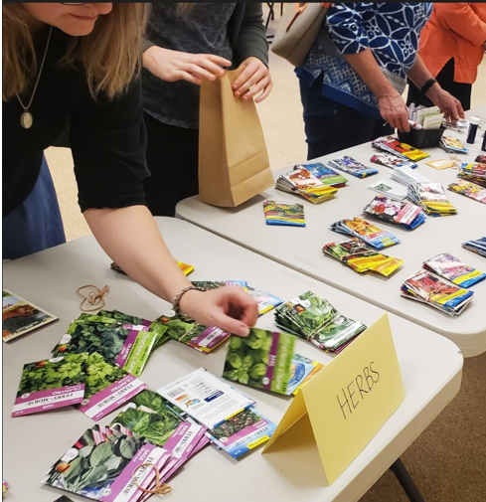
Fig. 3. Organizing seeds by type with good signage at an exchange event will help participants navigate the options. (Photo credit: Amanda Sears, Madison County Extension Service.)

Additional Tips for Success
- Be sure there are some easy-to-grow seed kinds (beans, sunflowers, for example), especially for beginners in attendance
- Furnish small envelopes, labels, pens, pencils, spoons, scoops, and other packaging and labeling supplies
- Provide Extension publications, seed catalogs, books, tools, or other items as educational take-aways
- Offer activity sheets or hands-on activities for youth (i.e. making seed bombs, planting seeds, etc...)
- Organize community resource or demonstration tables
- Consider offering refreshments or door prizes
- Add an evaluation component (i.e. pre-season intentions and post-season actions) to improve future events
- Have a plan for any seeds remaining after the event (use in programming, freely distribute from local office, donate to a community seed library, youth group, community garden, or other group)

There are a lot of right ways to set up seed exchange events. Acquiring seeds from commercial seed companies, securing donations, and recruiting seed saving enthusiasts to set up at the event will ensure there is a good supply of seeds for attendees. Be sure to provide an event summary to and thank any companies providing seeds for the event.

Sample Agenda for a Seed Swap Event
9:00 am | Registration / Check-in  Volunteer/staff member welcoming attendees and providing name tags  Distribute swap guideline sheets and offer empty envelopes and labels
9:30 am | Welcome and Speaker Introduction  Share event history and instructions about planned educational programming  Introduce speaker, with a reminder about the presentation length
10:00 am | Instructions and Event  Explain the event rules, keeping instructions simple  Remind participants that the host cannot guarantee any quality standards, including correct labeling, purity, germination, disease-free or other measures  Circulate to monitor and assist participants
11:00 am | Conclusion and Clean Up  Thank participants for attending and announce the next event date (if recurring)  Thank any event sponsors (i.e. donations of seeds, door prizes or other items)  Manage leftover seed (i.e. share with a local community garden or seed library)

References
Homstad, M. 2023. Saving and sharing at a spring seed swap. University of Minnesota Extension.
Seed Savers Exchange. nd. How to Organize a Seed Swap, Seed Savers Exchange. Decorah, IA.

Acknowledgments
The authors sincerely appreciate the efforts of Dr. Shawn Wright, Extension Specialist, UK Robinson Center, in development and review of this publication.

Authors
Dr. Cindy Finneseth – Extension Specialist Community Horticulture
Amanda Sears – Horticulture Extension Agent, Madison Co Extension Service
Emily Davis – ANR Extension Agent, Pike Co Extension Service

