Understanding Light Distribution in Controlled Environment Agriculture (CEA)
Arundathi Sharma and Qinglu Ying
Instructor Module
This educational module is presented in partnership with the Appalachian Regional Commission (ARC) and Extension Foundation. These activities are intended to provide inspiration for activities that supplement greenhouse technician/management curricula.
Background
Light is the primary energy source driving photosynthesis and is one of the most influential environmental factors affecting plant growth, development, yield, and crop quality in greenhouse production. The quantity, quality, and distribution of light determine how efficiently plants use available energy, making accurate light measurement an essential management tool. Measuring the greenhouse light environment helps growers:
- identify areas of uneven light distribution or "hot spots";
- evaluate the effects of greenhouse structures and equipment on light interception; and
- compare seasonal changes in natural light availability.
Light measurements can also guide decisions on the use of shade cloths to reduce excessive light during summer and supplemental lighting to increase crop productivity during periods of low natural light. For more information on light units, sources, light management practices for plant production, please refer to pending publication Lighting Considerations for Controlled Environment Plant Production.
Objectives
Students will measure and evaluate how light is distributed within a greenhouse or indoor production area using a quantum sensor. By the end of this activity, students should be able to:
- Measure light intensity using a quantum sensor (µmol·m⁻²·s⁻¹)
- Identify spatial variation in light distribution
- Interpret how light uniformity affects crop growth
- Make recommendations to improve lighting conditions

Materials Needed
- Quantum sensor (PAR meter)
- Tape measure
- Clipboard and printed data sheet with printed grinds
- Pencil/pen

Procedure
Step 1: Define the measurement area
- Select a representative production area (e.g., greenhouse bay, bench, or vertical rack).
- Measure the length and width of the area

Step 2: Create a grid
- Divide the area into a grid (e.g., 1 m space between each grid-line; you may use a different scale as needed for the area being measured). You may use masking tape or a pencil to draw the gridlines on the measurement area
- Label rows and columns (e.g., A–E, 1–5; see Datasheet and correlate to spatial grid. You may need to make a new datasheet if using a different grid for your measurement area).

Step 3: Take light measurements
- Hold the quantum sensor level and facing upward at each grid point. Avoid shading the sensor with your body
- Take measurements at canopy level and record photosynthetic photon flux density (PPFD; µmol·m⁻²·s⁻¹)
- Repeat and take all measurements on the grid at the same time of day

Step 4: Analyze the data
- Calculate the maximum, minimum, and average PPFD, as well as lighting uniformity
- Identify any areas with low or high light levels (e.g., 10% below and above average PPFD) and correlate them with visible factors affecting light distribution at the measurement time, like sun-angle, shade from structures or equipment, dirty glazing, distance from light sources etc.

Example:
Below is an example of a light distribution map (in µmol·m⁻²·s⁻¹) using a 3X5 grid for 4 ft x 6 ft nutrient film technique (NFT) unit in the greenhouse.

 | 1 | 2 | 3 | 4 | 5
A | 119.17 | 142.8 | 152.6 | 149.9 | 136.2
B | 115.4 | 140.2 | 140.8 | 153.5 | 136.7
C | 116.8 | 138.5 | 146.7 | 148.7 | 135.9
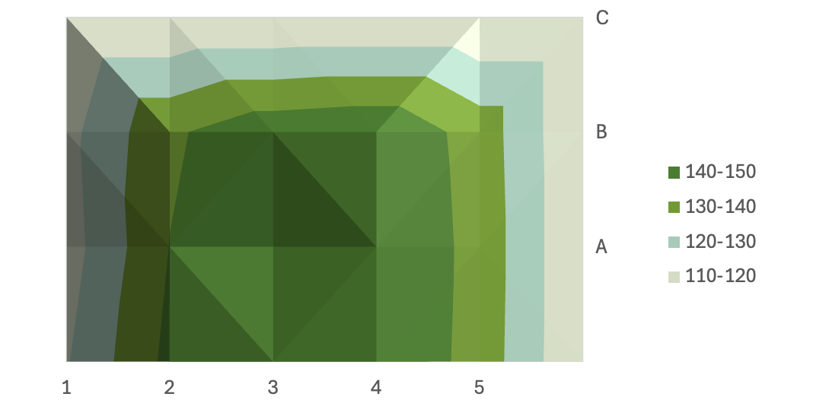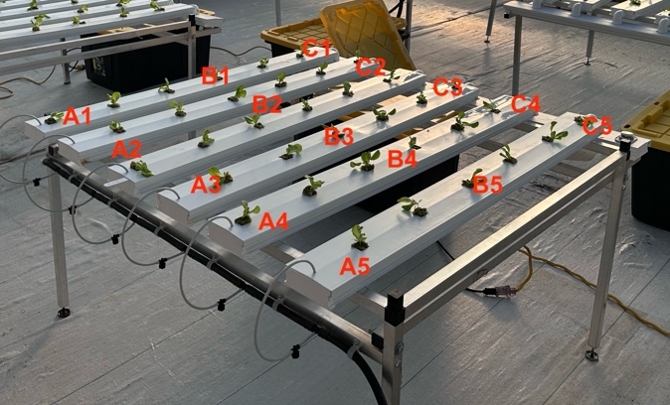

Data Sheet 1: Light Distribution Mapping in the Greenhouse
Location: ___________________________
Date/Time: __________________________
Crop/Stage: _________________________
Weather/Conditions: __________________
Grid measurements
 | 1 | 2 | 3 | 4 | 5
A
B
C
D
E

Summary Calculations
- Average PPFD: __________________
- Minimum PPFD: _________________
- Maximum PPFD: _________________
- Uniformity (Min ÷ Max): _______

Observations

Data Sheet 2: Understand Light Transmission Rate of a Greenhouse Structure
  - Measure Outdoor PPFD
Outdoor PPFD can vary across the area around a greenhouse because of sun orientation, solar angle, nearby structures, trees, and other obstructions. Take PPFD measurements at 5–10 outdoor locations around the greenhouse, selecting locations with minimal obstructions, measuring at approximately the same height, and collecting the measurements as close as possible to the indoor measurements.
Outdoor Measurements | PPFD (µmol·m⁻²·s⁻¹)
Location 1
Location 2
Location 3
Location 4
Location 5

Average Outdoor PPFD: __________ µmol·m⁻²·s⁻¹
  - Measure indoor PPFD
Follow data sheet 1 to measure PPFD at each location in the greenhouse grid at approximately crop-canopy height and calculate the average indoor PPFD.
Average Indoor PPFD: __________ µmol·m⁻²·s⁻¹
  - Calculate Greenhouse Light Transmission
$$Light transmission \left(\%\right)=\frac{Average Indoor PPFD}{Average Outdoor PPFD}×100$$

