County Agricultural Incentives Program (CAIP) Cost-Share Programs for Specialty Crop Growers
The County Agricultural Incentives Program (CAIP) offers cost-share incentives for Kentucky agricultural producers to implement practices that increase farm income and to try new or innovative technologies or systems that improve efficiency and productivity. Cost-share means paying for project expenses up front and being reimbursed for allowed expenses up to a maximum amount based on submission of receipts once the project is complete. This may be a percentage (i.e. 50% of project costs) or a total amount (i.e. 75% of project costs up to $1,500).
Project ideas listed in Table 1 are examples of potential specialty crop grower projects and many other expenses are eligible (Figs. 1 and 2). Explore all 11 CAIP incentive areas to determine the best fit for on-farm projects that most benefit the operation. Program Guidelines are updated annually and available online or from the local program administrator, explaining each program area, exclusions, and compliance requirements. Keep in mind that not all counties will offer CAIP each year and application deadlines vary by county.

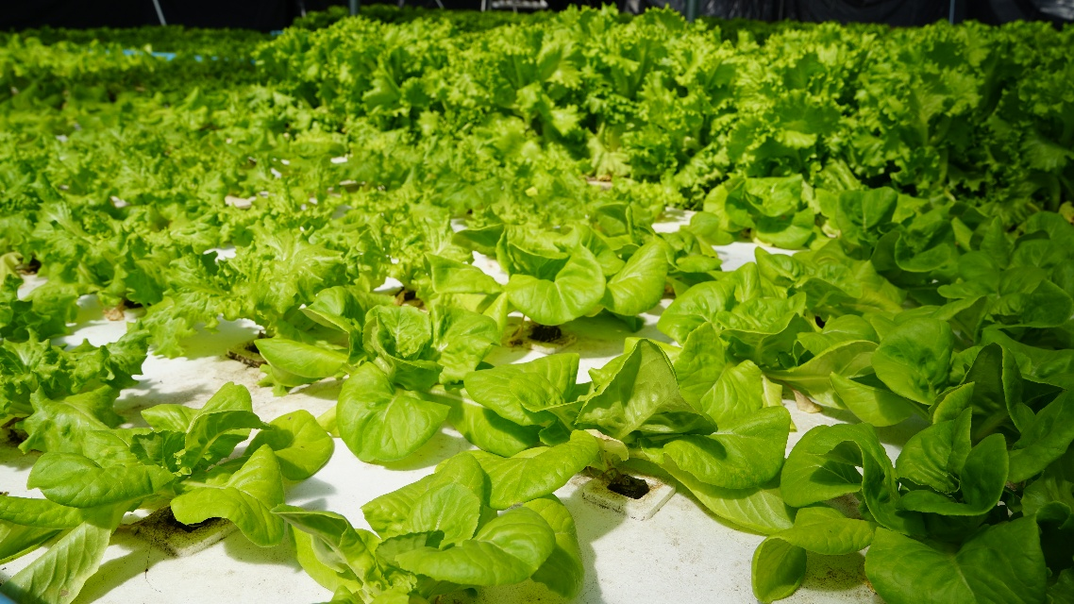
Fig. 1. Kentucky County Agricultural Incentives Program (CAIP) funded hydroponic lettuce project in Marshall County. (Photo credit: Kentucky Office of Agricultural Policy) [Alt text: green lettuce plants growing on a white raft]
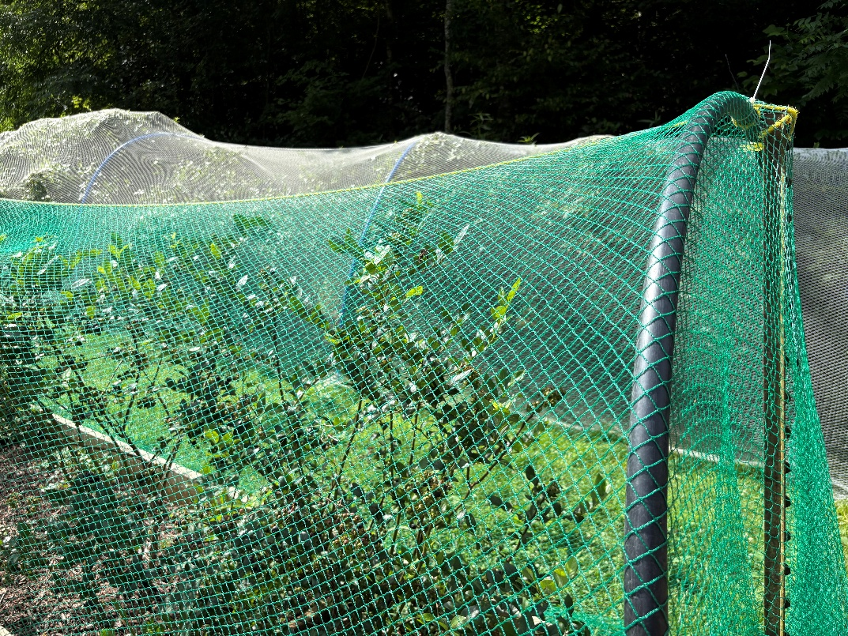
Fig. 2. Woven bird netting to protect fruit crops is an eligible Kentucky County Agricultural Incentives Program (CAIP) expense in the Agricultural Diversification program area. (Proto credit: Cindy Finneseth) [Alt text: green netting over green blueberry plants]

County Agricultural Development Councils develop community-based strategies to enhance agricultural opportunities and assist local farmers. These 9-member county-based groups review CAIP applications for state level approval. A local administrative entity sets application deadlines, makes the Producer Application available and handles program paperwork, and in many counties, this is the Soil Conservation District. To help growers find a local administrator, an interactive map has been created (Fig. 3). Click on the county of interest on the map and a popup will display the administrator’s contact details.

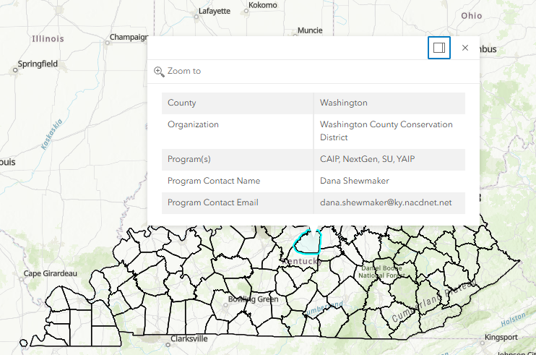
Fig. 3. Interactive online map used to find local administrators of County Agricultural Incentives Programs (CAIP) in Kentucky showing a pop-up of contact information for Washington County. [Alt text: Beige map of Kentucky with individual counties outlined and a white and gray popup of contact text]

Grower Participation
To participate in CAIP programs, growers must be at least 18 years old and along with the completed project application, must provide information such as Social Security Number (SSN), Farm Serial Number (FSN), proof of Kentucky residency, and verification of a Kentucky Agriculture Water Quality Act (AWQA) Plan. There is a mandatory educational requirement, with programs often available through local county Cooperative Extension Offices, which can be searched on this interactive map. Program Guidelines are updated annually and all program requirements should be carefully reviewed before submitting a project application.

Program Funding
CAIP is financed by funds directed to Kentucky as part of the Tobacco Master Settlement Agreement that go into the Kentucky Agricultural Development Fund (KADF), which is administered by the Kentucky Agricultural Development Board (KADB). Annual disbursements are based on the historic federal tobacco quota system, also known as farms’ “tobacco base”, within individual counties. Since 2001, KADF has awarded more than $846 million to nearly 8,000 projects to Kentucky agricultural producers through projects and programs, including CAIP projects, to support crop diversification and farm improvement. For general information about CAIP and other KADF programs, visit the Kentucky Office of Agricultural Policy (KOAP) website or contact at 502-573-0282 or KOAP@ky.gov.

CAIP is a valuable program for Kentucky specialty crop growers. Tips for grower success when thinking about submitting a project include:
- review annual program guidelines carefully
- note all application deadlines
- confirm that planned expenses are allowable and can be paid by non-cash methods
- fill out the Producer Application completely
- avoid spending money on the project before approved.
Once a project has been approved, keep accurate and well-organized records about the project. and save all receipts related to the project.

Resources:
The University of Kentucky Martin-Gatton College of Food, Agriculture and the Environment (MG-CAFE) manages an online interactive map to identify and connect with local County Cooperative Extension Offices: https://extension.mgcafe.uky.edu/county-offices
The University of Kentucky Center for Crop Diversification (UK CCD) maintains a library of interactive maps to help look up information and find local resources (including the CAIP Administrators map): https://ccd.uky.edu/resources/maps
Kentucky Agriculture Leadership Program (KALP) is an intensive 2-year program designed for young agricultural producers and agribusiness individuals interested in developing skills in preparation of accepting leadership responsibility in agriculture, agribusiness and rural communities: https://kalp.mgcafe.uky.edu/
Kentucky Farm Business Management Program (KFBM) provides a financial records-based information system across an 87-county service area to assist Kentucky farmers in best using their resources to accomplish goals and objectives: https://kfbm.mgcafe.uky.edu/
The Kentucky Office of Agricultural Policy (KOAP), within the Kentucky Department of Agriculture (KDA) provides staff support to the Kentucky Agricultural Development Board (KADB) and the Kentucky Agricultural Finance Corporation (KAFC), which provide grants, incentives and low-interest loans to help farmers and agribusinesses innovate and grow: https://www.kyagr.com/agpolicy/

Authors:
Dr. Cindy Finneseth – Community Horticulture Extension Specialist
Sarah Charles – KADF Programs Manager, Kentucky Office of Agricultural Policy
Shari Dutton – Extension Associate for Beginning Specialty Crop Growers
UK Logo & KADF Logo
Table 1. Examples of on-farm specialty crop production projects and potential County Agricultural Incentives Program (CAIP). Note that this is not an exhaustive list and some project expenses could fit in multiple categories.
Specialty crop growers interested in projects like: | Explore this program area:
- Cuttings, containers, and potting substrate to produce a mum crop  - Drop-chute hand planter to transplant vegetable seedlings  - Multi-plate seeder to direct sow a variety of seeds  - Backpack sprayer for in-season pest control of crops  - Insect netting to protect small fruit crops from spotted wing drosophila | Agricultural Diversification
- One-on-one farm consultation and financial planning with the Kentucky Farm Business Management Program (KFBM)  - Software packages to prepare annual tax documents  - Brix meter to measure sugar content to determine optimal fruit harvest timing  - pH/EC meter to monitor greenhouse irrigation water  - Ear protection, face guards, chaps, and steel-toed boots for clearing and controlling on-farm vegetation  - Tuition to participate in the Kentucky Agriculture Leadership Program (KALP) | AgTech & Leadership Development
- CoolBot controller system and insulated panels to build cold storage to preserve quality of fruits, vegetables, or cut flowers between harvest and sales  - Storage structure to protect farm equipment from extreme weather conditions  - Gutters for rain capture on a high tunnel or greenhouse  - Fertigation system to optimize delivery of nutrients to field crops  - Adding a climate control system to a high tunnel, converting it to a greenhouse | Farm Infrastructure
- Posts, wire, and electric fence chargers to build wildlife exclusion fencing  - Developing an on-farm reservoir for irrigating crops  - Gutters for rain capture on a high tunnel or greenhouse  - Adding a water hook-up to expand to a new production area  - Pump, sand filter, lay-flat, drip lines, and fittings to deliver water from a stream to crops  - Concrete mats or rock riprap for stabilization of high-flow channels and steep banks | Fencing & On-Farm Water
- Cider press and equipment to extract juice from produce crops  - Scale, vats, and drying oven to process flowers for natural dyes  - Building an on-farm store for direct to consumer sales of farm products  - Convert a barn into a certified commercial kitchen  - Harvest totes and a drum washer for post-harvest handling of produce | Value-Added & Marketing

