Gloucester Services: A pilot example on innovations for farms and food businesses

This publication describes Gloucester Services, a motorway service area in England that is run as a partnership between a family business and a community charity. It looks at how that model creates market opportunities for local farms and food businesses and supports the surrounding community. It is written for Kentucky farmers, food entrepreneurs, Extension agents, and community leaders who are interested in new ways to connect local food with local development.
- Introduction
In May and June 2026, a group from the University of Kentucky traveled through England as part of Farm to Fork: The British Way, a two-week study abroad program led by Dr. Tim Woods. The group visited farms, food cooperatives, markets, and museums across London, Birmingham, Bristol, Devon, and Cornwall, stopping at Gloucester Services along the way.
Gloucester Services is a motorway service area on the M5, the major motorway running south-west from the West Midlands to Devon, in the United Kingdom. Service areas are the UK equivalent of a highway rest stop with fuel, parking, food, and restrooms built off the motorway, so drivers can take a break on long journeys. There are two sites, one serving northbound traffic and the other southbound, that operate under the same model.
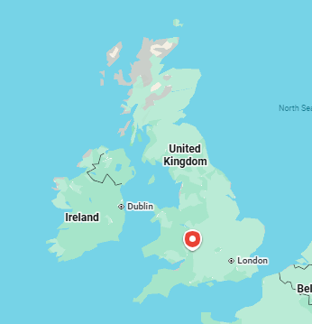
The enterprise’s location on Google Maps.
As you enter the car park (parking lot), you realize this is unlike any other motorway services. The car park was designed to disappear into the landscape over time as the trees planted on the site grow. From the top of nearby Robinswood Hill, you can now barely make out where the services are. The site also has more electric vehicle charging stations than any other motorway services in the UK. The building at each location is designed to blend in with the terrain so as not to detract from the natural beauty of the area. The enterprise operates as a full working farmshop, sourcing from more than 130 regional producers within a 30-mile radius (farmers and growers, butchers, bakers, cheesemakers, chocolatiers, potters, pastry chefs, and even skincare and clothing makers), plus 70 additional suppliers from across England’s Southwest. They are a “family-owned motorway services business that celebrates the people and produce of Gloucestershire”. Inside the building, a sign puts the idea in four words: "Farming. Food. People. Place".
The Services are the outcome of a joint venture between the Westmorland family and the Gloucestershire Gateway Trust (GGT). It’s worth mentioning that Gloucestershire is the county, Gloucester the city within it. The Gloucestershire Gateway Trust (founded in 2007) is built around an asset-based community development model. This approach, first promoted by John McKnight and John Kretzmann’s work in Chicago (1993), focuses on the strengths of a community including local organizations, infrastructure, natural environment, resources—and, of course, the people themselves. The GGT provides core funding to local non-profit organizations allowing them the freedom to innovate with the expectation that they will support one another in addressing local needs. Many of these organizations have been involved since the project was first proposed and have been strong supporters of the planning process. Most recently, the GGT was successful in their bid to provide child and family services across the county and into the nearby Forest of Dean, a significant expansion of the scope of work of the organization that builds on their core commitment to involving local people in decision making and fostering strong collaborations across the community.
The idea for Gloucester Services traces back to one of the founders, Mark Gale, who noticed that roughly 10 million vehicles pass through the county every year, leaving behind pollution and the cost of clearing wrecks, while the surrounding area remained economically deprived and short of jobs. Gale liked the business model the Westmorland family used at their other motorway services (they are farmers themselves and believe in sourcing locally) so the charity and the business joined forces to build Gloucester Services, at a cost of £35 million (roughly $44 million USD in 2026). The Trust’s mission is to transform social, economic, and environmental conditions in some of Gloucestershire’s most disadvantaged neighborhoods, such as Matson, Robinswood, White City, Podsmead, Tuffley, and Stonehouse.


The unique architectural design of Gloucester Services.
Since opening the northbound site in 2014 (the southbound site followed in 2015), Gloucester Services has employed between 400 and 500 people across both locations, including peak-season staffing, providing the region with far more than the fuel and food it sells.

- The Innovation Focus
A few elements stand out as genuine innovations here:
• the business-charity partnership model itself, which turns profit into a vehicle for social impact;
• an automatic royalty system that reinvests a share of sales into the community, formalized through a Royalty Agreement between the two partners;
• a pre-employment training program that turns retail jobs into a pathway out of long-term unemployment;
• a structured process for discovering and scaling local food entrepreneurs;
• an award-winning ecological building design.
All the topics above make Gloucester Services worth studying because GGT built them to reinforce each other, and the same business pays for all five innovations at once. The building has a 4,000-square-meter green roof, planted with grasses and wildflowers. The service's sunken car parks and sustainable drainage system won the RIBA (Royal Institute of British Architects) National Award for architecture and design in 2016 and the Gloucestershire Wildlife Trust’s Building with Nature Award. The buildings were designed to sit in harmony with the landscape, an approach meant to minimize their visual impact on the countryside around them, which is part of a recognized Area of Outstanding Natural Beauty.
Walking around the site makes clear how different the concept is from typical American truck stops and/or rest areas or those found elsewhere in the United Kingdom: indoor and outdoor seating, cup recycling stations, a quick-coffee counter serving beans roasted in the nearby city of Bristol, and a food hall that feels closer to a small artisanal grocery store rather than a fuel-stop shop, with foods like fresh meat and fish (including venison and pigeon), baked goods, canned beef stock, fresh pasta, gelato, jams, cheeses, and ready-to-bake meals like beef-and-ale pie or jammu chicken curry all sourced from the same regional network of producers.
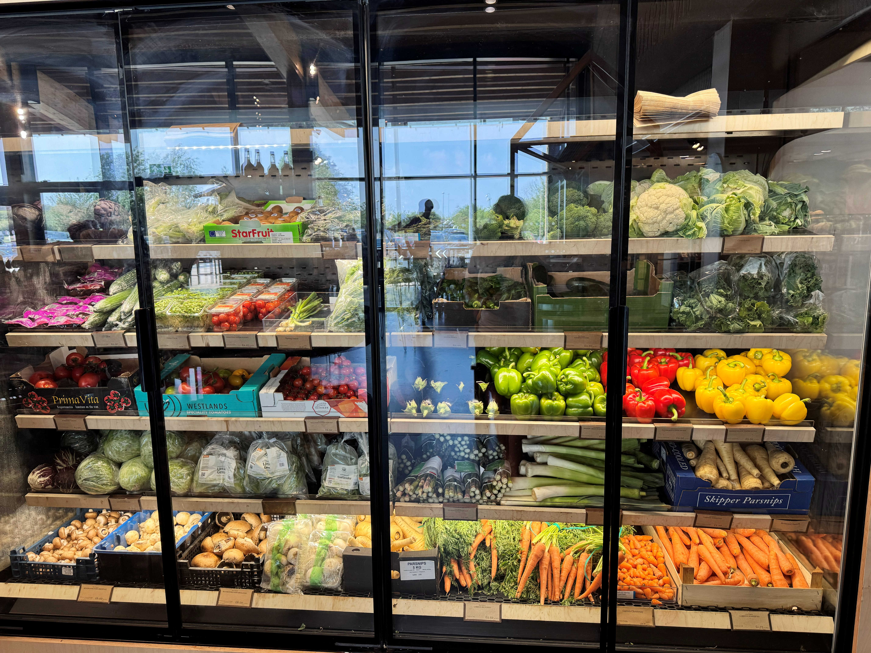
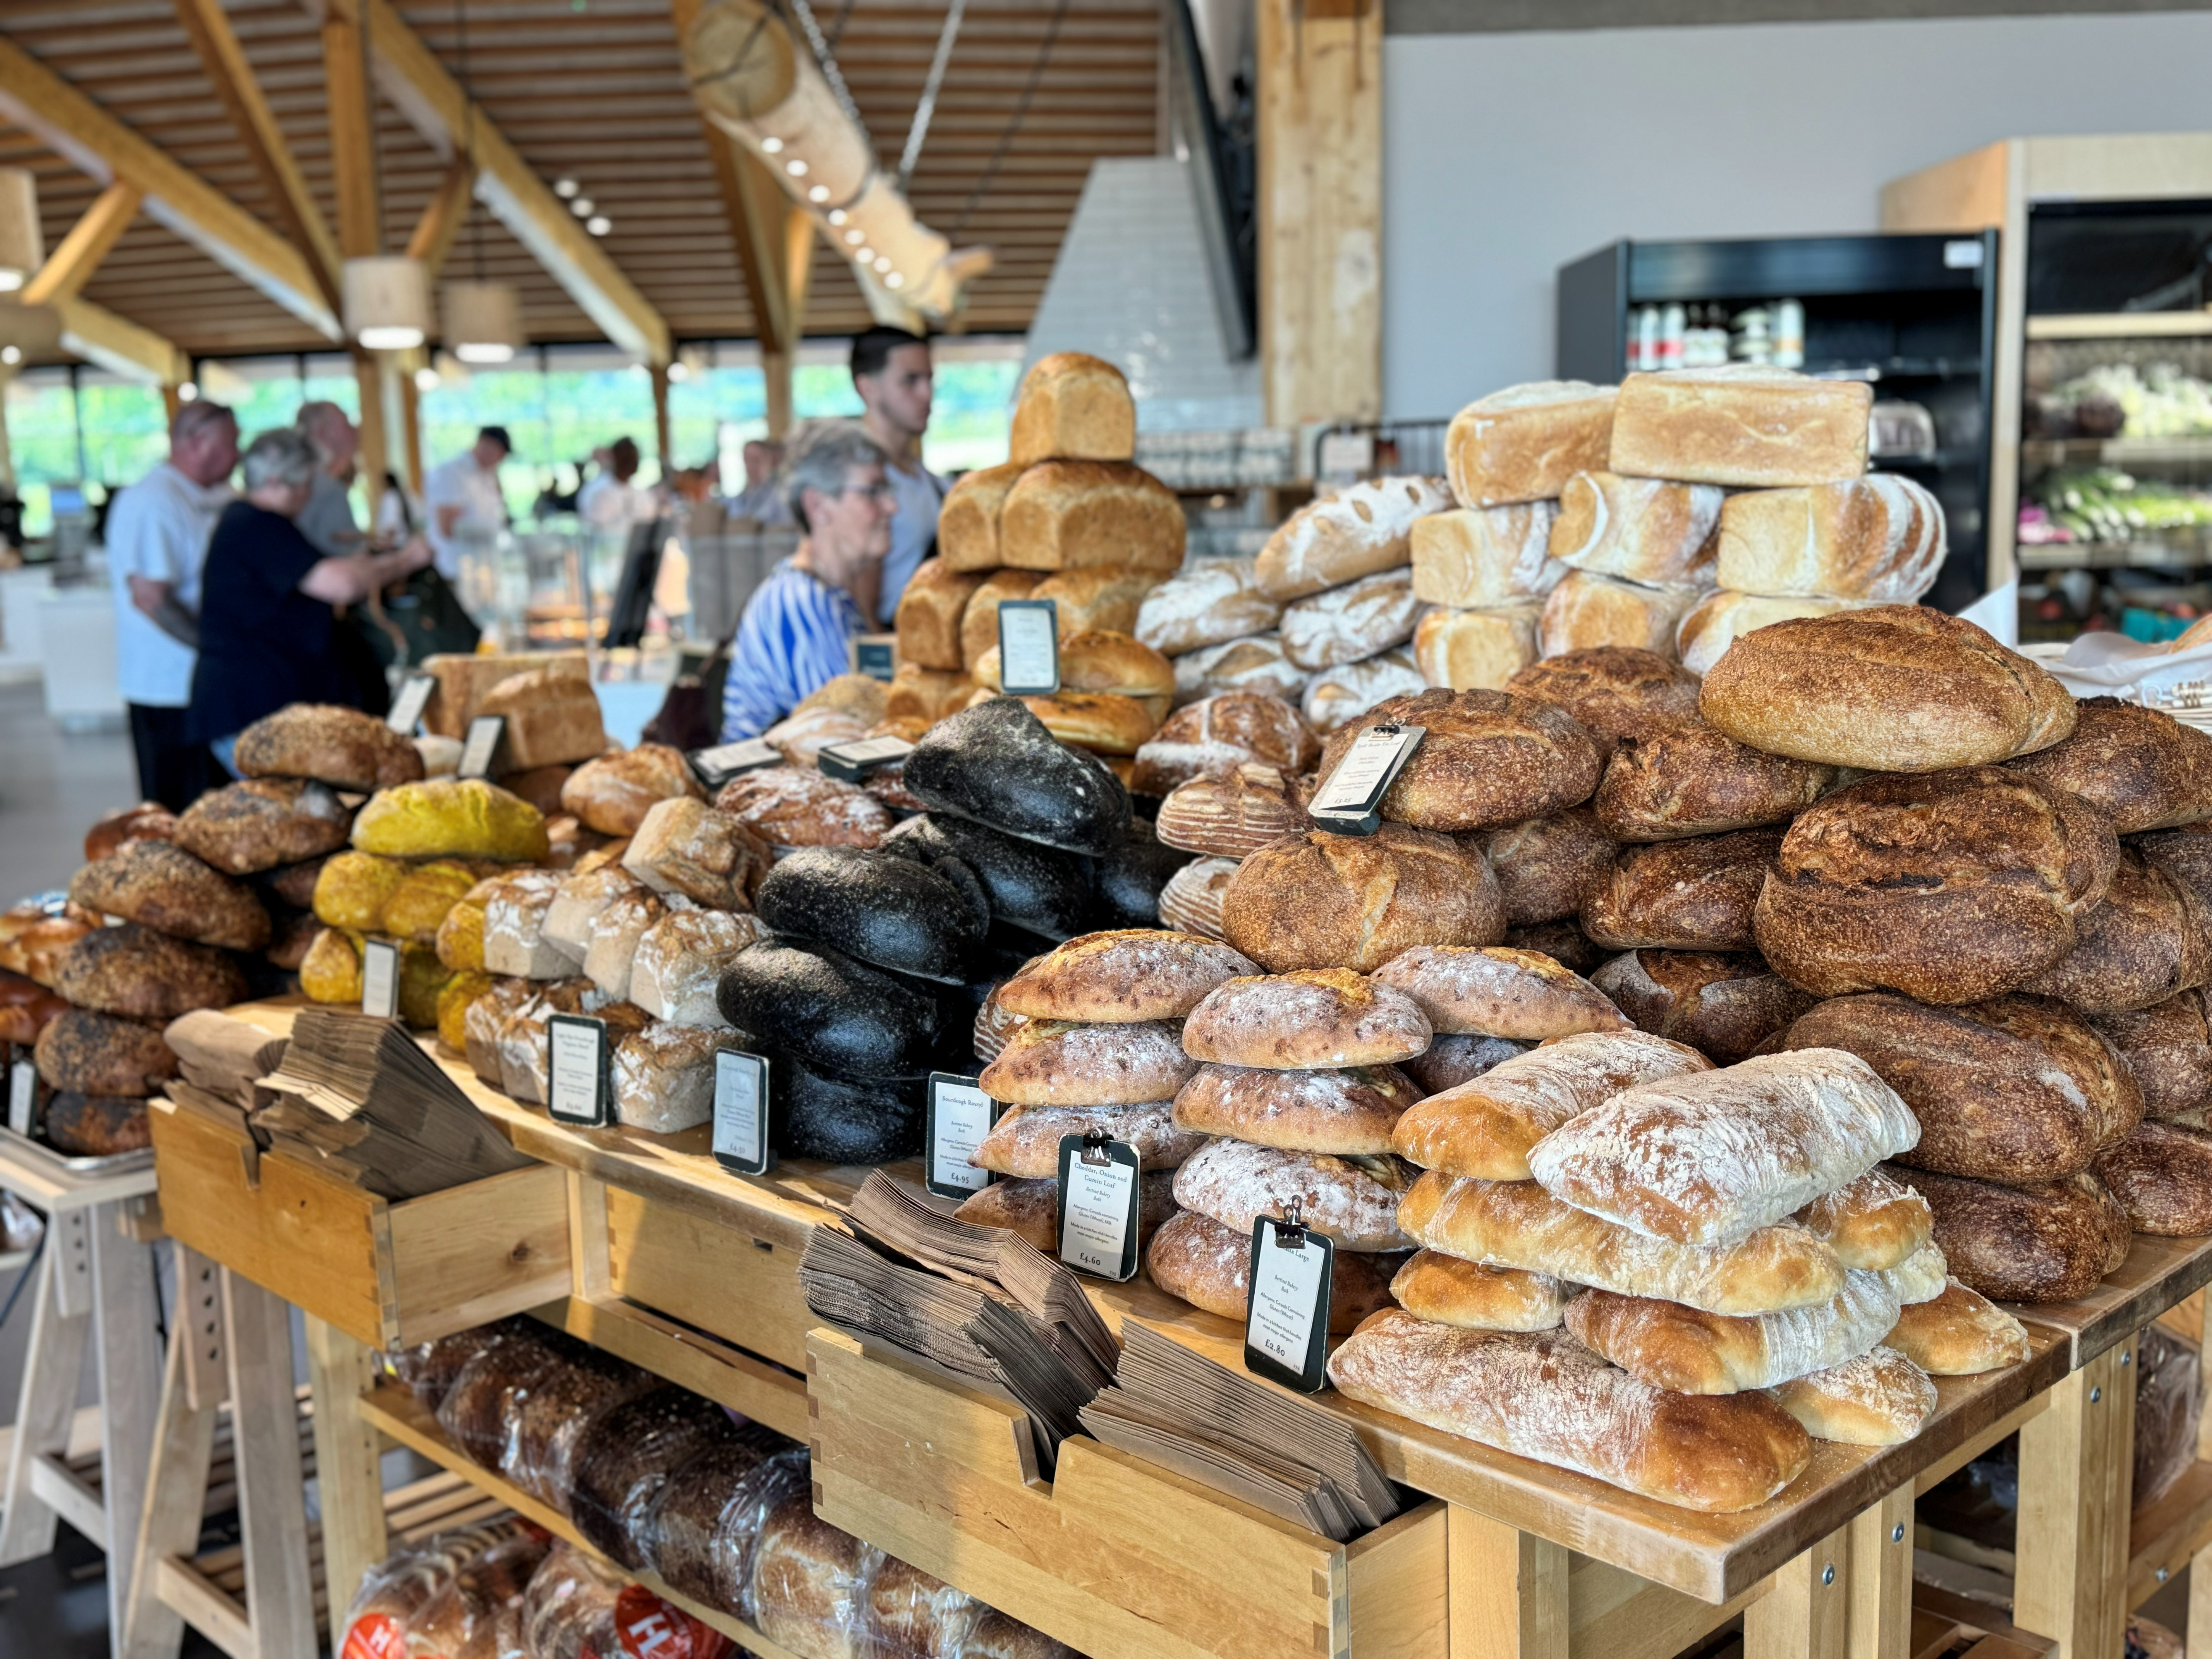
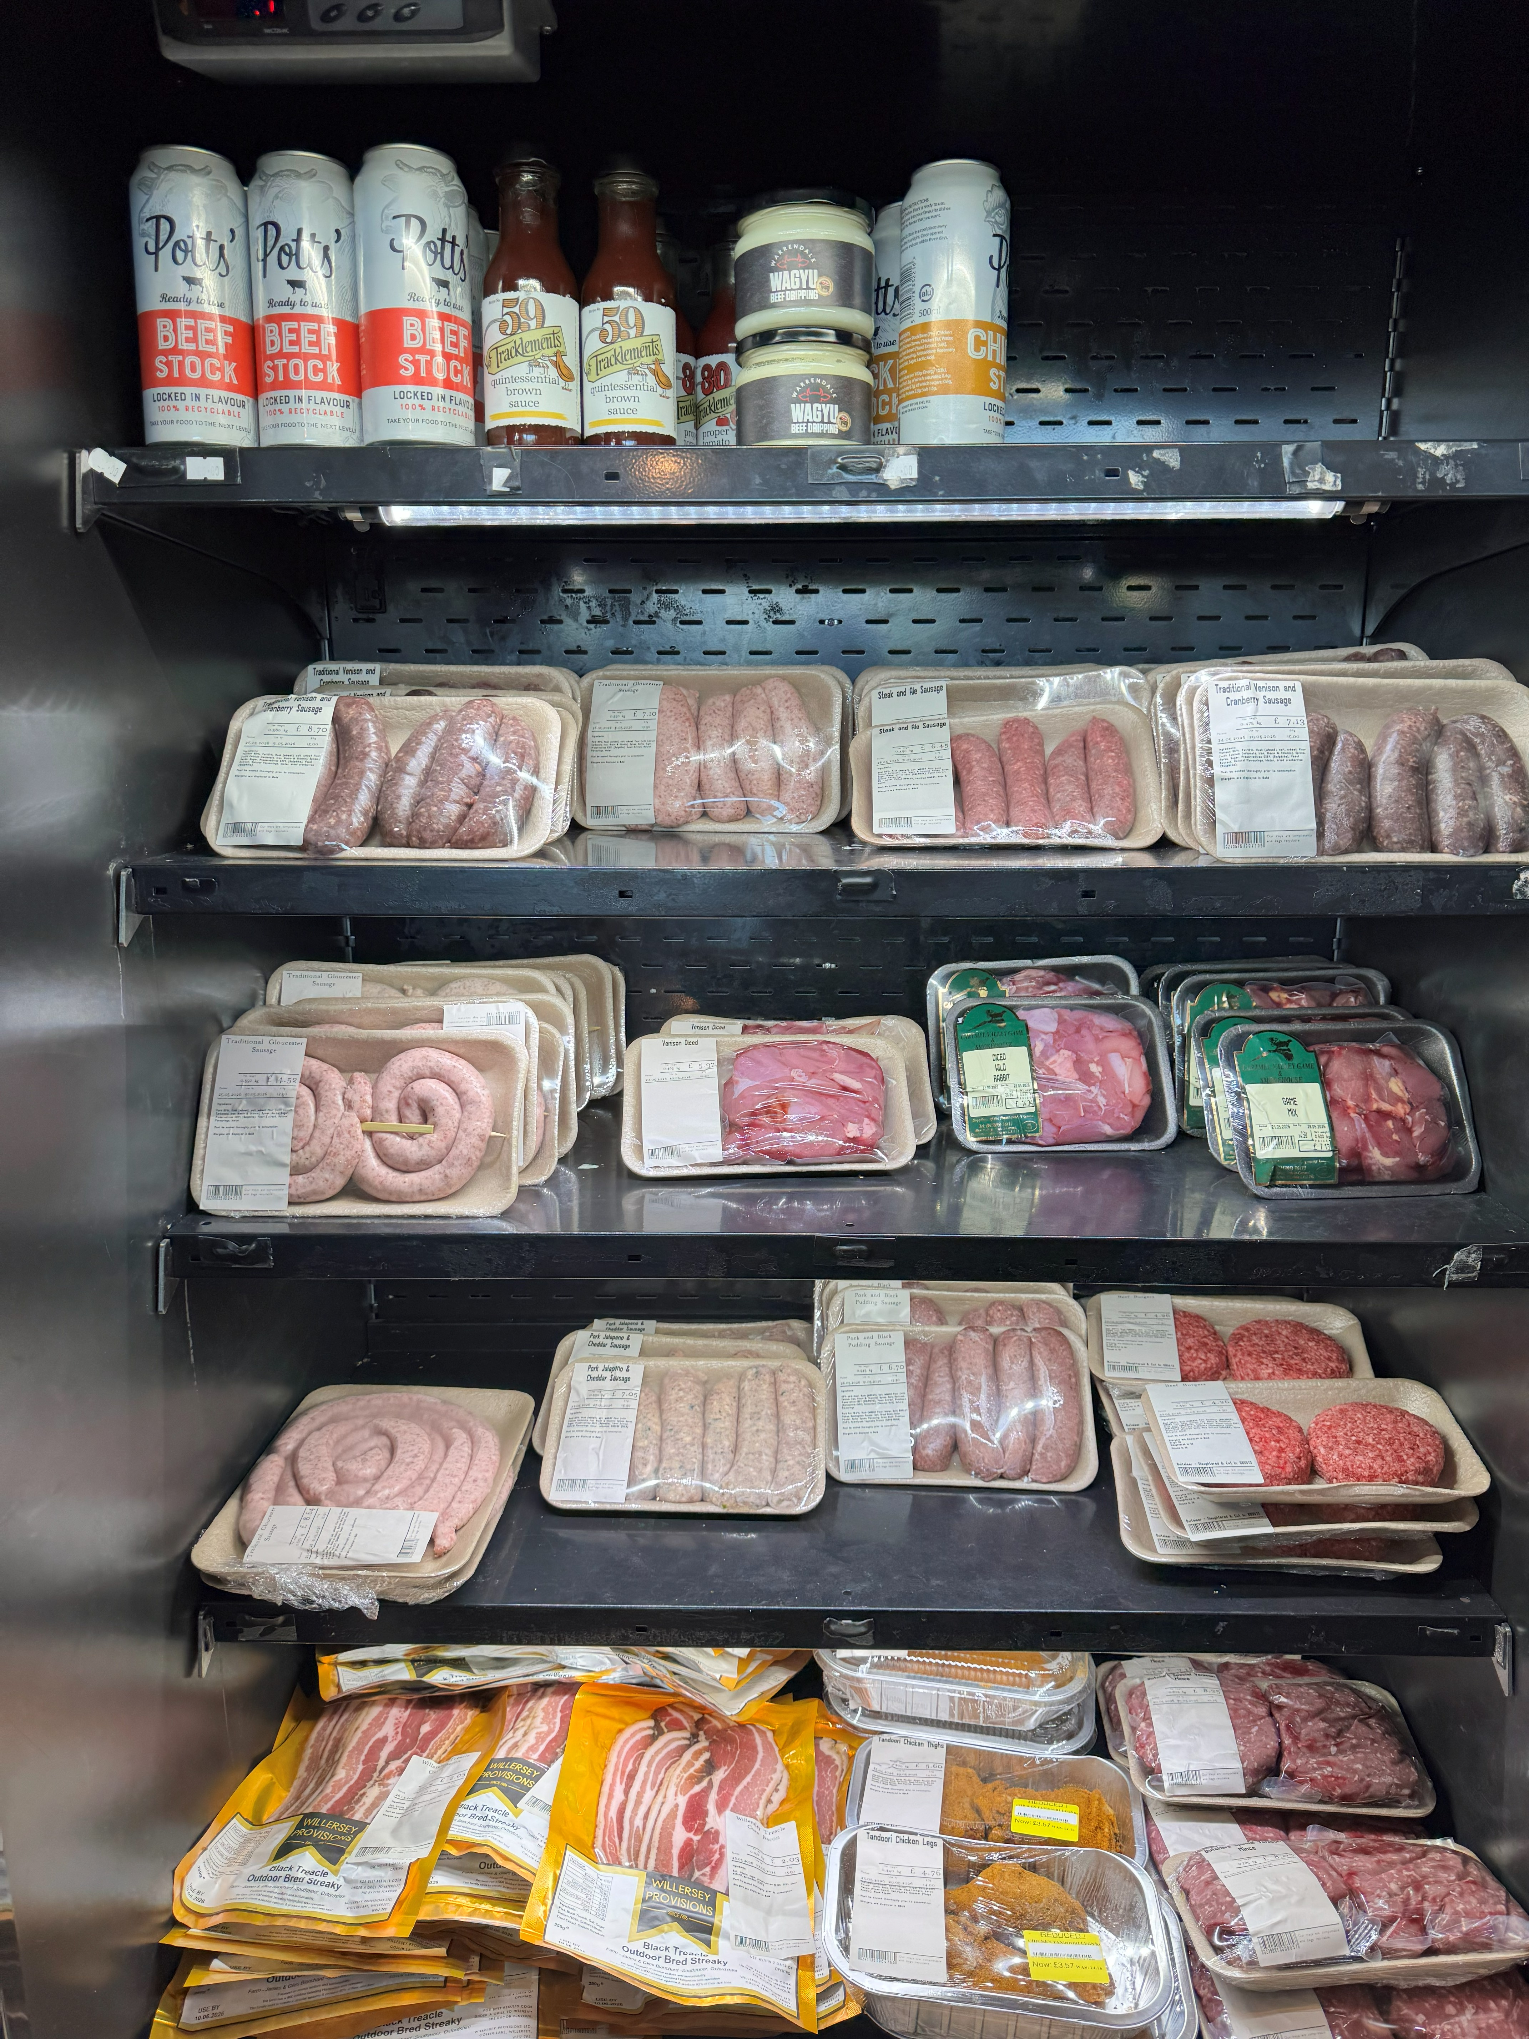
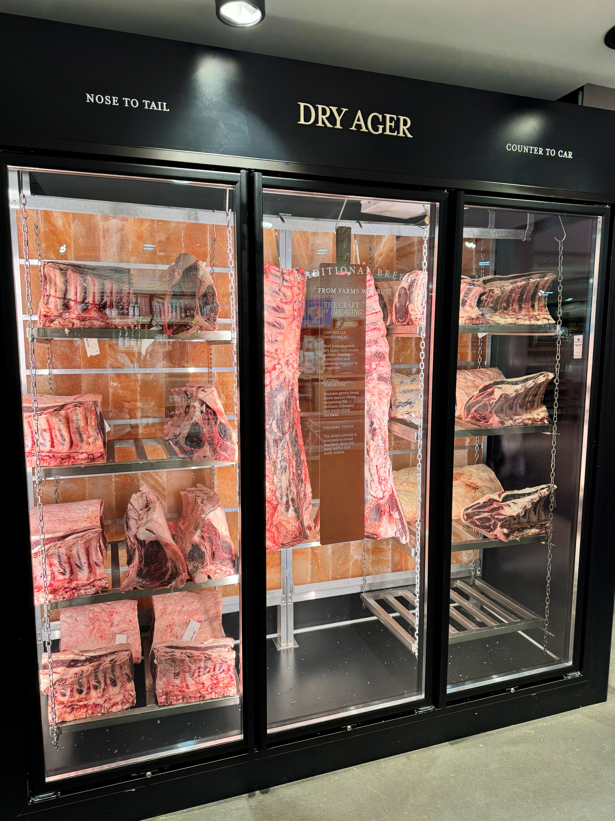
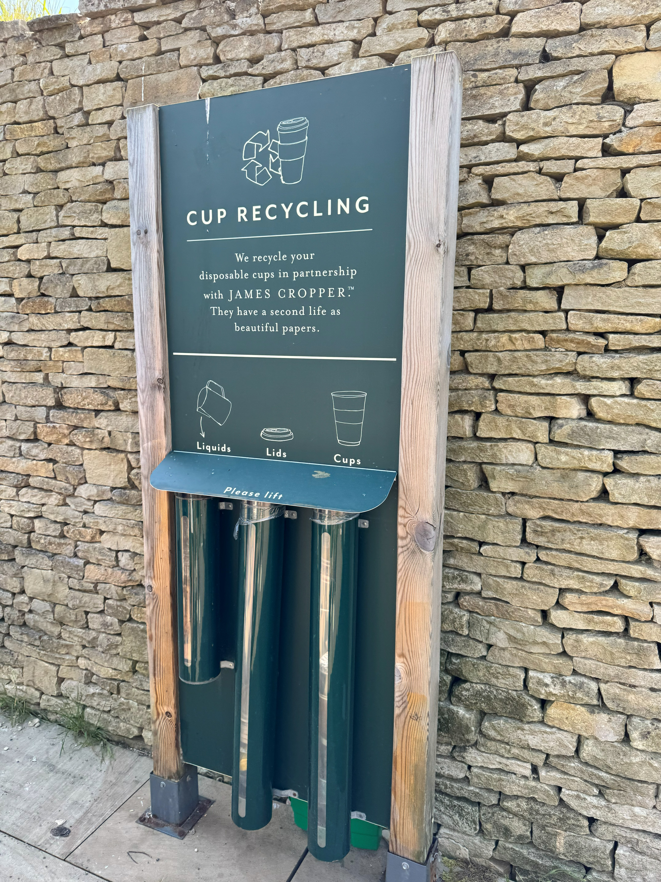
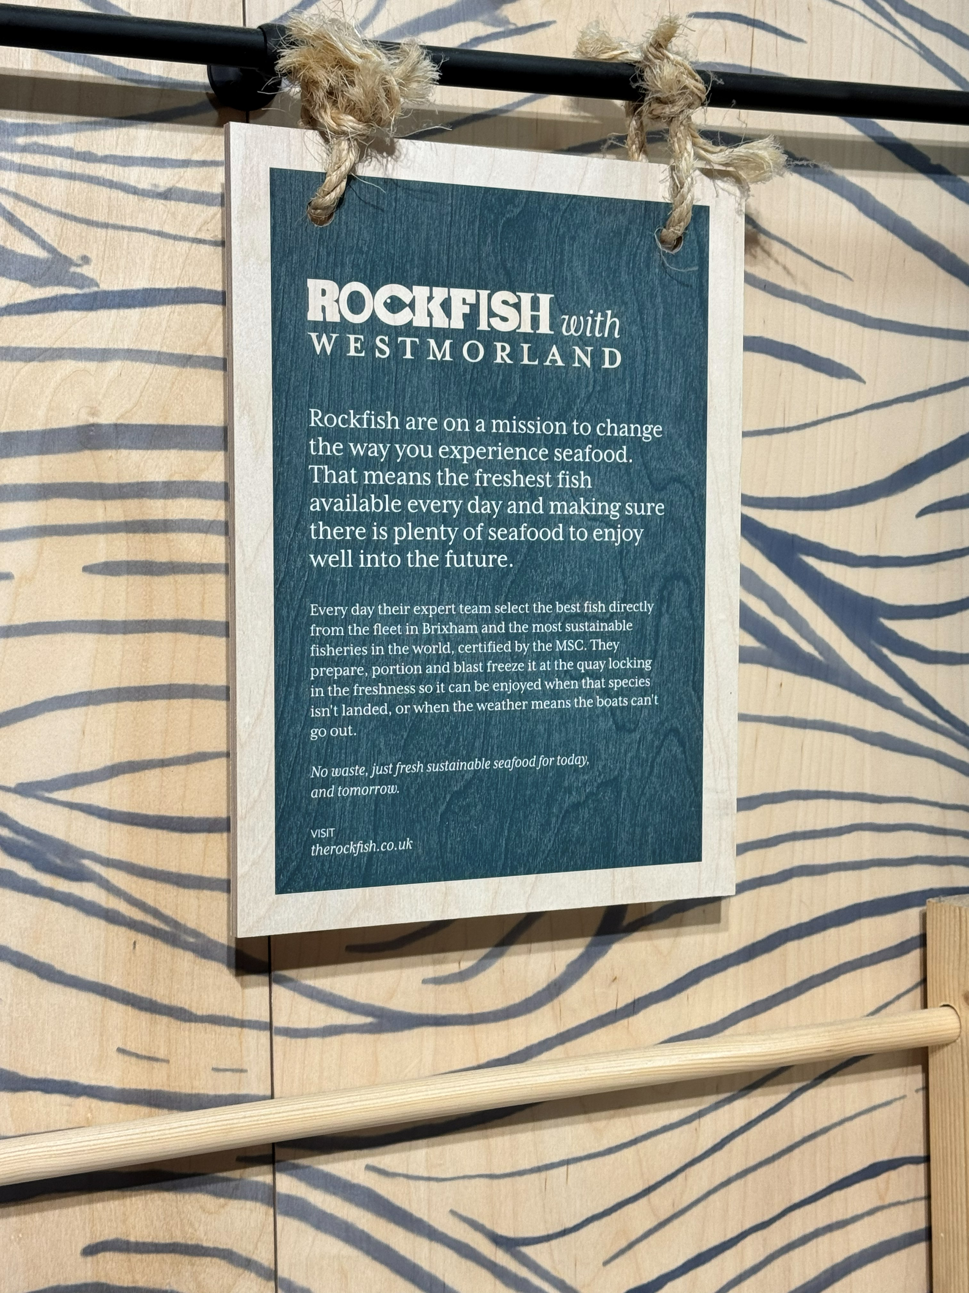
Photos across the farmshop and its unique goods.

- Creating Opportunities for Farms and Food Businesses
Their team works actively to find new talent and bring it to the farmshop. Part of one staff member’s job is to keep finding and developing partnerships with local suppliers. This is funded through the Royalty Agreement between the two partners. The idea behind it is that for every £1 spent on non-fuel purchases, 2 to 3 pence ($0.03 - $0.04 for every $1.26 USD, 2026) is automatically paid to the Gateway Trust, passing it on to other local charities and partner organizations. This mechanism has generated roughly £500,000 a year and more than £4 million over the site’s first decade, funding community partners and initiatives such as Bridging the Gap, a three-day employability skills course open to anyone facing a barrier to work such as disabilities; extended time out of work due to illness, childbirth, or imprisonment; or language barriers. The course provides participants support in a relaxed environment where they can build their skills and confidence. After completing the program, many can secure a position at one of the Services because of the skills learned through the program.
- Considerations for Implementation
Every community operates under different circumstances, and no single model transfers directly from one place to another. That said, Gloucester Services points to a few conditions that appear to matter wherever a partnership like this is attempted.
- Choose a commercial partner for whom local sourcing is already good business. The Westmorland family are farmers who already sourced locally at their other motorway services, so the partnership built on something that was already part of their business model rather than asking them to adopt a new one.
- The funding mechanism must be contractual. Community reinvestment stays reliable only when it is written into the business agreement itself (many enterprises leave that as an annual decision to be made on how much to give).
- Producer discovery requires active outreach. Local vendors rarely present themselves ready-made. Someone within the organization has to seek them out, help them gain market access, and help forecast demand for their products.
- The meaning of “local” depends on geography. A 30-mile sourcing radius is a small, easily verified claim in a country the size of England. Across the much larger United States, the same distance covers a very different scale of economy, and “local” may need to be defined differently to stay credible.
While the specifics of the approach developed by the Gloucestershire Gateway Trust and the Westmorland Family may not be something that can be replicated exactly in Kentucky, the core principles of building upon local assets, working with local suppliers, encouraging workforce development efforts, and creating sustainable and environmentally thoughtful sites, are certainly something Kentucky communities can emulate. Kentucky is rich in material and cultural resources all of which can be put in the service of creating positive change. The first step is to identify local assets that can be brought together to address issues facing our communities. By reframing the M5 as a potential site for a lucrative business partnership, the GGT opened up new possibilities for local development. The second step is to create collaborations, as the GGT did with the Westmorland Family building on the knowledge and experience of both partners. And the third step is to think big. Everyone said the Motorway Services project was impossible. Twelve years on it’s still thriving and its success creates new opportunities for the local community.
- Resources and More Information
- Gloucester Services (Westmorland Family)
https://www.gloucesterservices.com/
- Gloucestershire Gateway Trust
https://gloucestershiregatewaytrust.org.uk/
- Limited Edition Youth Entrepreneurship Program (Gloucestershire Gateway Trust)
https://gloucestershiregatewaytrust.org.uk/limited-edition/
- Learning and Work: Bridging the Gap and Related Programs (Gloucestershire Gateway Trust)
https://gloucestershiregatewaytrust.org.uk/learning-and-work/
- GGT Publications (Gloucestershire Gateway Trust)
https://gloucestershiregatewaytrust.org.uk/about/publications/
- Services with Cult Following Marks Tenth Anniversary (BBC News, 2024)
https://www.bbc.com/news/articles/cwy4g1vyndzo
- Introduction to Building Communities from the Inside Out (Kretzmann and McKnight, 1993)
http://bonner.pbworks.com/w/file/fetch/130234920/Introduction-AssetBasedApproach_Article_2018.pdf

