On-Farm Case Studies of Fine-Mesh Netting Row Covers Over Leafy Greens
Elaine Losekamp and David Gonthier
Graduate Research Assistant and Associate Professor, Department of Entomology, University of Kentucky
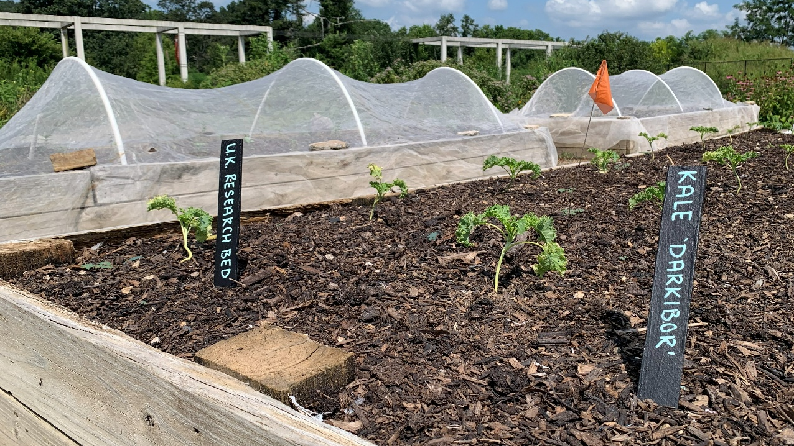
Figure 1. Uncovered research bed at Farmer 1’s growing site at the initiation of the experiment in front of beds covered with row covers.

Introduction
Leafy greens are an important group of crops for Kentucky vegetable growers, but consumer tolerance for insect feeding injury on leafy greens is low. Pest management is especially challenging for organic production of leafy greens in the Brassicaceae family (cole crops), which are hosts to a complex of difficult-to-manage insect pests (Figure 2). Physical insect exclusion with row covers is a promising strategy for protecting leafy greens. Many Kentucky vegetable growers already use spunbonded row covers for frost protection during the shoulder seasons and winter; however, in warm conditions spunbonded row covers can induce heat stress and bolting and reduce the quality of leafy greens. Fine-mesh row covers (insect netting) are a promising alternative to spunbonded row covers for warm season production of leafy greens because they trap less heat (Chaudhary & Nair, 2026). Mesotunnels (~3.5-ft-tall structures made from bent EMT conduit hoops) are sturdy support structures for fine-mesh row covers that increase airflow around plants and prevent insects from feeding or laying eggs through the mesh.
Fine-mesh row covers have been shown to increase yield, reduce feeding damage, and accelerate plant growth rates for leafy greens (Böckmann, 2022; Brockman et al., 2020; Chaudhary & Nair, 2026; Dhakal & Nandwani, 2020; Ester et al., 1994). However, past studies have also highlighted challenges with using fine-mesh row covers, including increased incidence of certain diseases and secondary pest problems, such as aphids (Böckmann, 2022; Ester et al., 1994). Furthermore, mesotounnels are costly and labor-intensive to install and maintain.
To better understand how mesotunnels perform in field-realistic settings, University of Kentucky researchers affiliated with the Crops Under Cover project (https://cropsundercover.mgcafe.uky.edu/) partnered with vegetable growers throughout the state of Kentucky in 2025 to test mesotunnels at their growing sites. Participating farmers grew one or more crops of their choice in paired mesotunnel and uncovered control plots. Participants were provided with materials to construct mesotunnels: ExcludeNet row cover (mesh size: 0.95mm x 0.95 mm; Tek-Knit Industries, Montreal, Quebec, Canada), cut to size, installed over hoops made from bent sections of 10-ft-long EMT conduit, and secured with 10-lb sandbags and 0.75-in snap-on greenhouse plastic clamps (Bootstrap Farmer, Paris, Texas, USA). Data was collected through researcher-led insect pest surveys, before and after surveys of participants, and interviews with participants. Case studies from three participating farmers who grew leafy greens are presented here with their consent. To protect the participants’ privacy, no identifying information is included.
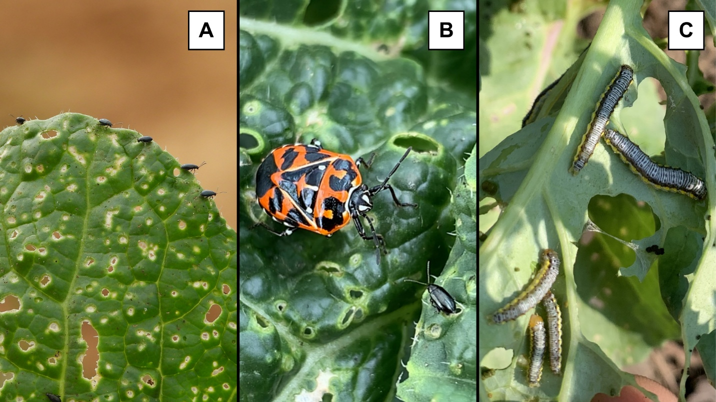
Figure 2. Insect pests of brassica crops and associated damage. (A) Flea beetles and feeding damage (‘shot holes’) on bok choy leaf, (B) Harlequin bug and crucifer flea beetle, and (C) cross-striped cabbageworms and feeding damage on broccoli leaf. Photos: Elaine Losekamp (A-B) and Amelia McCurry (C).

Case Study 1
Mesotunnel provided yield increases in a high pest-pressure environment.
Table 1. Description of Farmer 1’s experiment.
Crop | Kale ‘Darkibor’ (Brassica oleracea)
Plot dimensions | - Mesotunnel: 15’x5’ raised bed  - Control: 15’x5’ raised bed
Transplant spacing | 1.5’ in-row spacing, 3 rows
Planting date | July 9

Farmer 1 works at a 2.4-acre farm site where most crops are produced in raised beds (Figure 3). Row covers are integrated with succession planting and rotated across a series of raised beds to provide early-season protection for crops (Figure 3B). For this study, Farmer 1 chose to test the mesotunnel over a late summer planting of kale (Figure 3A, Table 1).
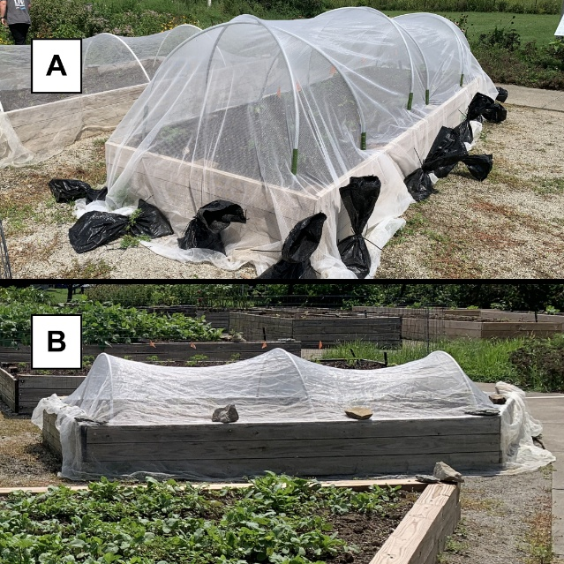
Figure 3. (A) Mesotunnel plot for the study. (B) Farmer 1’s original row cover setup.
During the study period, insect pests quickly colonized the kale in the uncovered bed. Farmer 1 explained, “We just had such heavy pest pressure in that area already on… brassicas from the spring, so once I removed those and we had that fresh kale bed, they were like, thank you!, and just... swarmed it and covered it.” When the research team visited three weeks after transplanting to survey the plants for insect pests, flea beetle density was twice as high in the uncovered plot as in the mesotunnel (Figure 2A, Figure 4A). Later in the season, other insect pests colonized the plants. “Harlequin bugs, the cabbage caterpillars, and the flea beetles were there... And then towards the end of the season, we got a ton of the brown marmorated stink bugs... The only other pests that I really noticed, which was actually on the covered bed, was the yellow-striped armyworm.”
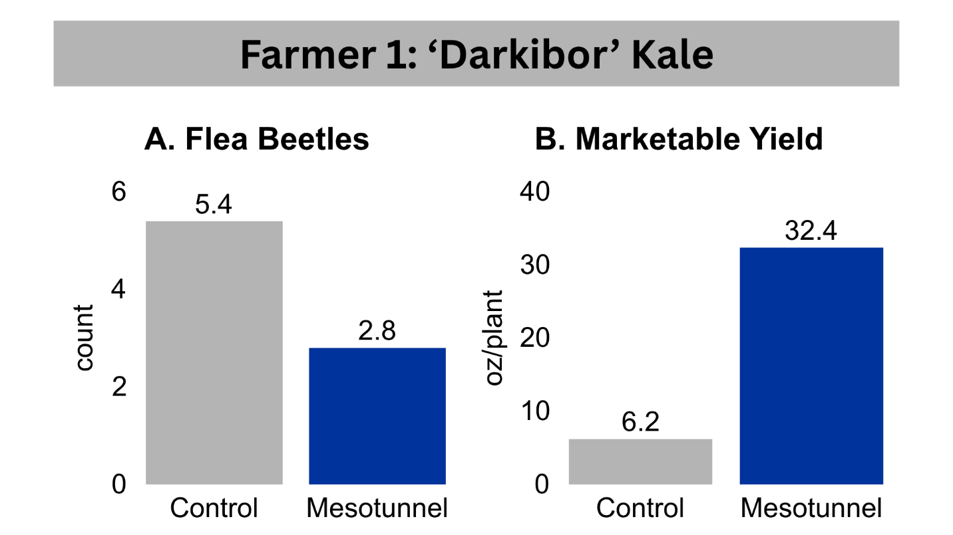
Figure 4. (A) Average number of flea beetles counted per plant during a pest survey and (B) marketable yield per plant harvested from the control and mesotunnel plots at Farmer 1’s site.
Greater insect feeding damage on uncovered kale slowed the plants’ development and reduced the quality of the leaves. “It just seems like those plants on the uncovered bed are just kind of permanently smaller, and not growing as fast, and just a little bit more stunted than the ones that are covered.” Over the six-week harvest period, per-plant marketable yield from the mesotunnel treatment was more than five times that of the plants from the control (Figure 4B, Figure 5).
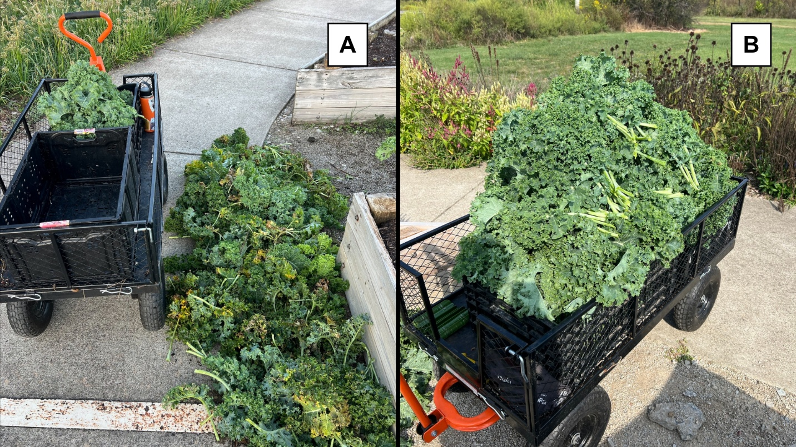
Figure 5. Harvested kale from (A) control and (B) mesotunnel beds at Farmer 1’s growing site. Harlequin bug damage was extensive in the uncovered bed.
Comparing the outcomes of the trial to past experiences using row covers, Farmer 1 noted that pest pressure plays a significant role in yield outcomes. Because of the greater pest pressure for brassica plants, “I would say [row covers] were more effective on the kale than… romaine or a salad mix.” Farmer 1 also attributed some of the benefits to the design of the mesotunnel. “Seeing the full setup with the clips… I think going forward, that's something to invest in, because it really makes such a difference, when you have all those gaps covered, and, you know, the row cover's not flying everywhere, and it's tight.” The mesotunnel used for the study had taller hoops than the row cover setup previously used at the growing site, and the row cover was fastened more securely with sandbags and greenhouse clamps (Figure 3). Farmer 1 attested, “The clips and the sandbags, it just… it makes all the difference, when it comes to bugs not wiggling their way in there.”
Moving forward, Farmer 1 will continue to use fine-mesh row covers at the site for pest exclusion. Farmer 1 explained that following organic growing practices, growing with “even organic pesticides is really difficult if you don't have your plants covered. I mean, you can take care of the plant and the soil as good as you possibly can, and those bugs are still going to find those plants, you know?” Participating in the study affirmed Farmer 1’s perceptions of using row covers as a pest management strategy: “It kind of just solidified how I already view them, which is that they're really effective, especially when it comes to those cole crops.”
Case Study 2
Tradeoffs between increased yield and increased labor.
Table 2. Description of Farmer 2’s experiment.
Crop | Red Russian kale (Brassica napus)
Plot dimensions | - Mesotunnel: 24’x2.5’, bare ground  - Control: 6’x2.5’, bare ground
Transplant spacing | 1’ in-row spacing, 2 rows
Planting date | May 1

Farmer 2 chose to grow spring-planted Red Russian kale for the study (Table 2). The mesotunnel did not completely exclude insect pests: flea beetles were present in both plots and caterpillars began to infiltrate the mesotunnel in late July. Nevertheless, the kale in the mesotunnel grew more vigorously, had less insect feeding injury, and had more tender leaves than the uncovered plants. Farmer 2 commented of the mesotunnel, “I think it serves also as a little bit of shading, because I noticed that the kale outside, even in rows that weren't in this study, you could tell the sun was hard on them as the year went on.” One month after transplanting, plants in the mesotunnel were on average 1.4 times taller than those in the control (Figure 6A). Over the course of two months and seven harvests, plants in the mesotunnel plot produced double the marketable yield of the uncovered plants (Figure 6B).
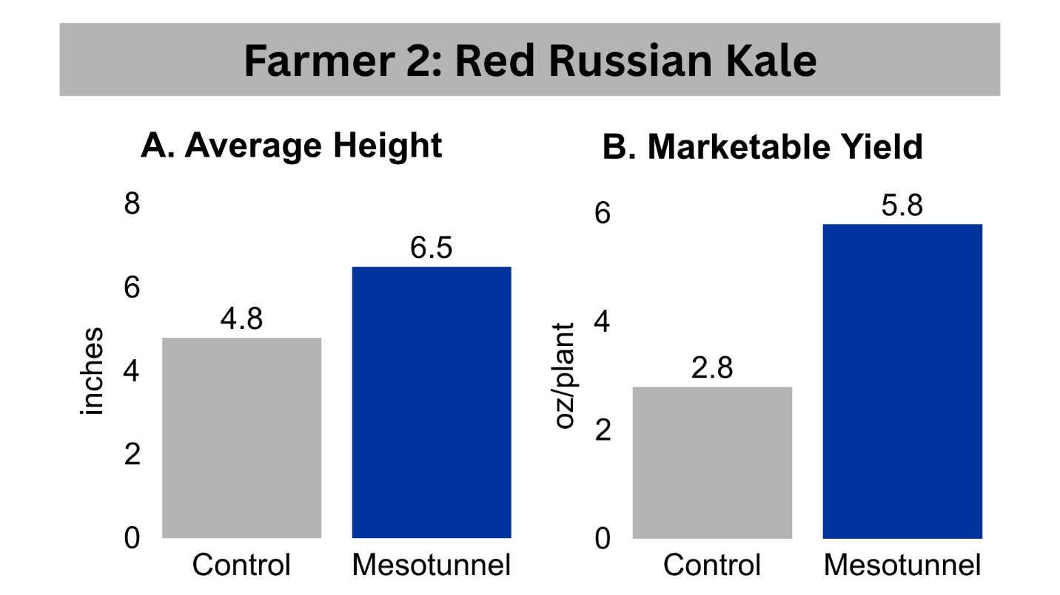
Figure 6. (A) Average plant height measured one month after transplanting and (B) per-plant marketable yield harvested from the control and mesotunnel plots at Farmer 2’s site.
Prior to this study, Farmer 2 had tested two different fine-mesh row cover products over lettuce and blueberry crops and found that durability varied across products. “So, the row cover that I used before [over lettuce]… It sort of shreds if the wind even looks at it, and that was just a total waste of time and effort.” For blueberries, Farmer 2 had tried ExcludeNet – the product used in this study – over T-posts with promising results (Figure 7A). “Well, it was fantastic for the blueberries… The reason I loved it better on the berry patch was because I could stand up.” The higher clearance within the T-post structure allowed for greater ease of movement than would be possible in a mesotunnel.
Farmer 2 praised the sturdiness of the mesotunnel structure used in this study but noted that it was challenging to remove the clamps, sandbags, and row cover to access the plants underneath (Figure 7B-C). “There is some time needed for taking the cover off. I have arthritis in my hand, so, taking the [clamps] off the posts was challenging for me.”
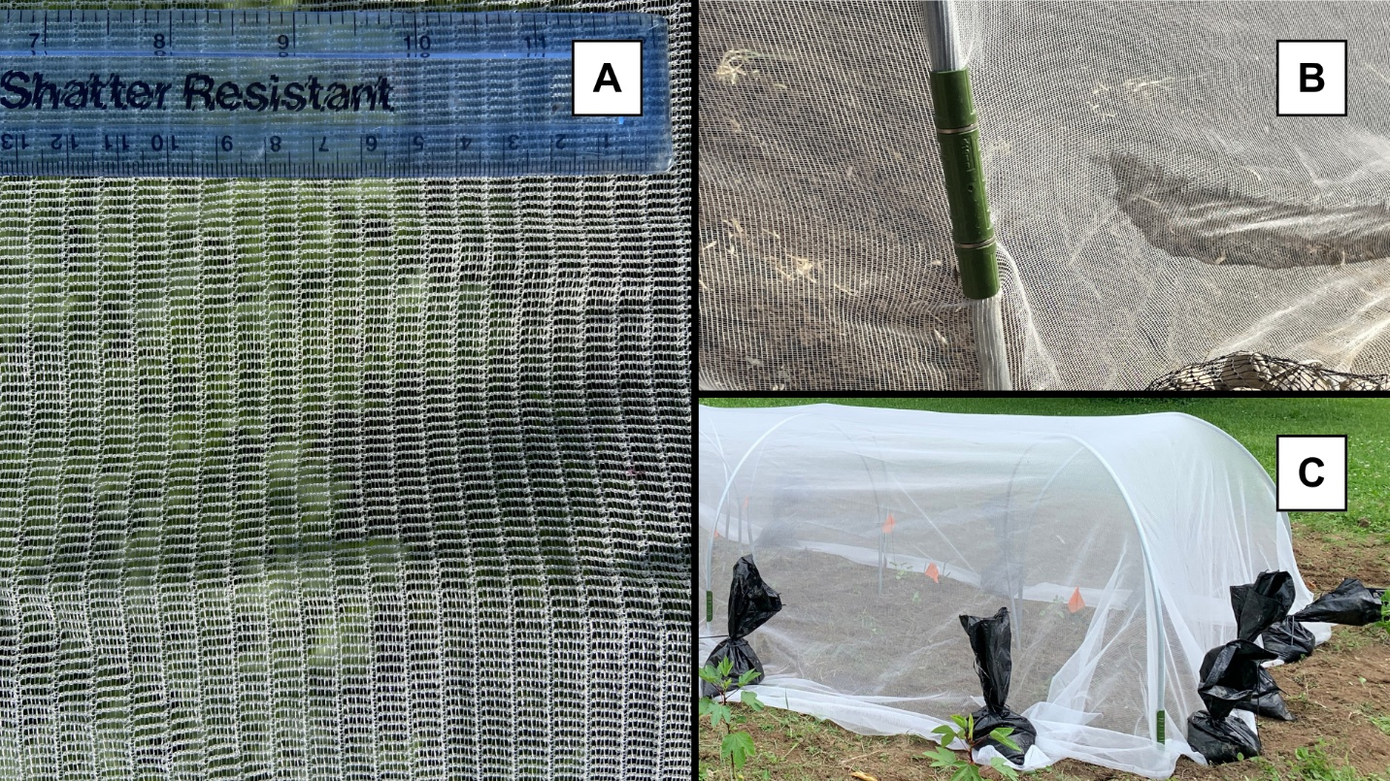
Figure 7. Components of a mesotunnel: (A) fine-mesh row cover (here, ExcludeNet row cover with a mesh size of 0.95x0.95mm), (B) clamps to attach the row cover to hoops, and (C) sandbags to secure the edges of the row cover to the soil. Photos: (A) Kathleen Fiske Pulliam, (B-C) Elaine Losekamp.
Weed management and harvesting were also more challenging in the mesotunnel plot compared to typical, open field conditions. “The maintenance aspect is a little more. You know, when you have a regular row, you can go in and hoe and pull up the weeds, but with the row cover, it's a little bit more challenging… Well, there's a little bit of trade off, you know… get some knee pads and do some yoga on the day you're going to harvest and weed that because it is a lot of kneeling and bending over.”
Despite the ergonomic challenges, Farmer 2 maintained a positive perception of the mesotunnel. It provided yield and quality increases without requiring pesticides, which Farmer 2 avoided using because of concerns about pollinator and other beneficial insect conservation. “I love the fact that I didn't have to even spray like horticultural oil, or you know, anything like that. I mean, we're organic. So anything that I do spray is OMRI certified... But I don't even think I'd have to use anything, you know, on it at all, which is sweet.”
Case Study 3
Tradeoffs between expedited growth rate and secondary pest problems.
Table 3. Description of Farmer 3’s experiment.
Crop | - Salanova® Green Bibb lettuce (Lactuca sativa)  - Chalupa romaine lettuce (Lactuca sativa)
Plot dimensions | - Mesotunnel: 25’x5’, bare ground  - Control: 25’x5’, bare ground
Transplant spacing | 6” in-row spacing, 3 rows per lettuce cultivar
Planting date | May 13

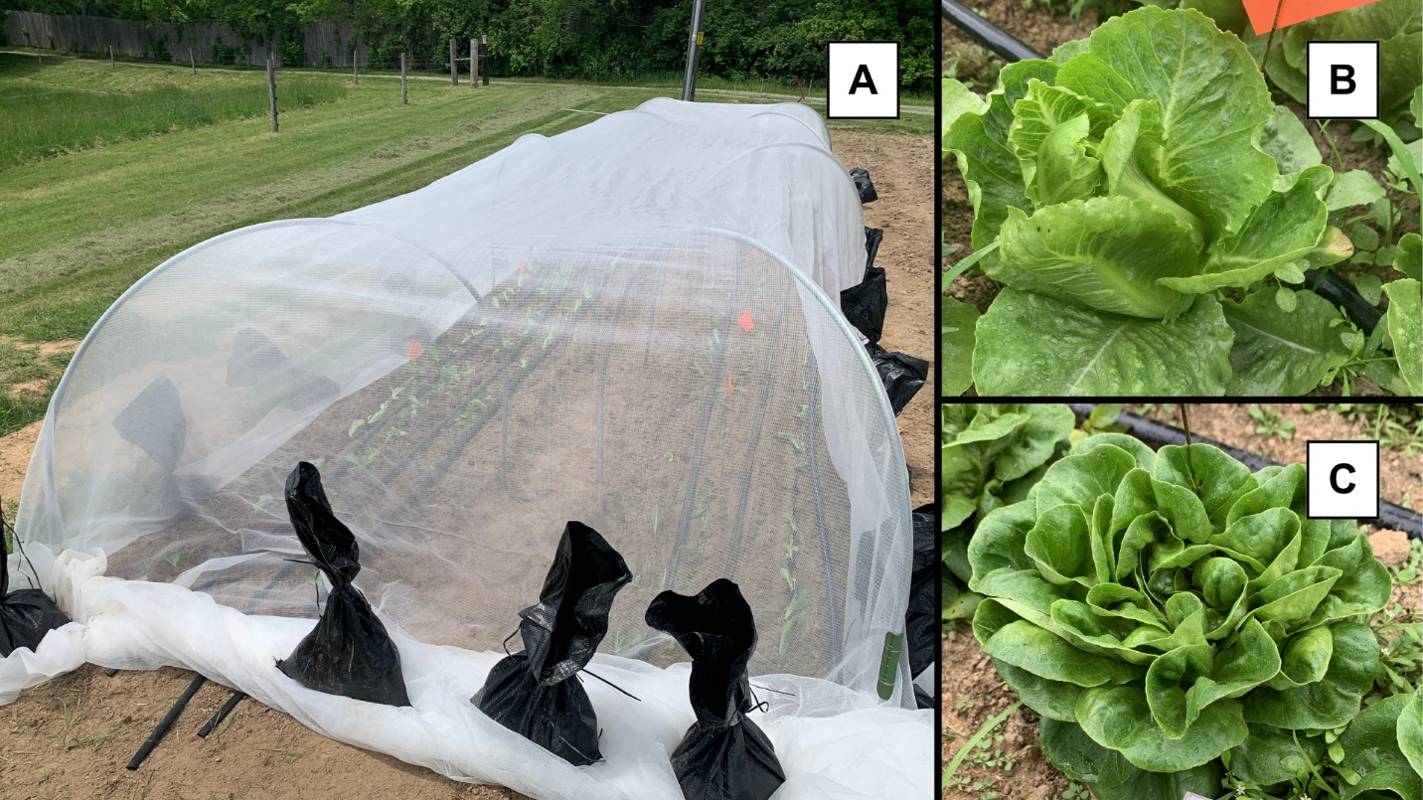
Figure 8. (A) Mesotunnel plot at Farmer 3’s site immediately after transplanting and mesotunnel installation. Farmer 3 tested the mesotunnel over (B) romaine and (C) Bibb lettuce varieties.
As the owner of a certified-organic, diversified farming operation, Farmer 3 grows many varieties of leafy greens. For this study, Farmer 3 chose to test the mesotunnel on two spring-planted lettuce cultivars (Figure 8, Table 3). Secondary pest issues were a challenge, with warm, humid, and protected conditions in the mesotunnel favoring the development of aphids and slugs. One month after transplanting, the research team counted 8.7 aphids per Bibb lettuce and 46.4 aphids per romaine plant in the mesotunnel, compared to none in the control plot (Figure 9A).
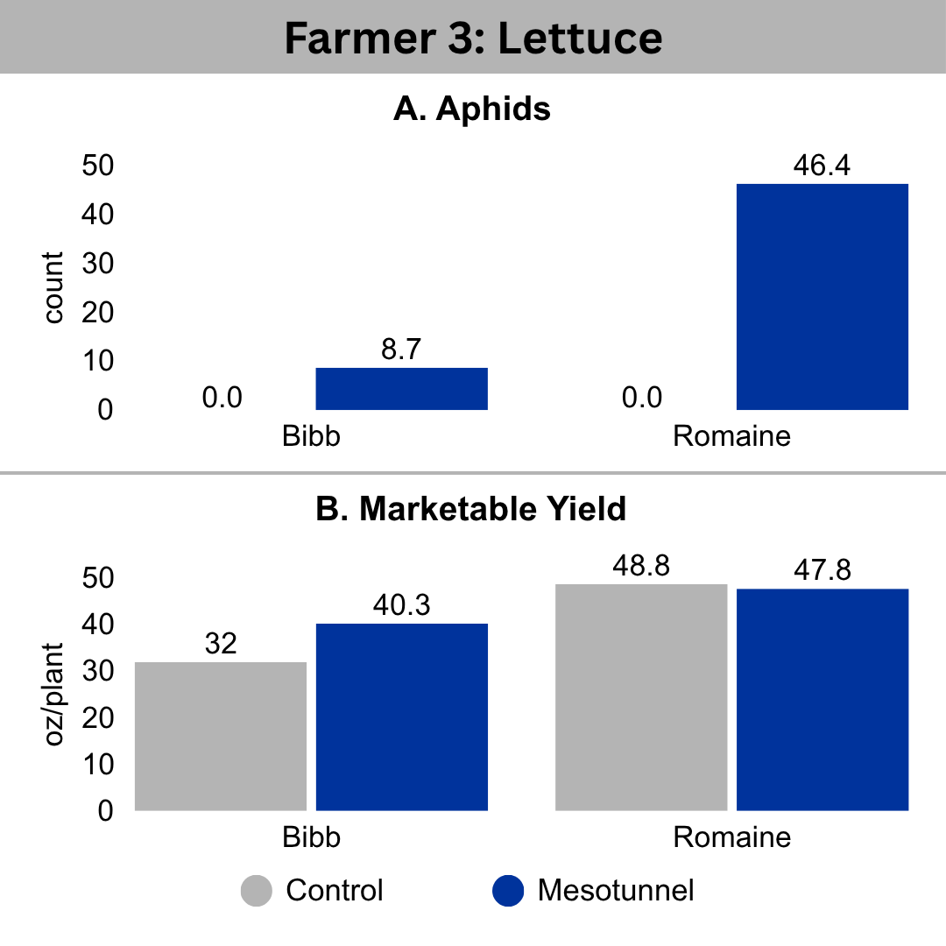
Figure 9. (A) Average number of aphids per plant from a pest survey one month after transplanting and (B) marketable yield per plant harvested from Bibb and romaine lettuce in the control (gray) and mesotunnel (blue) plots at Farmer 3’s site.
Farmer 3 found that quality and total marketable yield did not differ drastically between the treatments, but the mesotunnel fostered rapid plant growth (Figure 9B, Figure 10). “It looked like pest damage wasn't necessarily a thing between the two... but the growth rate was drastically different between what was covered, and what was uncovered. The covered sections were running about a week and a half, maybe two weeks ahead of what was left out.” While accelerated growth rate provided a benefit in terms of less time in the field and earlier access to market, it was also tied to an earlier peak in quality for the crops in the mesotunnel than the uncovered lettuce.
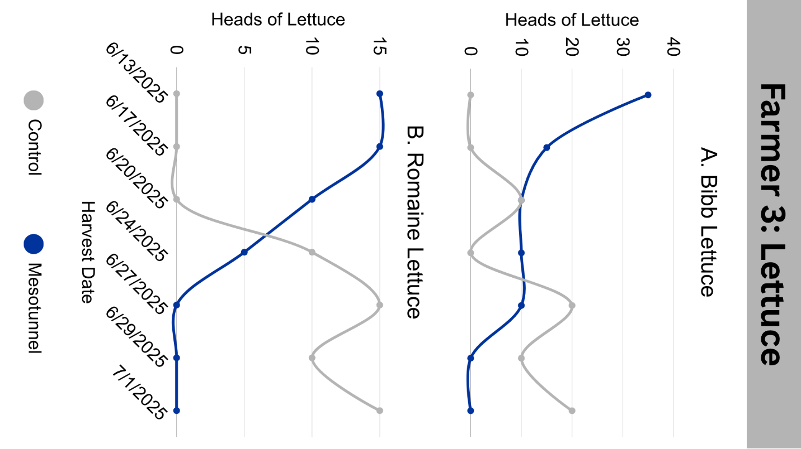
Figure 10. Number of heads of (A) Bibb and (B) romaine lettuce harvested from Farmer 3's control (gray) and mesotunnel (blue) plots at each harvest date throughout the season.
Farmer 3 stopped harvesting lettuce when quality began to decrease because of increasing bitter flavor, leaf yellowing, and presence of slugs. For plants in the mesotunnel, the final harvest occurred about one week earlier (Figure 10). At first, the microclimate conditions within the mesotunnel had spurred plant growth rates, but eventually unfavorable weather led to excessively warm and humid conditions under the row cover. “We had some significant rain events. Like two to three inches at a time, and... maybe like six inches in a span of like a week, and I think just the early onset of high temperatures and all that moisture, what was in the row cover bolted or had fungal disease issues before the uncovered.”
Farmer 3 was excited to continue adapting and repurposing elements of the mesotunnel structure to meet the farm’s needs, describing plans to get started “by buying a [hoop] bender and start getting EMT, to start putting everything under cover, because we want to get a jump start on our late summer/early fall lettuces and radishes and all the stuff that we haven't had good luck with growing when summer showed up in June, and putting everything under cover... and then we're also looking to put the insect netting on both sides of our high tunnels. We've had a horrendous infestation of squash bugs and stink bugs. So we're looking to get that cleaned out, and then use that as a preventative measure for end of the season.” Farmer 3 released thousands of ladybugs into high tunnels each month to manage insect pests and planned to increase the efficacy of the biocontrol agents by installing fine-mesh row cover on the sides of the tunnels to “keep pests out, to keep beneficials in.” Other Kentucky vegetable farmers have successfully utilized biocontrol agents, such as ladybugs and lacewings, to control aphid populations under fine-mesh row covers. Research is ongoing at the University of Kentucky (https://cropsundercover.mgcafe.uky.edu/) to study how best to use ladybugs in conjunction with mesotunnels for aphid issues like those observed here.
Moving forward, fine-mesh row covers will continue to factor into the farm’s pest management plan. “Yeah, I think I think it was a good example of using… the row covers. And it's definitely going to be incorporated at a larger scale throughout the farm.”
Conclusions
Mesotunnels are an emerging strategy for insect exclusion in vegetable production and may be especially useful for production of high-value crops with difficult-to-manage insect pests, such as organic leafy greens. Three case studies from a 2025 University of Kentucky on-farm research project highlight benefits and challenges of using mesotunnels for pest management in leafy greens. Both trials of kale and one of two lettuce plantings had higher per-plant yield in the mesotunnel treatment. Mesotunnels reduced insect damage for kale, although complete insect exclusion was never achieved. Participants described accelerated growth rates of covered plants. However, several challenges emerged, including added labor to manage the row cover and increased secondary pest (aphids and slugs) and disease problems in lettuce. Growers should consider the history of insect pest pressure in their growing site and weigh added cost and labor requirements when deciding whether to install mesotunnels.
References
Böckmann, E. (2022). Effects of insect net coverage in field vegetables on pests, diseases, natural enemies, and yield. Journal of Plant Diseases and Protection, 129, 1401–1415. https://doi.org/10.1007/s41348-022-00644-1
Brockman, R., Kuesel, R., Archer, K., O’Hearn, K., Wilson, N., Scott, D., Williams, M., Bessin, R., & Gonthier, D. (2020). The Impact of Plant Essential Oils and Fine Mesh Row Covers on Flea Beetle (Chrysomelidae) Management in Brassicaceous Greens Production. Insects, 11.
Chaudhary, S., & Nair, A. (2026). Insect exclusion netting improves pest suppression, yield, and harvest timing in organic napa cabbage production. Renewable Agriculture and Food Systems, 41. https://doi.org/10.1017/S1742170526100490
Dhakal, K., & Nandwani, D. (2020). Evaluation of row covers for yield performance of the leafy green vegetables in organic management system. Organic Agriculture, 10(Suppl 1), 27–33.
Ester, A., Zande, J. v. d., & Frost, A. (1994). Crop covering to prevent pest damage to field vegetables, and the feasibility of pesticides application through polyethylene nets Brighton Crop Protection Conference, Brighton, England. https://research.wur.nl/en/publications/crop-covering-to-prevent-pest-damage-do-field-vegetables-and-the-/

