Lighting Considerations for Controlled Environment Plant Production in Kentucky
Arundathi Sharma and Qinglu Ying
Crop production in controlled environment agriculture (CEA) depends on the grower's ability to manage environmental conditions that influence plant growth and development. Among these factors, light is the primary energy source driving photosynthesis and one of the most important determinants of crop growth, yield, and quality. Although natural sunlight provides adequate light for crop production during much of the year, Kentucky growers seeking to extend production into the winter months often encounter periods when light levels are insufficient to support optimal growth. In these situations, supplemental lighting becomes an important tool for maintaining crop productivity and enabling year-round greenhouse production.
This publication aims to offer Kentucky growers practical guidance about: different light measurements and units; how much light is available in greenhouses in Kentucky; lighting requirements for common local crops; light measurements and mapping; when and how to consider adding supplemental light to CEA; management of light intensity and photoperiod.
Units For Light Sources and Measurements
Before discussing the technical aspects of light availability, measurement, and supplemental lighting selection, it is helpful to clarify some commonly used terminology. Light is described using a variety of units, which can sometimes be confusing. Depending on the context, different units may be more appropriate.
It is important to understand that what we commonly call “light” represents only a small portion of the full electromagnetic (EM) radiation spectrum—specifically, the range of wavelengths visible to the human eye (visible spectrum). Traditional units used to describe light illuminance were developed to characterize visibility in human-occupied spaces. As a result, these measurements account for factors such as the human eye’s sensitivity to different colors and how our visual system interprets brightness. The most common units used for this purpose are lux and footcandles.
Plants also respond to electromagnetic (EM) radiation, but they do not “see” light the same way humans do. Instead, plants capture energy from particles of light (i.e., photons) and use that energy to drive photosynthesis. The portion of light that plants use for photosynthesis is called photosynthetically active radiation (PAR), which includes wavelengths between 400 and 700 (or 750) nm. Horticultural light requirements commonly report photosynthetic photon flux density (PPFD) in micromoles per square meter per second (µmol·m⁻²·s⁻¹). This unit describes the number of photons reaching a given area each second and is widely used in CEA to evaluate the light available for crop growth. Table 1 summarizes the units commonly encountered in greenhouse climate data, lighting product specifications, research publications, and crop production guides. Regardless of the units used, accurately assessing the greenhouse light environment requires reliable light measurement tools rather than relying on visual observations, as the human eye is a poor indicator of the amount of light available for plant growth.

Table 1. Common light metrics used in greenhouse production, including their units, conversions, descriptions, and typical sources where they are encountered.
Light metrics | Units/conversion | Description | Typical sources
Photosynthetically Active Radiation (PAR) | Wavelength measured in nanometers (nm).  PAR intensity is measured in units of µmol·m⁻²·s⁻¹ (see next row) | The portion of the light wavelength that plants use for photosynthesis, ranging from 400 to 700 (or 750) nm. | Spectral range for light/quantum sensors and meters.  Spectral output curves for artificial light fixtures – should contain mostly PAR for horticulture applications
Photosynthetic Photon Flux Density (PPFD) | µmol·m⁻²·s⁻¹ (micromoles per square-meter per second) | Used to measure PAR levels or light intensity i.e., the number of photosynthetically active photons (in µmol) that reach a unit surface area (1 m²) per second. | Output of quantum light sensors  Production guidelines may indicate crop light requirements in units of light intensity, especially when specifying needs at different development stages (germination, vegetative, flowering/fruiting phase).
Daily Light Integral (DLI) | mol·m⁻²·d⁻¹ (moles per square-meter per day)  Recall:  1 mol = 10⁶ μmol  3600s = 1 hour  So  100 µmol·m⁻²·s⁻¹ light intensity with 16 hours daily photoperiod is:  100 µmol·m⁻²·s⁻¹ *16 hours·day⁻¹  *(3600s·h⁻¹)=  5,760,000 µmol·m⁻²·d⁻¹ =  5.76 mol·m⁻²·d⁻¹ | DLI represents the accumulated number of photons passing through a unit surface area (m²) over one daily photoperiod. Simply, DLI is the total light that the plant receives per day.  DLI can be estimated by multiplying light intensity (measured in or converted to units of PPFD) by the daily photoperiod (in seconds). | National DLI maps  Production guidelines may indicate crop light requirements as DLI.  Some higher-cost sensors may provide DLI “measurements” based on a series of instantaneous light intensity (PPFD) measurements summed throughout the data collection period.
Illuminance | Lux (lumen·m⁻²) or footcandles (lumen·ft⁻²)  1 footcandle ≈ 10 lux  Conversions to PPFD vary across light sources:  1 lux (Sunlight) ≈ 0.02 µmol·m⁻²·s⁻¹  1 lux (HPS lamp) ≈ 0.013 µmol·m⁻²·s⁻¹  1 lux (R-660 LED) ≈ 0.08 µmol·m⁻²·s⁻¹  1 lux (B-450 LED) ≈ 0.12 µmol·m⁻²·s⁻¹  1 lux (W-4000K LED) ≈ 0.02 µmol·m⁻²·s⁻¹ | Illuminance measures light intensity (in lux or foot-candles) based on human sensitivity to different colors. Unlike PPFD, it is not a measure of light particles but is rather used to characterize visibility in human-occupied spaces. | Light sensors outputting measurements in lux are ubiquitous, and they can also be much cheaper than PPFD sensors.  However, the conversion factor from lux to PPFD-units will vary by light source. Therefore, light intensity specifications for plants should never be expressed in lux, and lux measurements should be used and converted only when the light source is known.
Solar irradiance and irradiation | Irradiance: W·m⁻²  Irradiation: Joules·cm⁻²·d⁻¹  1 W·m⁻² (sunlight) ≈ 1.96 µmol·m⁻²·s⁻¹  Recall:  1 W·m⁻² = 1 J·s⁻¹·m⁻²  And:  1 m² = 10⁴ cm²  So:  51 J·cm⁻²·d⁻¹ of sunlight ≈ 10 mol·m⁻²·d⁻¹ (DLI) | Instantaneous power (from solar radiation) per unit surface area, analogous to light intensity, is measured in watts per square meter (W·m⁻²) and called irradiance.  Accumulated solar energy over a given time period is called irradiation and commonly expressed in joules per square-centimeter per day (J·cm⁻²·d⁻¹). This can be converted to DLI (see example) | National solar radiation database, regional weather and climate data like Kentucky Mesonet  Greenhouse weather stations or sensors

Availability of Ambient Light in Kentucky
Plant growth, yield, and crop quality are directly influenced by the amount of light plants receive each day. Daily light integral (DLI) is the cumulative amount of photosynthetically active radiation (PAR) received on a unit surface area (m²) over a 24-hour period and is the standard metric used to describe crop light requirements. Simply put, DLI represents the total amount of plant-usable light available to a crop each day.
To characterize natural light availability for greenhouse production in Kentucky, solar radiation data collected from the Kentucky Mesonet weather station network were used to estimate ambient DLI. Because Mesonet stations measure total incoming solar radiation (W·m⁻² or J·s⁻¹·m⁻²) rather than PAR directly, solar radiation values were converted to estimated DLI (mol·m⁻²·d⁻¹) using a standard conversion factor (see Table 1 for an example). These estimates provide a practical assessment of seasonal and geographic variation in plant-available light across the state.
Figure 1 illustrates the daily fluctuation in ambient DLI throughout the year using Kentucky Mesonet dataset collected between 2021 and 2024, along with the estimated DLI inside a typical greenhouse assuming 60% light transmission through the greenhouse covering. The horizontal reference lines represent example minimum and optimal DLI requirements for greenhouse crops like lettuce. Table 2 summarizes the average monthly ambient DLI from the same dataset.
Figure 1. Greenhouse structure further blocks 30-60% of ambient light. Optimal and minimum DLI for lettuce production is indicated as an example of a crop requiring minimal light supplementation in CEA.
Months | Average ambient light DLI (mol·m⁻²·d⁻¹)
Jan | 13.2 ± 0.8
Feb | 20.8 ± 1.3
March | 29.1 ± 0.4
April | 36.6 ± 1.0
May | 41.7 ± 0.7
June | 47.1 ± 1.6
July | 43.1 ± 0.5
August | 40.7 ± 1.3
Sep | 31.1 ± 3.2
Oct | 26.6 ± 1.7
Nov | 19.5 ± 0.7
Dec | 12.8 ± 0.1

Table 2. Average daily light integral (mol/m²/day) of ambient light in Kentucky from 2021 to 2024, based on monthly average radiation across all county data.
Although seasonal changes have the greatest influence on DLI, natural light availability also varies geographically across Kentucky. Figure 2 presents the average monthly DLI for 2025 at individual Kentucky Mesonet weather stations, illustrating regional differences in light availability across the state. Western Kentucky generally receives higher DLI than eastern Kentucky during much of the year, although these differences are less pronounced during the winter months. Understanding both the seasonal and geographic variation in DLI can help growers optimize crop scheduling and determine when supplemental lighting or shade management may be beneficial.
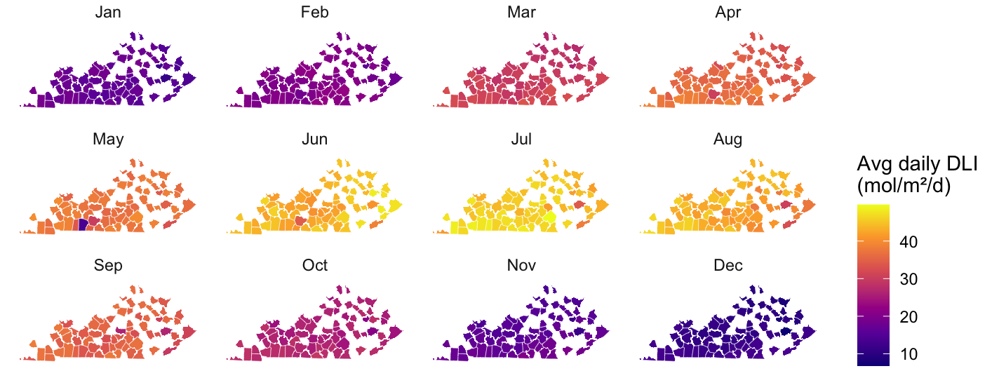
Figure 2. Geographic distribution of average monthly ambient daily light integral (DLI; mol·m⁻²·d⁻¹) across Kentucky based on 2025 Kentucky Mesonet weather station data. Notice that the western part of the state generally receives higher DLI, but these differences are less pronounced during the winter months.
Different greenhouse crops have different optimal DLI requirements. Based on the amount of light that is available in Kentucky (Table 2) and the DLI requirement for greenhouse crops (Table 3), growers may need to supplement light in order to meet different crop needs (visualized in Figure 3). In Kentucky, growing any reliable, high-quality crop through the winter (particularly through December and January) will likely require some supplemental lighting, and some crops may not be economical to grow in certain months at all, based on the lighting cost alone.
 | Seedlings and cuttings | Ornamentals | Lettuce | Cucumber | Tomato | Pepper | Strawberry
DLI requirement | 5-15 | 10-20 | 12-17 | 20-35 | 20-35 | 20-30 | >17-19
Table 3. Daily light integral (DLI) requirements for common greenhouse crops (mol·m⁻²·d⁻¹);
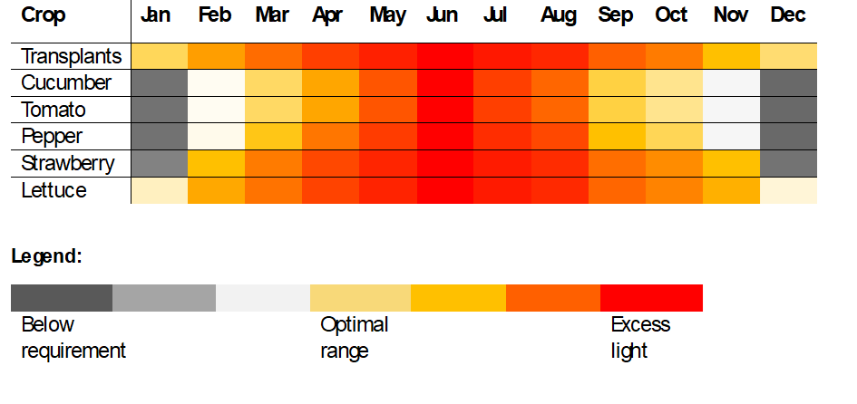Figure 3. Crop requirements and average daily DLI (Tables 2 and 3) were used to create a visual representation of months when available natural light in Kentucky is (in)sufficient for common greenhouse crops
Based on crop-specific DLI requirements, supplemental lighting can enable significantly (2-3 months) extended production of even high-light crops like tomato and cucumber. This presumes that all other environmental factors (temperature, CO₂ concentration, nutrients) are within the optimal ranges. Regular harvest of fruiting vegetables in the darkest months may not be feasible for small-scale operations due to the energy cost of supplying all crop needs in that period. Nevertheless, for Kentucky growers across all scales, lower-energy crops like early transplants, leafy greens, and even some soft fruits like strawberries may be produced profitably through the winter if temperature and light levels are carefully managed to balance energy costs with market demand.
Light Measurements and Mappings
How do we know how much light is really available to our plants? While light models and maps are helpful, light measurements are an essential tool for understanding how much light is actually reaching a crop. In general, a quantum sensor is the preferred tool for measuring light intensity in horticulture production systems. If other tools are used that report light intensity in other units (e.g., illuminance), those measurements should be converted to plant-relevant units by using conversion factors provided in Table 1.
Measurements are affected by the time of day and the time of year when the data is collected. In addition to weather variations, shadows cast by the greenhouse itself or other surrounding structures (e.g., trees, mountains) will land at different angles on the crop canopy depending on the solar angle, which varies by season. It is for this reason that we recommend growers in Kentucky use multiple on-location measurements as a basis for understanding light availability and selecting supplemental lights, rather than the state DLI maps alone.
Measuring in multiple locations following a grid layout in the greenhouse or growing space (light mapping) can reveal spots of high/low light and give a basis for both supplemental lighting design and crop management decisions (Fig. 4). In general, light intensity decreases under crop canopy and as the distance from a light source increase. Therefore, it may also be valuable to make measurements at multiple heights, e.g., crop top canopy and mid/lower canopy (height of lower leaves). Knowing the difference between these values can inform, for instance, growers’ decisions about leaf pruning of a high-wire crop. Comparing light levels measured inside and outside of the covered structure can also inform decisions about when to remove or apply shade cloth/whitewash and whether greenhouse plastic film is too degraded and needs to be changed. A light mapping activity guide is included in an Instructional Module as a sperate Extension publication; you may also consult your Extension Specialist for guidance about how to make a light map of your growing area.
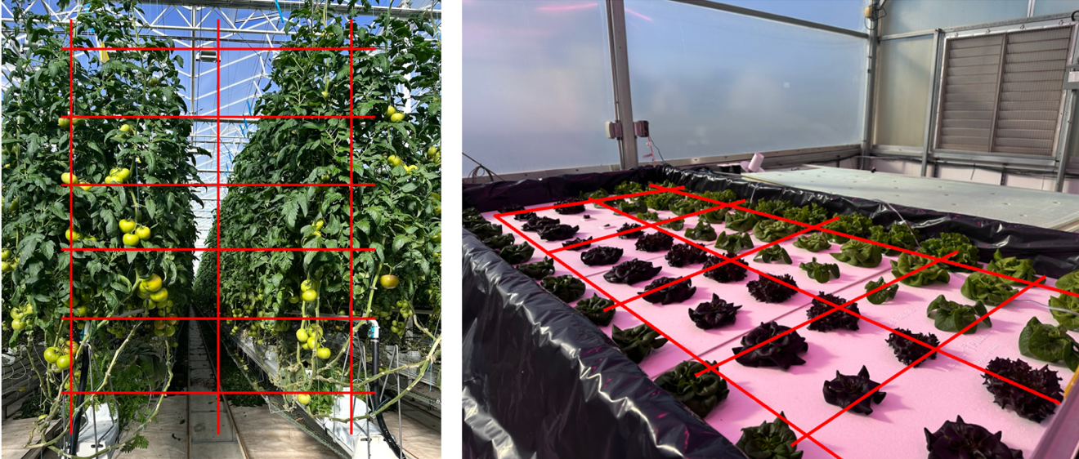
Figure 4. An example of 3x5 grid used to measure light distribution vertically (left) and horizontally (right) within a specific production area at 15 positions within the greenhouse.
Managing Light Intensity
During the winter months, supplemental lighting is the primary strategy for increasing light availability in greenhouses. Fixed-intensity light fixtures provide a constant light output and are generally less expensive than dimmable fixtures. Dimmable LED fixtures, while requiring a higher initial investment, offer greater flexibility for managing light and optimizing energy use, e.g., by reducing light intensity on sunny days. This would require both a) a light sensor or solar radiometer in the greenhouse and b) a central controller that is compatible with both the sensor and the light fixtures. An activity outlining how to select appropriate supplemental lights is in a separate publication.
Growers who are unable to achieve high light intensities using supplemental light may also consider extending the photoperiod to meet the target DLI. However, overly-high light intensity should not be used to reduce photoperiod. While increasing light availability generally promotes faster plant growth and higher yields, providing supplemental light beyond the crop's light saturation point does not further increase the rate of photosynthesis or crop productivity (i.e., yield) – see Figure 5. Instead, excessive supplemental lighting increases electricity consumption and production costs without providing additional yield benefits, also causing photodamage like leaf scorch, necrosis and fruit sunscald.
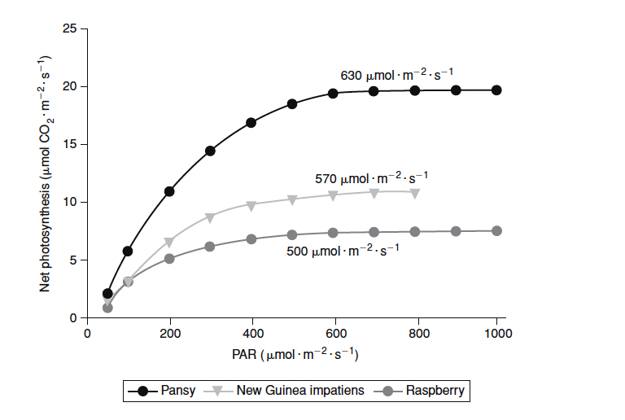
Figure 5. The relationship between photosynthetically active radiation (PAR) and rate of photosynthesis of pansy, new guinea impatiens and raspberry
In high light months, growers can apply shade cloths, which cut incident solar radiation at specified rates to reduce both light intensity and air temperature inside the greenhouse. Crop management can also be adjusted in hotter months to make use of surplus solar energy, provided other crop inputs are appropriately modified as well (e.g., through more frequent irrigations or CO₂ supplementation). For instance, in tomatoes, a second growing head (e.g., sucker) may be grown out or fruit pruning may be reduced - see production guide for more details.
Managing Photoperiod and Crop Flowering
As mentioned previously, there are diminishing returns associated with increasing DLI; at the same time, a minimum light intensity is needed to keep up the desired rate of photosynthesis and consequent biomass accumulation. Therefore, maintaining a minimum period of darkness is generally important to both plant health and economic viability of indoor production. A photoperiod between 12-18 hours (dark time 12-6 hours) is typical in the greenhouse industry. However, growers (especially in the ornamentals industry) should consider that adjustments in photoperiod can also have impacts on crop quality and development, which they may need to closely control and time.
Flowering in some popular greenhouse crops may be promoted or inhibited according to photoperiod. Among those plants whose flowering is regulated by the photoperiod, there are two categories: short-day plants (SDP) and long-day plants (LDP); plants whose flowering is unaffected by photoperiod are called day-neutral plants (DNP). Despite the names, these plants’ responses are actually regulated by the length of the dark period, rather than the light period. This allows us to use some cost-effective tools to achieve the desired crop quality at a specific time (see Figure 5). For instance, a blackout curtain in the greenhouse can be used to artificially shorten the photoperiod for SDP, and a few minutes’ exposure to low-intensity lighting from any source at night should be enough to mimic a short night for LDP. See the Additional Resources section to find more information about common SDP and LDP and photoperiod regulation in plants (Currey, 2011).
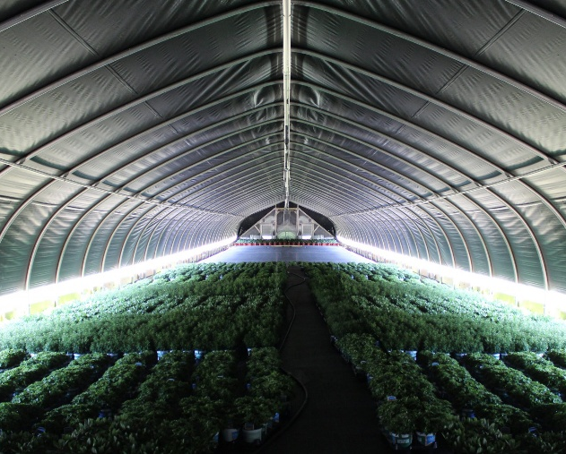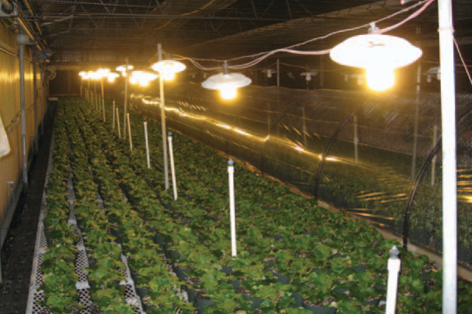
Figure 6. Examples of blackout curtains used to create short-day conditions (left) and incandescent bulbs used to induce long-day response in plants (right). Note that low-intensity lighting is sufficient for the purpose of shortening the “night-time,” but not as supplemental lighting. Photos courtesy of Roberto Lopez (right) and Griffin Greenhouse Supplies (left)
Additional Resources
Meinen, E. and Dieleman, A. Light measuring protocol: A protocol to measure LED lighting in horticulture. Wageningen University and Research. Available: https://research.wur.nl/en/publications/light-measuring-protocol-a-protocol-to-measure-led-lighting-in-ho/
Faust, J.E., and J. Logan. 2018. “Daily Light Integral: A Research Review and High-resolution Maps of the United States” HortScience 53(9):1250-1257
Sharma, A., Leonberger, K., Gauthier, N., Ying, Q. (2026). High-wire Soilless Tomato Production in the Greenhouse. CCD-SP-21. Lexington, KY: Center for Crop Diversification, University of Kentucky, Martin-Gatton College of Agriculture, Food and Environment. Available: https://ccd.uky.edu/resources/systems
Stallknecht E. 2025. Calculating and Using Daily Light Integral (DLI): An Introductory Guide. Virginia Cooperative Extension. Available: https://www.pubs.ext.vt.edu/SPES/spes-720/spes-720.html
Currey, C., Lopez, R., Mattson, N. (2011). Commercial Greenhouse and Nursery Production: Flower Induction of Annuals. HO-249-W. Purdue Extension. Available: https://edustore.purdue.edu/ho-249-w.html

Faust, J. E. & Logan, J. (2018). Daily Light Integral: A Research Review and High-resolution Maps of the United States. HortScience, 53(9), 1250–1257. https://doi-org.ezproxy.uky.edu/10.21273/HORTSCI13144-18
https://www.kymesonet.org/
Reproduced from Nelson, P.V., and Bugbee, B. (2014) Greenhouse operation and management (8th ed.)

