______________________________________________________________________________
Center for Crop Diversification
______________________________________________________________________________
On-Farm Case Studies of Fine-Mesh Netting Row Covers Over Cucurbits
Elaine Losekamp and David Gonthier
Entomology Graduate Researcher and Associate Professor of Entomology
____________________________________________________________________________________
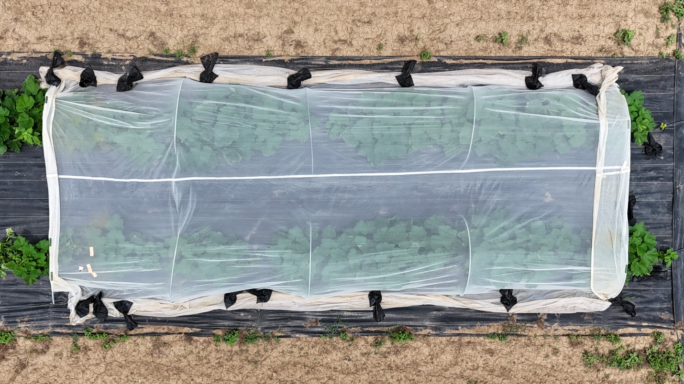
Figure 1. Overhead view of pattypan squash growing under a mesotunnel with ends clipped open to enable pollination. Photo: Mario Reyes Castillo.
Introduction:
The plant family Cucurbitaceae includes many crops that are often grown in Kentucky, including cucumber, melon, pumpkin, and squash (Figure 1). Production of cucurbit crops is challenged by a complex of insect pests and the pathogens they vector (Figure 2). These include squash bug (Anasa tristis; Figure 2A), a vector of Cucurbit Yellow Vine Disease (CYVD, caused by the bacterium Serratia ureilytica); cucumber beetles (Acalymma vittatum and Diabrotica undecimpunctata howardi; Figure 2B-C), vectors of bacterial wilt (Erwinia tracheiphila); and squash vine borer (Melittia cucurbitae; Figure 2D), a moth which as a larva feeds and develops inside cucurbit vines (Bessin, 2026a, 2026b). Feeding by these insects may stunt or kill plants and cause cosmetic damage to fruits (Bessin, 2026a, 2026b). These pests can be difficult to manage with organic-compliant insecticides. Disease inoculation can occur rapidly after feeding by squash bugs and cucumber beetles, and squash vine borers are protected from insecticides inside plant tissues.
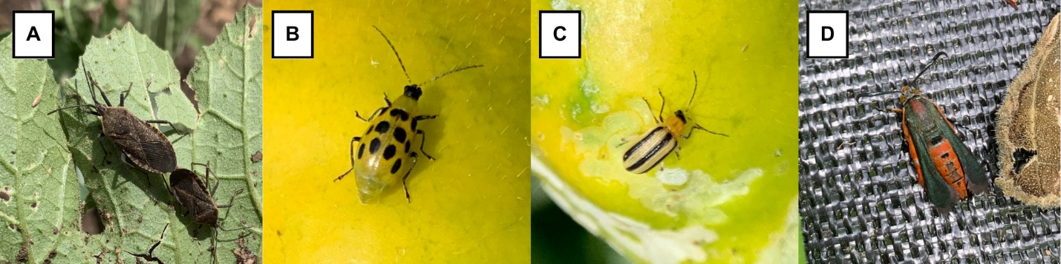
Figure 2. Insect pests of cucurbits. Adult (A) squash bug, (B) spotted cucumber beetle, (C) striped cucumber beetle, and (D) squash vine borer. Photos: Elaine Losekamp.
Mesotunnels - temporary structures constructed by installing fine-mesh row covers over approximately 3.5-ft-tall bent conduit hoops – can be an effective strategy for managing insect pests in cucurbit production (Figure 1). Mesotunnels reduced insect pest density and increased marketable yield in research studies of acorn squash (Fiske et al., 2024), muskmelon (Nelson et al., 2023), and zucchini (Larkin, 2025). Although past studies of mesotunnels in cucurbit production have shown promising results, pollination management remains a significant challenge. To ensure that insects can pollinate flowers, growers can remove or open the ends of row covers at flowering; however, doing so may also allow insect pests to access crops. Studies comparing the efficacy of different pollination management strategies on pest exclusion, rates of pollination, and yield of cucurbits in mesotunnel systems have provided inconclusive results. Effects of pollination management strategy are likely to vary in response to a variety of factors, including mesotunnel size and plant spacing.
In 2025, University of Kentucky researchers affiliated with the Crops Under Cover project (https://cropsundercover.mgcafe.uky.edu/) partnered with vegetable growers across the state to test paired mesotunnel and control (uncovered) plots with crops of their choice at their growing sites. All mesotunnels in the study utilized ExcludeNet row cover (mesh size: 0.95mm x 0.95 mm; Tek-Knit Industries, Montreal, Quebec, Canada) installed over hoops made from bent sections of 10-ft-long EMT conduit and secured with 10-lb sandbags and 0.75-in snap-on greenhouse plastic clamps (Bootstrap Farmer, Paris, Texas, USA). The research team conducted insect pest surveys, collected yield data, and assessed participants’ perceptions of the mesotunnels through before and after surveys and interviews. In this document, we present two case studies from the study to illustrate some of the opportunities and challenges with this pest management strategy in cucurbit production. Identifying information has been removed to protect the participants’ privacy, and the case studies are described with the participants’ permission.

Case Study 1
Successful Season Extension.
Table 1. Description of Farmer 1’s experiment.
Crop | Zucchini (Cucurbita pepo var. ‘Dunja’)
Plot dimensions | - Mesotunnel: 2.5’x50’  - Control: 2.5’x50’
Transplant spacing | 3.3’ in-row spacing, single row
Planting date | June 24, 2025
Pollination strategy | Row cover removed at flowering

Farmer 1 operates a certified organic, diversified vegetable farm in central Kentucky. Squash vine borer (Figure 2D) is a problematic pest of cucurbit crops at the farm. To test whether fine-mesh row cover could protect cucurbits against this pest, Farmer 1 planted 16 zucchini plants per plot into bare ground beds (Table 1; Figure 3A).
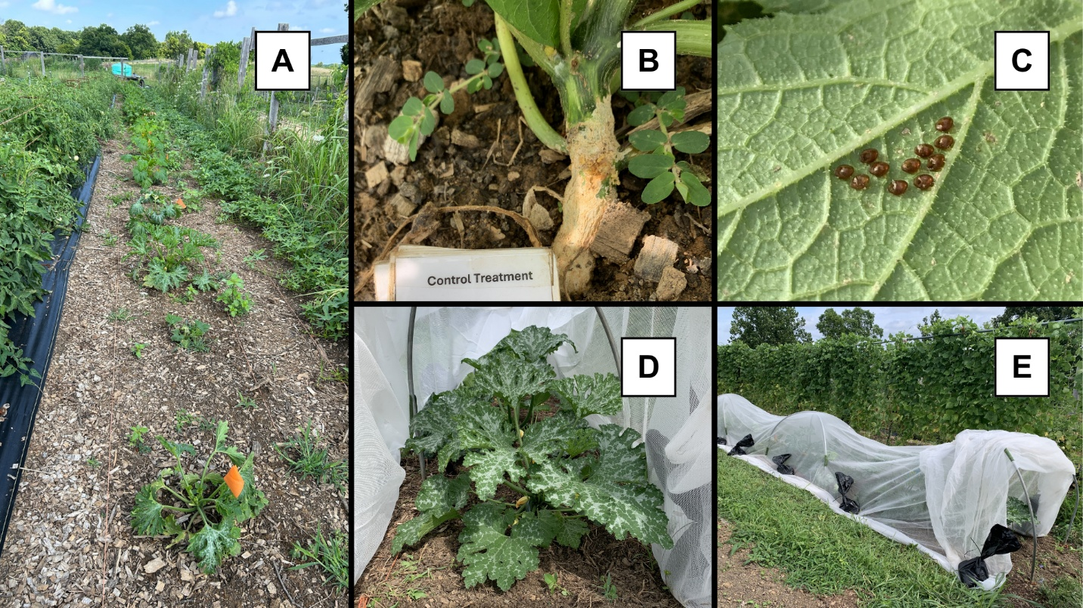Figure 3. Farmer 1’s experimental plots three weeks after transplanting. (A) Plants in the control plot. (B) Squash vine borer damage and (C) squash bug eggs on plants in the control plot. (D) Healthy plant inside the mesotunnel and (E) view of the mesotunnel treatment, with ends opened, prior to removal.
The mesotunnel plot was covered immediately after transplanting. The row cover was removed one month later to facilitate harvesting and because the plants had grown large enough that they were pressing against the mesh (Figure 3D). Farmer 1 explained, “The plants just get so large, right? That's one of the problems with the squash… Once it gets pressed up against the netting… you no longer exclude some stuff.”
More rapid growth of cucurbit plants under row covers compared to open field conditions has been documented in past studies and was a common theme reported by most participants in this study (Ibarra et al., 2001; Nair & Ngouajio, 2010). Vigorous plant growth under mesotunnels can introduce management challenges when plants fill the confined space and are in contact with the row cover. As Farmer 1 described, direct contact between plants and the row cover material allows insects to feed or lay eggs through the mesh. Additionally, it can damage both leaves and the row cover material through abrasion or tendrils growing through the mesh. Finally, several participants who tested narrow, single-bed mesotunnels and kept the row covers on, with ends opened after flowering (Figure 3E), observed yield declines towards the middle of the mesotunnel. These participants suspected that limited space between the dense foliage and the row cover may have impeded the movement of pollinators. They recommended increasing plant spacing or incorporating between-bed walkways (Figure 1) within mesotunnels to counteract this effect. A past University of Kentucky research study of 120-ft-long mesotunnels containing three beds of acorn squash separated by walkways found no effect of distance from open ends on pollinator visitations (Pulliam et al., 2025). This finding suggests that the incorporation of open walkways may facilitate pollinator movement; however, it is important to note that the study of pollinator movement within mesotunnels is in its infancy.
By the time Farmer 1 removed it, the mesotunnel had served its intended purpose of protecting the zucchini plants from insect herbivory. When the research team visited to survey the plants for insects, plants in the mesotunnel treatment were visibly healthier than their uncovered counterparts (Figure 3A, D). Plants in the mesotunnel treatment were on average 1.5 times taller and 1.8 times wider than those in the control treatment. The number of insect pests in the control plot was 3.6 times greater than that of the mesotunnel (Figure 4A). Some aphids were present in the mesotunnel, while squash bugs and evidence of squash vine borer damage were prevalent on uncovered plants (Figure 3B, C). Farmer 1 found that early season coverage with the mesotunnel was sufficient to protect plants from squash vine borer damage. “Once I get them up to full size, then they seem to be pretty resistant to vine borers... So, at least with this netting on the squash, after the first harvest, I went ahead and left it off. And they seem to be fine, at that point in time… for at least the vine borers, anyway.”
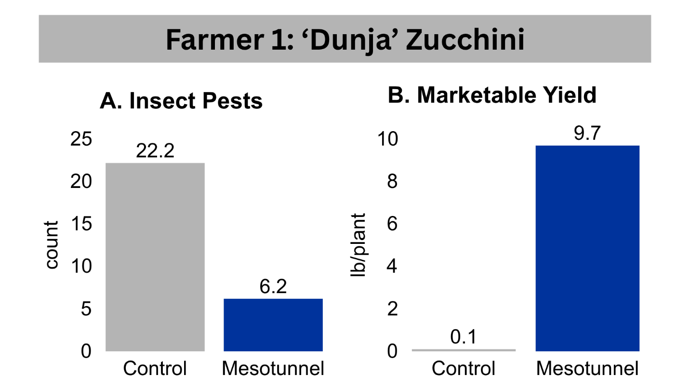
Figure 4. (A) Average insect pest counts per plant from a pest survey three weeks after transplanting and (B) marketable yield per plant harvested from the control and mesotunnel plots at Farmer 1’s site.
By late July, most plants in the control plot had perished from insect feeding damage, producing less than two lb. of zucchini in total (Figure 4B). In contrast, plants in the mesotunnel plot continued to produce fruit for a ten-week period, yielding a total of 155.5 lb. (Figure 4B). For Farmer 1, the mesotunnel provided an important function of season extension. The farm has limited bed space, and longer harvest periods translate to less land used. “The fact that I could go, say, 10 weeks of production, you know, harvesting… puts me down to maybe just two rotations to make it through a whole season. My season's only 25 weeks, so if I can get close to 20, then that kind of saves me a couple beds.”
Prior to the study, Farmer 1 had previous experience using another type of fine-mesh row cover (ProtekNet; mesh size: 0.35mm x 0.35mm) for insect exclusion over brassica crops. Farmer 1 found the row cover provided for the study (ExcludeNet; mesh size: 0.95mm x 0.95 mm) to be more durable. “I've only messed with the ProtekNet, which is really fine, and pretty delicate, and this was much sturdier, so easier. Obviously, it doesn't exclude as much stuff, but it excludes what I needed for the squash, so I did like that particular cover for squash.” Farmer 1 was pleased with the results of the study and has since purchased additional fine-mesh row covers, with plans to continue using mesotunnels over cucurbit plantings moving forward (Figure 5).
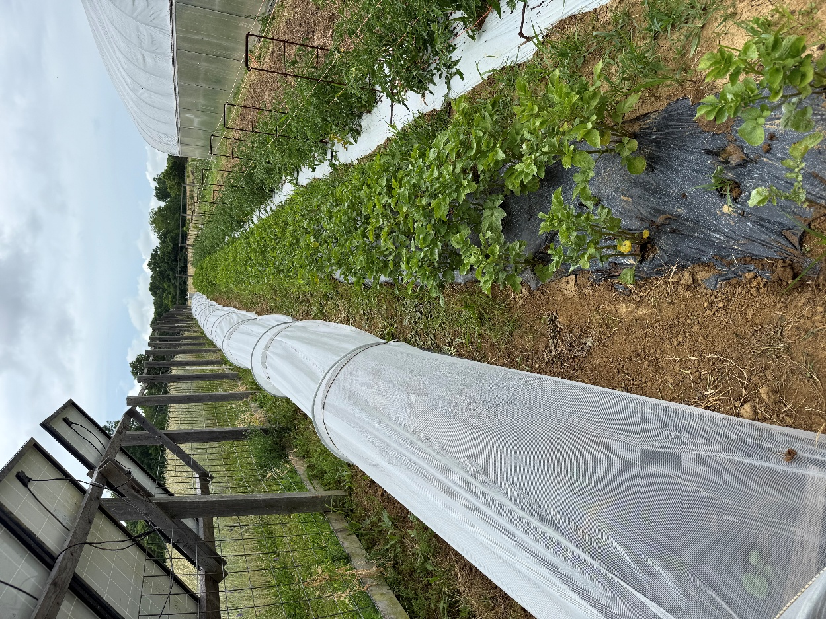
Figure 5. Mesotunnel over a planting of winter squash in 2026. Photo provided by Farmer 1.

Case Study 2
Variable Outcomes Across Crops.
Table 2. Description of Farmer 2’s experiment.
Crops | - Zucchini (Cucurbita pepo var. ‘Dunja’)  - Zucchini (Cucurbita pepo var. ‘Golden Glory’)  - Cucumber (Cucumis sativus var. ‘Diva’)  - Bean (Phaseolus vulgaris, var. unknown)
Plot dimensions | - Mesotunnel: 12’x30’  - Control: 12’x15’
Transplant spacing | - Zucchini: 1’ in-row spacing, 2 rows  - Cucumber: 9” in-row spacing, 1 row  - Beans: 3” in-row spacing, 2 rows
Planting date | May 2, 2025
Pollination strategy | Row cover removed at flowering

For this study, Farmer 2 aimed to use the mesotunnel to control cucumber beetles. Cucumber beetles had been so destructive to past cucurbit plantings that Farmer 2 had stopped growing especially susceptible varieties, such as watermelon and cantaloupe. Farmer 2 tested a mesotunnel made with 27-ft-wide fine-mesh row cover over four beds of crops, including two zucchini cultivars, cucumber, and beans (Table 2). The beans experienced minimal pest pressure and exhibited few differences between the treatments, except for taller, spindlier (“leggier”) plants in the mesotunnel. However, treatment differences emerged for the cucurbits.
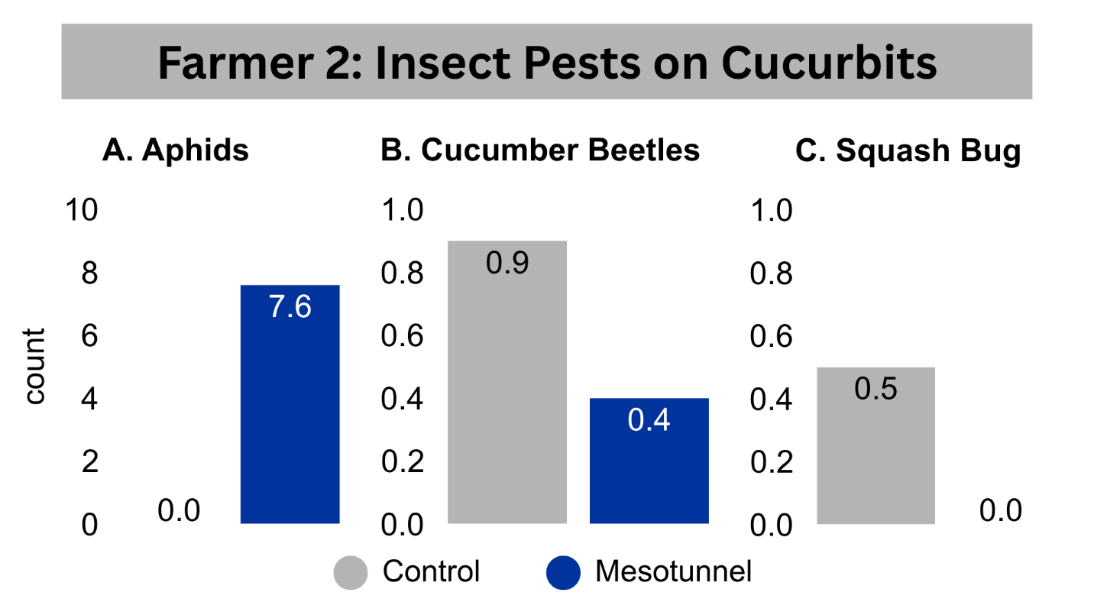Figure 6. Average number of (A) aphids, (B) cucumber beetles, and (C) squash bugs per cucurbit plant in the control (gray) and mesotunnel (blue) treatments.

When the research team visited three weeks after planting to survey the plants, aphids were present only on cucurbit plants in the mesotunnel, while cucumber beetles and squash bugs were more common on uncovered plants (Figure 6). The cucurbit plants were 1.7 times taller in the mesotunnel than in the control plot and appeared more robust (Figure 7). At the end of the harvest period, per-plant yield for zucchini was about one-third higher from the mesotunnel than the control. Unfortunately, the cucumber planting was less successful, which Farmer 2 attributed to cucumber beetles and a hailstorm early in the season that damaged uncovered plants. “Well, one, it was the weather that beat them half to death, on the control group. But then as soon as I took that row cover off, we had bacterial wilt. That entirely planting went down to bacterial wilt, almost immediately.”
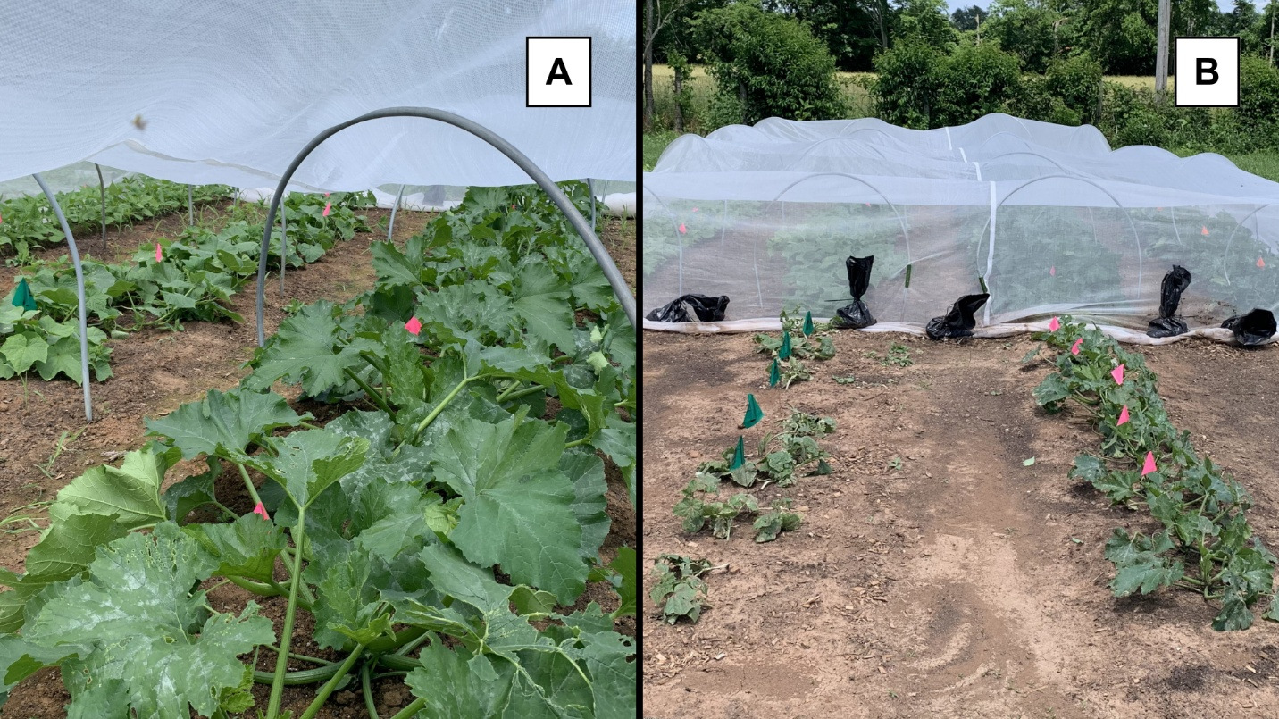
Figure 7. Rows of (L-R) bean, cucumber, and zucchini plants in the (A) mesotunnel and (B) control treatments at Farmer 2’s growing site. Photos taken on the same day three weeks after transplanting.
There is evidence that mesotunnels reduce incidence of disease-vectoring insects and disease, including cucumber beetles and bacterial wilt (Fiske et al., 2024; Nelson et al., 2023) and squash bug and CYVD (Pethybridge et al., 2024). Unfortunately, this effect is compromised once mesotunnels are opened or removed to enable pollination, allowing disease-vectoring insects to access the plants (Fiske et al., 2024). Research at the University of Kentucky is investigating alternative mesotunnel strategies to overcome this challenge, including introducing bumblebee colonies under sealed mesotunnels and growing parthenocarpic cucumber cultivars that do not require insect pollination (https://cropsundercover.mgcafe.uky.edu/).
For zucchini, Farmer 2 found that the mesotunnel provided more benefits than the yield increase alone. “I think the earliness of the zucchini and the quality of the plant were a lot better under the experimental conditions… I don’t think I got like, a ton more out of the experimental plants, but I do think that the harvests were substantially earlier in the experimental conditions. I feel like I was able to get a significant harvest from the experimental conditions two weeks before the control plants.” For Farmer 2, earlier harvests represented the possibility of future labor and cost savings. “If you’re trying to calculate how much crop is coming in, with your expectation of how much you’re going to harvest… I think if you could achieve that two weeks earlier, you get a whole lot of cultural leeway of choosing to not spray… because you’ve already made your money.”
Farmer 2 is no stranger to using spunbonded row covers, relying on season extension tools to grow vegetables through the relatively mild southern Kentucky winters. While low tunnels, caterpillar tunnels, and high tunnels are a common sight at the farm during winter, Farmer 2 had not tested mesotunnels prior to this experiment. Despite experiencing initial skepticism, Farmer 2 developed a positive view of the mesotunnel structure. “I thought I was going to hate the clips; I liked the clips. I thought the [hoops] you all were using were, maybe overkill. But I actually ended up really liking them… The amount of space that it provided, I think it’s far better than just a standard wire hoop… You can do less of the hoops, the larger ones.” Farmer 2 anticipated being able to easily integrate the mesotunnel into the farm’s infrastructure and crop rotation plan. “With the midsize hoops, I can fit large brassicas under them with no difficulty, I can fit the cucurbits under them. But it can still easily work within my field rotation… I don’t have to build an entire high tunnel any time a crop goes in.”
As a grower with about a decade of farming experience, Farmer 2 placed a high value on efficiency. “[The mesotunnel] took less management than I was expecting. It can be a low management tool… how can I put it? I think you can see a lot of benefit with a little effort. I’m sure you can get more if you’re raising up the sides, or taking it off to cultivate and then putting it back on… I’m sure you can go that route to maximize benefits. But I feel like the way I did it, you’re getting like 80% of the benefit with 20% of the work. So, I like that, I appreciate that, it’s not something that has to be high maintenance to get a lot out of it.”

Table 3. Farmer 2’s proposed mesotunnel crop rotation plan for cucurbit and brassica production in southern Kentucky.
Rotation # | Crop | Mesotunnel Installation Date
1 | Summer squash | ~ May 1
2 | Summer squash | ~ June 1
3 | Winter squash | ~ July 1
4 | Brassica leafy greens | ~ August 1

To get the maximum use out of the mesotunnel materials provided for this study, Farmer 2 developed a crop rotation plan spanning spring through fall (Table 3). Beginning in May, Farmer 2 planned to cover three rotations of cucurbits for about a month each, moving the mesotunnel to the next crop when the previous crop began flowering, and ending with fall-planted brassicas. In this way, Farmer 2 could protect four plantings from the most destructive insects at the farm – cucumber beetles and fall armyworms – with a single mesotunnel. At a larger scale, implementing the row cover over cucurbit and brassica crops could allow Farmer 2 to cease using pesticides. “If it is effective on armyworms in the fall, then I could completely get rid of using Bt [Bacillus thurengiensis]… and have a pesticide-free operation.” Mesotunnels also opened the door for new market opportunities. “If I can get early success with cucurbit transplants… I may begin to grow cucumbers again or even extend to other crops that I’m not currently growing because of that early pest pressure.”

Conclusions
In the case studies described here, both farmers found that cucurbit crops benefitted from early-season protection with mesotunnels. Both farmers utilized the strategy of removing the mesotunnel midway through the growing season to enable pollination. This strategy was successful for zucchini plantings, but Farmer 2’s cucumber planting succumbed to bacterial wilt vectored by cucumber beetles after removal of the row cover. In Farmer 1’s experiment, the mesotunnel extended the harvest period by over two months compared to the control treatment. In Farmer 2’s experiment, zucchini plants were ready to harvest two weeks earlier than uncovered plants. In both trials, insect feeding damaged uncovered crops. Both farmers found ways to optimize the efficiency of the mesotunnels in their farm plans. These case studies demonstrate successful implementation of mesotunnels for early-season protection of cucurbit crops in Kentucky.

References
Bessin, R. (2026a). ENTFACT-311: Cucumber Beetles. Martin-Gatton College of Agriculture, Food and Environment. Retrieved June 12, 2026 from https://entomology.mgcafe.uky.edu/ef311
Bessin, R. (2026b). ENTFACT-314: Squash Vine Borer and Squash Bug. Martin-Gatton College of Agriculture, Food and Environment. Retrieved June 12, 2026 from https://entomology.mgcafe.uky.edu/ef314
Fiske, K., Cheng, N., Kuesel, R., Zhang, W., Bessin, R., Williams, M. A., & Gonthier, D. (2024). Row covers limit pests and disease and increase profit in organic acorn squash. Frontiers in Sustainable Food Systems. https://doi.org/10.3389/fsufs.2024.1347924
Ibarra, L., Flores, J., & Dı́az-Pérez, J. C. (2001). Growth and yield of muskmelon in response to plastic mulch and row covers. Scientia Horticulturae, 87(1-2), 139–145.
Larkin, R. P. (2025). Evaluation of Biochar and Humus Amendments and Early-Season Insect Netting on Soil Properties, Crop Yield, and Pest Management in Organic Vegetable Production in Maine. Agronomy, 15(11), 2567. https://doi.org/10.3390/agronomy15112567
Nair, A., & Ngouajio, M. (2010). Integrating Rowcovers and Soil Amendments for Organic Cucumber Production: Implications on Crop Growth, Yield, and Microclimate. HortScience, 45(4), 566–574. https://doi.org/10.21273/hortsci.45.4.566
Nelson, H. M., Gonzalez-Acuna, J. F., Nair, A., Cheng, N., Mphande, K., Badilla-Arias, S., Zhang, W., & Gleason, M. L. (2023). Comparison of Row Cover Systems for Pest Management in Organic Muskmelon in Iowa. HortTechnology, 33. https://doi.org/10.21273/HORTTECH05096-22
Pethybridge, S. J., Damann, K., Murphy, S., Diggins, K., & Gleason, M. L. (2024). Optimizing Integrated Pest Management in Mesotunnels for Organic Acorn Squash in New York. Plant Health Progress, 25(2). https://doi.org/10.1094/PHP-08-23-0072-RS
Pulliam, K. F., Brockman, R., Avery, C., Gauger, A., Williams, M., Bessin, R., & Gonthier, D. (2025). Balancing row cover pest and pollination management in organic cucurbit production. Renewable Agriculture and Food Systems, 41(1), 1–14. https://doi.org/10.1017/S1742170525100203

