Soil Solarization in Kentucky and Tennessee
Paula Luize Lessmann¹, Rachel Rudolph¹, Nicole Gauthier², April Lamb², Annette Wszelaki³, Kathryn Pettigrew¹, Henry Smith², Ed Dixon², Kimberly Leonberger², Erin Haramoto⁴, Jonathan Larson⁵, Amanda Carroll³
¹Department of Horticulture, University of Kentucky; ²Department of Plant Pathology, University of Kentucky; ³Department of Plant Sciences, University of Tennessee; ⁴Department of Plant and Soil Sciences, University of Kentucky; ⁵Department of Entomology, University of Kentucky

Introduction
Soil solarization is a sustainable, chemical-free method to manage biotic soil issues, such as weeds or weed seeds, plant-parasitic nematodes, and soilborne pathogens. Clear plastic tarps are placed on irrigated soil to trap heat from the sun (Figure 1). When solar radiation is trapped under the plastic, it raises the soil temperature, especially in the top few inches. When soil temperatures reach or exceed 104°F (or 40°C), many pests, diseases, and weeds are weakened or killed.
FIGURE 1 HERE
High tunnel vs open field
The temperature inside high tunnels can be managed by opening and closing side and end walls. During the warm months, walls can be opened to allow air to flow through the tunnel, preventing it from becoming excessively hot. In early spring and late fall, walls can be closed—especially at night—to protect crops from cold temperatures. Soil solarization relies on high temperatures, so the higher the temperature, the more effective the results. Because air temperature in high tunnels is typically higher than outside air, soil temperatures are also higher for longer periods compared to open field conditions. Therefore, soil solarization is more effective in high tunnels, but it can also be conducted in open fields (Table 1).
TABLE 1 HERE
How to Solarize Soil
Step 1: Prepare the soil. Soil must be smooth to avoid clods and debris, which can slow soil heating, prevent the tarp from fitting tightly across the surface, and potentially create holes in the plastic tarp over time. Use a rototiller and/or disc to manage weeds beforehand and to create a smooth soil surface (Figure 2). It may be necessary to rake the soil smooth after tillage.
FIGURE 2 HERE
Step 2: Irrigate the soil to 70% of field capacity (Figure 3). Soil moisture is crucial in order to transfer heat through the soil profile and reach the high temperatures needed for effective solarization. Ideally, a moisture sensor or tensiometer buried 6 inches deep should be used to confirm soil moisture. However, if those tools are not available, irrigate until the soil is very moist, nearly muddy, to a depth of 6 inches. Closely spaced (one foot apart), drip irrigation tape will provide the most uniform soil moisture, but sprinklers may be used for a faster setup.
FIGURE 3 HERE
Step 3: Lay clear plastic tarp over moist soil (70% field capacity), with the edges pulled tight to maintain close contact and prevent air pockets from forming. It is recommended to use thin transparent polyethylene, usually from 1 mil to 6 mil thick. Plastic should be clean, undamaged, and transparent to improve heat transfer and to reach the high temperatures necessary for effective solarization. It is important that there are no air pockets and that heat does not escape. In our trials, we dug a trench around the perimeter of the solarized area and buried the edges to ensure that the plastic tarps were completely sealed. We used sod staples to secure the plastic tarp to the soil (Figure 4). Growers may decide to use another method, but this method was successfully employed in our trials over several years.
FIGURE 4 HERE
Step 4: Finally, cover the edges of the tarp with soil to ensure that hot air does not escape through the sides and that the tarp is well-sealed (Figure 5). This traps heat, allowing soil temperatures to increase. Again, growers may use a different method, but whatever method used should maintain sealed tarp edges to trap heat.
FIGURE 5 HERE

Timing and Duration of Soil Solarization
Soil solarization requires high soil temperatures to be effective, so the ideal time for solarizing in Kentucky and Tennessee is during the hottest months of the year, between May and September. June through August are especially good for soil solarization due to the higher seasonal temperatures. The minimum target temperature is 104°F, and the more hours at or above this temperature, the more effective solarization is likely to be. The weather during soil solarization should ideally be sunny, with few clouds and little wind, to help achieve higher soil temperatures. The duration of solarization is also important. Based on multiple trials conducted in Kentucky and Tennessee, it is recommended to solarize the soil for 2 to 4 weeks.

Target Organisms
During solarization, the soil reaches high temperatures that can be lethal to organisms such as plant-parasitic nematodes and soilborne pathogens. It can even affect weed seed viability and vegetative structures, such as rhizomes and roots.
Soilborne pathogens
Some of the most common plant diseases in Kentucky and Tennessee are found in both high tunnels and open fields. Diseases such as lettuce drop, Rhizoctonia fruit rot of cucurbits, southern blight, and timber rot of tomato have wide host ranges, and their causal pathogens can persist for many years in the soil. They can affect below-ground or surface-level plant parts, causing fruit rots, root rots, stem rots, and plant death. These soilborne pathogens can be especially problematic inside high tunnels due to fungicide limitations and limited to no crop rotation. Soilborne pathogens can build up over time, resulting in higher plant losses in subsequent years.
Solarization trials in Kentucky in 2022-2025 have included:
- Agroathelia rolfsii, causal agent of southern blight
- Rhizoctonia solani, causal agent of Rhizoctonia crown, root, and fruit rot (Figure 6)
- Fusarium oxysporum, causal agent of Fusarium wilt
- Sclerotinia sclerotiorum, causal agent of lettuce drop, timber rot, and white mold (Figure 7)
FIGURE 6, FIGURE 7 HERE
In trials, soil solarization decreased survivability of these pathogens, especially during the 4-week summer solarization when the tunnel remained closed throughout solarization (Table 2). Additional research trials helped confirm that sensitivity of soilborne pathogens to high temperatures can vary considerably.
TABLE 2 HERE

Plant-parasitic nematodes
Plant-parasitic nematodes are responsible for severe crop damage and yield loss in a wide range of crops. In the U.S., one of the major causes of crop loss is root-knot nematode (RKN), Meloidogyne spp. The most common RKN species in Kentucky are the northern root-knot nematode (Meloidogyne hapla) and the southern root-knot nematode (Meloidogyne incognita). These nematodes have a wide host range, including vegetables, fruits, ornamentals, and weeds. They cause galls on roots, resulting in aboveground symptoms such as stunting͕ wilting͕ and dieback (Figure 8). Soil solarization has been shown to effectively reduce southern RKN populations in Kentucky. However, for long-term management, it is recommended to combine solarization with other strategies, such as cover cropping, soil amendments, and resistant crop cultivars.
FIGURE 8 HERE

Weeds
Many weed species pose a significant challenge as they reduce crop productivity by competing for essential resources such as light, water, nutrients, and space. In the absence of a cash crop, weeds can also serve as hosts for soilborne pathogens and plant-parasitic nematodes, or as a green bridge or source of food for arthropod pests, leading to future yield losses if not properly managed. Soil solarization can affect weeds either by reducing survivability after solarization or damaging seeds or vegetative structures and decreasing emergence over time. In Kentucky and Tennessee, 4-week soil solarization in a closed high tunnel during summer effectively killed many weeds under the soil surface during solarization, and reduced or delayed weed emergence after solarization (Figures 9; 10). Solarization conducted in the spring and fall stunted or killed some weed species, particularly broadleaf weeds, but was less effective than in the summer, as soil temperatures were not sufficiently high (Table 3).
FIGURE 9 AND 10 HERE
Over time in our solarization trials, we observed that repeated soil solarization can lead to the weed community being dominated by certain species that are less sensitive to solarization. In Kentucky, we observed that solarization did not sufficiently kill purslane, bindweed, and Bermuda grass (Table 3). As a result, these weeds began to dominate in certain seasons in our tunnels. Integrated weed management, such as cultivation, flaming, physical removal, sanitation, and herbicides (for open fields), should be used in conjunction with soil solarization.
TABLE 3 HERE

Pests
Aboveground arthropods have a significant impact on agriculture. While some are beneficial—such as pollinators that support food production—others can be harmful by feeding on crops or transmitting plant diseases. Insect pests like aphids, thrips, leafhoppers, and caterpillars can severely reduce both crop quality and yield. Managing aboveground pests using soil solarization alone has proven to be challenging. By managing weeds, insect pests can be reduced, but there does not appear to be direct control of insect pests through soil solarization. Therefore, integrated pest management (IPM) strategies should be employed. These may include crop rotation, biological control using natural predators or parasites, and the use of pest-resistant crop cultivars.

Beneficial Soil Microbes
The soil microbiome is vital for nutrient cycling, organic matter decomposition, and soil productivity. Soil solarization heats moist soil under clear plastic to reduce soilborne diseases and pests. Beneficial microbes can also be impacted by solarization, especially those in the top few inches of soil. The level of heat tolerance and impact of solarization is dependent on the species of each microbe. Research in Kentucky has shown that summer high tunnel solarization can reduce some soil bacteria that are considered beneficial, such as Azospirillum and Pseudomonas spp., and also can result in increases in other beneficials such as Bacillus spp. Overall, research suggests that soil microbial diversity is not significantly altered or negatively impacted following solarization in Kentucky.

Crop Yield
Due to the potential reduction in weed pressure, arthropod pests, soil-borne pathogens, and plant-parasitic nematodes, as well as improvements in soil structure and increased nitrogen availability (Elmore 1997), crop yield may increase. In soil trials conducted in Kentucky and Tennessee high tunnels in July 2024, soil was solarized for 2 and 4 weeks. After solarization, butterhead lettuce was transplanted (Figure 11). Marketable lettuce yield was overall higher in the solarized plots compared to those without solarization (Figure 12). In a separate experiment in Kentucky in spring 2022, solarization was conducted for 2, 4, and 6 weeks in a high tunnel naturally infested with Southern root-knot nematode. At the end of the season, marketable tomato yield was not significantly affected by soil solarization (Figure 13). Although soil solarization can lead to improved crop performance, our research has demonstrated mixed results.
FIGURE 11, FIGURE 12 AND FIGURE 13 HERE

Closed Tunnel vs. Open Tunnel

As discussed above, soil solarization has greater benefits when conducted in high tunnels compared to open fields, primarily due to the higher soil temperatures achieved within the tunnels. However, when the tunnel is closed to maintain even higher soil temperatures, it is taken out of production, potentially contributing to lost revenue. If solarization could be effectively performed in an open high tunnel, with the end and side walls left open, growers could produce crops in some beds, while solarizing adjacent beds. This would help limit the income loss from lack of production. Research trials in Kentucky and Tennessee in 2024 showed that solarization in closed tunnels consistently reached higher temperatures and accumulated more hours above 104°F compared to open tunnel treatments (Table 4). Due to the lower soil temperatures achieved during soil solarization in the open tunnel, weed suppression was less effective, and lettuce yield was lower compared to the closed high tunnel. These lower temperatures failed to reach lethal doses needed to manage soilborne pathogens as well. As a result, for effective soil solarization, it is recommended that tunnels remain closed during the treatment period.
Air and soil temperatures are dependent on geographic location. Research trials confirmed that soil temperatures were higher in Tennessee than Kentucky, though air temperatures for the two locations across the solarization periods were very similar. Soil and air temperatures can also be affected by transparency of plastic. For example, polyethylene high tunnel plastic becomes opaque with age and reduces radiation, which affects the soil temperatures that can be achieved by soil solarization. Double-layer plastic likely also reduces radiation compared to single-layer plastic.
TABLE 4 HERE

Conclusion
Summer soil solarization in closed high tunnels can raise the daily maximum soil temperature in the top few inches by 6-13°F in Kentucky and Tennessee compared to solarization in the field or an open high tunnel. This temperature increase can help reduce weeds and subsequent weed emergence, decrease soilborne pathogen and plant-parasitic nematode populations, and may impact certain aboveground arthropod pests. However, soil solarization alone may not provide long-term management of these issues. Additionally, soil solarization may increase subsequent crop yield, but mixed effects have been observed. Integrating additional practices such as crop rotation, resistant cultivars, cover crops, and proper equipment sanitation is recommended.

Table 1. Soil temperatures documented during 4-week soil solarization research trials in spring (April-May), summer (July), and fall (September) 2024 in open field and closed high tunnel.
Season* | Soil Depth (in) | 2024 Field solarization (30 days) |  |  | 2024 HT solarization (30 days)
Season* | Soil Depth (in) | Average Daily Soil Temperature (°F) | Average Daily Maximum Soil Temperature (°F) | Hours above 104 °F | Average Daily Soil Temperature (°F) | Average Daily Maximum Soil Temperature (°F) | Hours above 104 °F
Spring | 3 | 80 | 91 | 1 | 87 | 100 | 41
Spring | 6 | 77 | 82 | 0 | 85 | 91 | 5
Summer | 3 | 92 | 104 | 78 | 100 | 111 | 204
Summer | 6 | 91 | 100 | 31 | 97 | 104 | 101
Fall | 3 | 80 | 89 | 0 | 89 | 97 | 43
Fall | 6 | 80 | 87 | 0 | 87 | 92 | 0
*6-mil clear polyethylene tarps used for soil solarization in all trials.
Spring solarization duration for field and HT: 4/16 to 5/15
Summer solarization duration for field: 7/8 to 8/5; HT: 7/1 to 7/29
Fall solarization duration for field: 9/9 to 10/7; HT: 9/5 to 10/3

Table 2. Efficacy of soil solarization on disease-causing fungi, number of daily cycles >104°F to reach a lethal dose, and minimum temperature needed to reach a lethal dose for each pathogen.
Disease (Pathogen) | Spring* | Summer* |  | Fall*
Fusarium wilt (Fusarium oxysporum) | - | +/- |  | -
Rhizoctonia crown, fruit, and root rot (Rhizoctonia solani) | +/- | + |  | +
Southern blight (Agroathelia rolfsii) | - | +/- |  | -
White mold, lettuce drop, timber rot (Sclerotinia sclerotiorum) | +/- | + |  | +
Disease/Pathogen | Number of consecutive days needed for complete elimination** |  | Minimum temperature needed for lethal dose***
Fusarium wilt (Fusarium oxysporum) | 24 |  | 122°F
Rhizoctonia crown, fruit, and root rot (Rhizoctonia solani) | 9 |  | 115°F
Southern blight (Agroathelia rolfsii) | 3 |  | 122°F
White mold, lettuce drop, timber rot (Sclerotinia sclerotiorum) | 6 |  | 100°F
*Efficacy of solarization: +: managed; no germination or growth of pathogens following treatment.
+/-: weakened; some germination or growth of pathogens following treatments, but greater than 50% reduction.
-: did not affect; germination or growth of pathogens following treatment at levels greater than 50%.
**Laboratory research mimicked daily heat cycles that occur under solarization treatments (4 hrs per day at maximum temperatures).
***Laboratory research confirmed the minimum temperature needed to kill soilborne pathogens after xx hours/days.

Table 3. Efficacy of soil solarization on weed species in a closed high tunnel in Kentucky and Tennessee during spring, summer, and fall.
Weed (KY) | Spring* | Summer* | Fall*
Bermuda grass (Cynodon dactylon) | - | - | -
Bindweed (Convolvulus arvensis) | - | - | -
Carpetweed (Mollugo verticillata) | - | + | -
Common chickweed (Stellaria media) | +/- | + | +/-
Common lambsquarters (Chenopodium album) | +/- | + | +/-
Common yellow oxalis (Oxalis stricta) | - | + | -
Crabgrass (Digitaria spp.) | - | + | -
Eastern black nightshade (Solanum ptychanthum) | +/- | + | +/-
Field pansy (Viola spp.) | +/- | + | +/-
Flower-of-an-hour (Hibiscus trionum) | +/- | + | +/-
Foxtail (Setaria spp.) | - | + | -
Goosegrass (Eleusine indica) | - | + | -
Groundcherry (Physalis spp.) | +/- | + | +/-
Hairy galinsoga (Galinsoga spp.) | - | + | -
Henbit (Lamium amplexicaule) | - | + | -
Honeyvine milkweed (Cynanchum leave) | +/- | + | +/-
Pennycress (Thlaspi arvense) | +/- | + | +/-
Purslane (Portulaca oleracea) | - | +/- | -
Stinky grass (Eragrostis cilianensis) | - | + | -

Weed (TN) | Spring* | Summer* | Fall*
Bermuda grass (Cynodon dactylon) | - | +/- | -
Carolina geranium (Geranium carolinianum) | + | +/- | +/-
Carpetweed (Mollugo verticillata) | +/- | +/- | +/-
Common morning glory (Ipomoea purpurea) | + | +/- | +
Common yellow oxalis (Oxalis stricta) | - | +/- | +/-
Crabgrass (Digitaria spp.) | - | +/- | -
Johnson grass (Sorghum halepense) | - | + | -
Palmer amaranth (Amaranthus palmeri) | - | +/- | +/-
Prickly lettuce (Lactuca serriola) | - | + | +
Purple dead-nettle (Lamium purpureum) | - | +/- | -
Redroot pigweed (Amaranthus retroflexus) | + | + | -
*Efficacy of solarization:
+: managed; compared to the nonsolarized plots, there were visually no weeds or very few weeds after tarp removal, and few or none emerged over time.
+/-: weakened; there were still some weeds present after solarization, but noticeably fewer than in the nonsolarized plots, but over time they emerged again.
-: did not affect; weed presence and emergence over time was about the same compared to the nonsolarized plots.

Table 4. Soil temperatures during four weeks of soil solarization in spring (April-May), summer (July), and fall (September) 2024 in closed and open high tunnels in Kentucky and Tennessee.

Kentucky
Season | Soil Depth (in) | Closed High Tunnel |  | Open High Tunnel
Season | Soil Depth (in) | Average Daily Maximum Soil Temperature (°F) | Hours above 104 °F | Average Daily Maximum Soil Temperature (°F) | Hours above 104 °F
Spring | 2 | 104 | 65 | 92 | 4
Spring | 4 | 98 | 16 | 85 | 0
Spring | 6 | 94 | 5 | 82 | 0
Summer | 2 | 114 | 231 | 105 | 92
Summer | 4 | 108 | 176 | 97 | 7
Summer | 6 | 104 | 101 | 95 | 0
Fall | 2 | 99 | 71 | 93 | 2
Fall | 4 | 95 | 14 | 88 | 0
Fall | 6 | 92 | 0 | 86 | 0

Tennessee
Season | Soil Depth (in) | Closed High Tunnel |  | Open High Tunnel
Season | Soil Depth (in) | Average Daily Maximum Soil Temperature (°F) | Hours above 104 °F | Average Daily Maximum Soil Temperature (°F) | Hours above 104 °F
Spring | 2 | 108 | 111 | 100 | 47
Spring | 4 | 101 | 57 | 94 | 19
Spring | 6 | 95 | 10 | 91 | 0
Summer | 2 | 126 | 288 | 117 | 197
Summer | 4 | 119 | 262 | 111 | 170
Summer | 6 | 114 | 261 | 101 | 70
Fall | 2 | 116 | 164 | 104 | 106
Fall | 4 | 106 | 126 | 101 | 74
Fall | 6 | 103 | 102 | 97 | 33

Figure 1. Soil solarization.
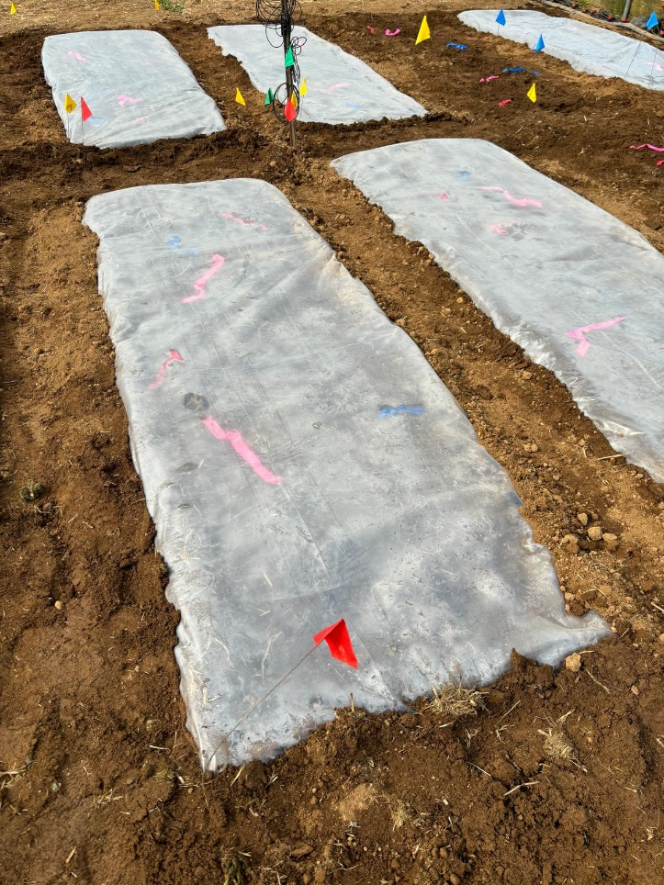
Photo credit: Paula Luize Lessmann.

Figure 2. Tilling the soil. 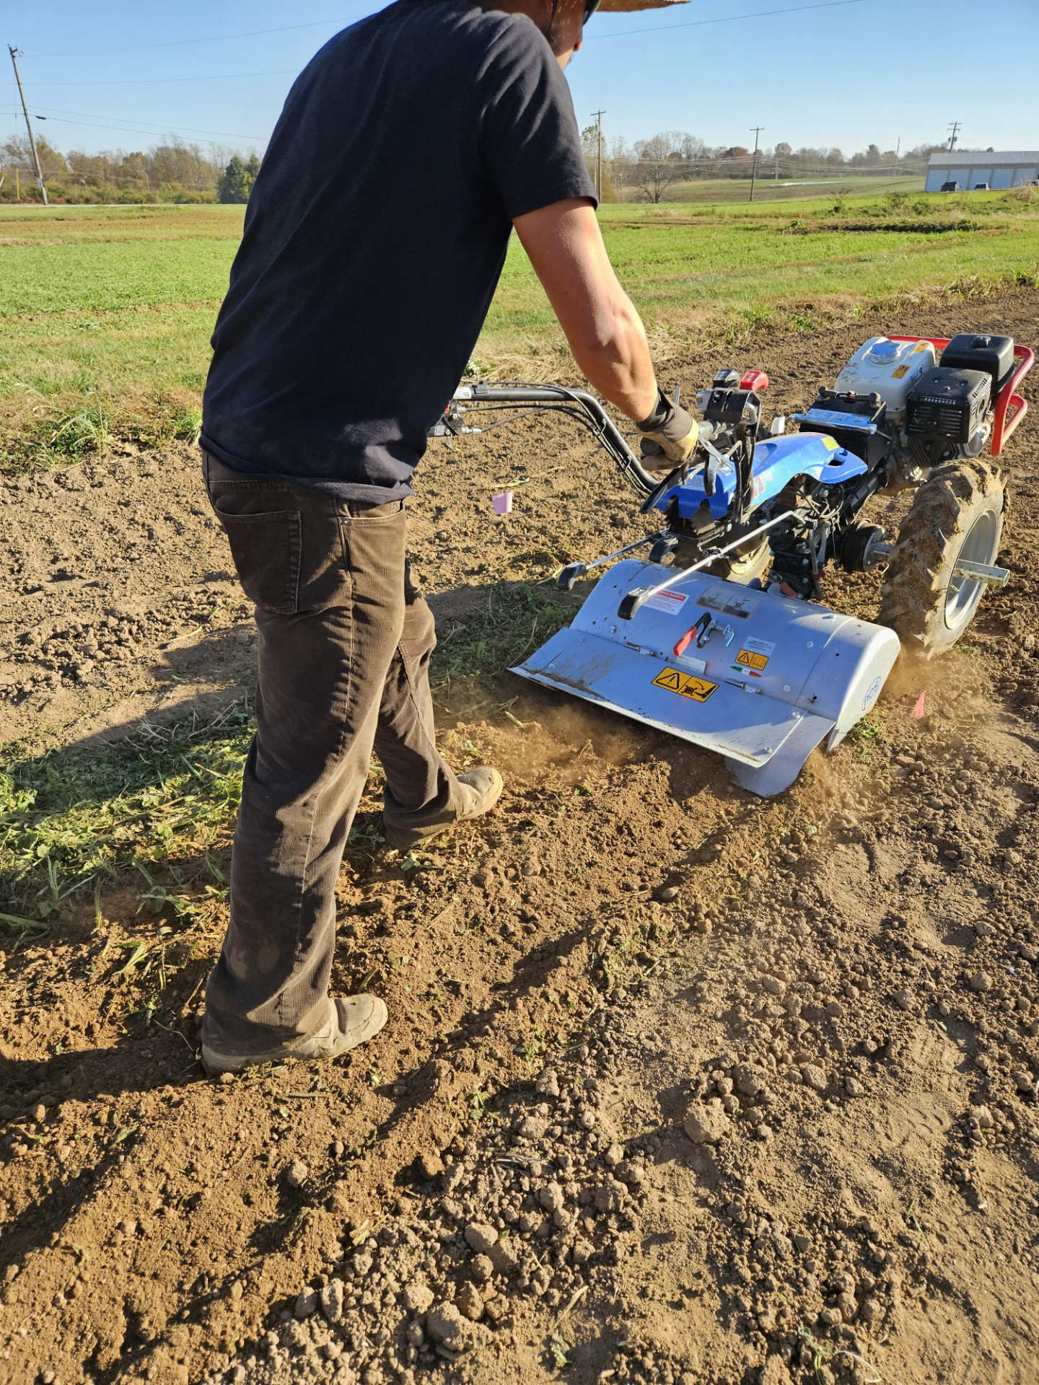
Photo credit: Rachel Rudolph.

Figure 3. Irrigating soil to 70% field capacity prior to soil solarization.
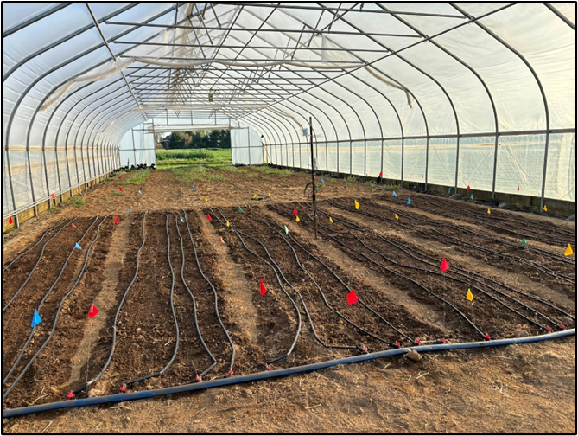
Photo credit: Paula Luize Lessmann.

Figure 4. Placing the tarps and sod staples after trenching the soil.
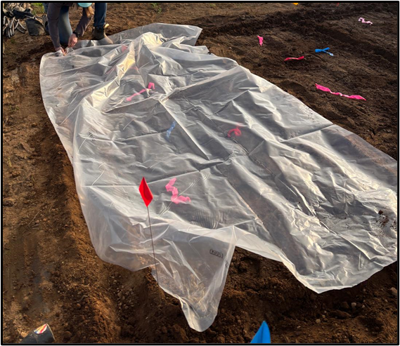
Photo credit: Paula Luize Lessmann.

Figure 5. Covering the edges of tarp with soil.
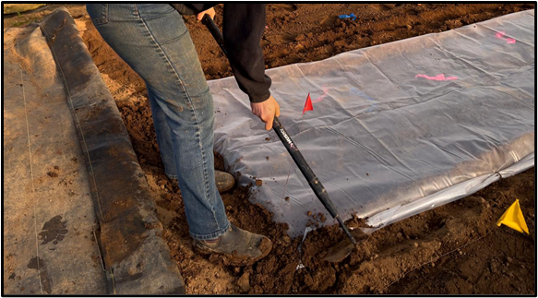
Photo credit: Paula Luize Lessmann.

Figure 6. Rhizoctonia Rot of lettuce.
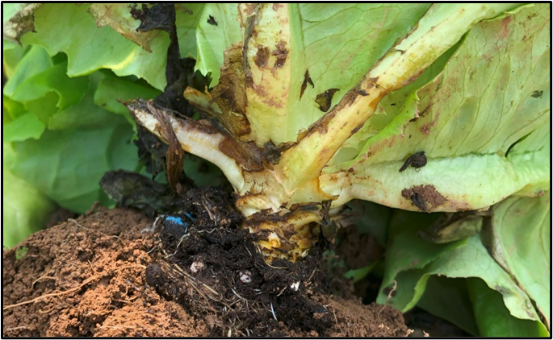
Photo credit: April Lamb.

Figure 7. Timber Rot.
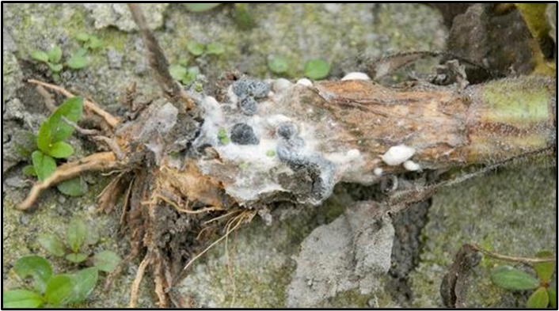
Photo credit: Nicole Gauthier
Figure 8. Galled roots of a tomato plant caused by root-knot nematode infection.
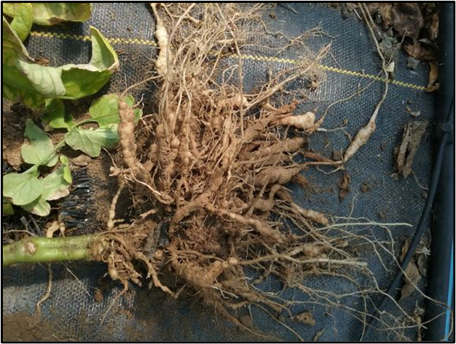
Photo credit: Rachel Rudolph

Figure 9. Weed population in a nonsolarized (control, no tarp) plot in a high tunnel that was closed during 4 weeks of soil solarization in Lexington, KY.
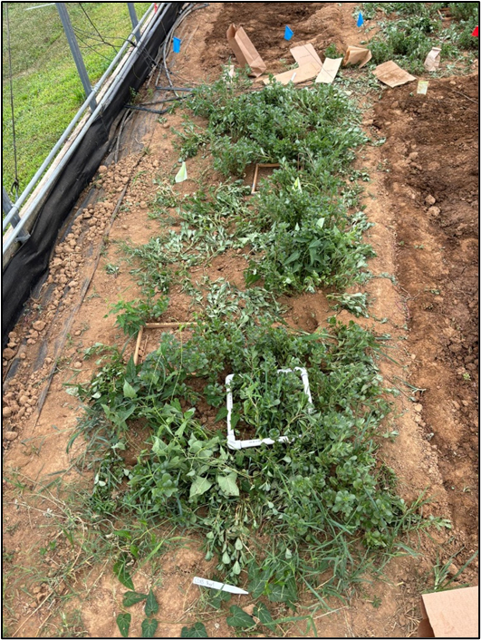
Photo credit: Paula Luize Lessmann.

Figure 10. Weed survival in July after 4 weeks of solarization in a closed high tunnel in Lexington, KY.
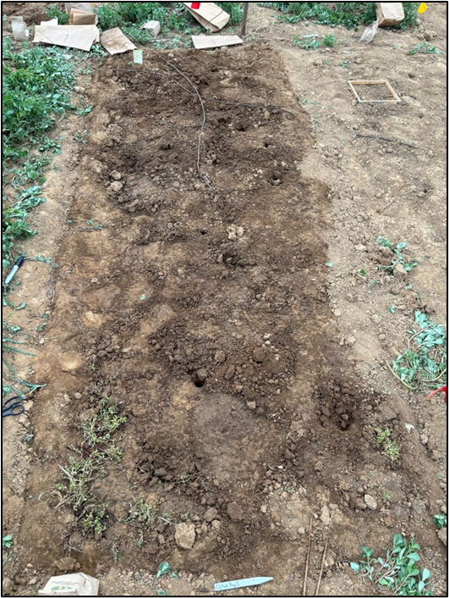
Photo credit: Paula Luize Lessmann.

Figure 11. Lettuce right before harvest in high tunnel that was left open (end walls and side walls up) during 4 weeks of solarization in Lexington, KY.
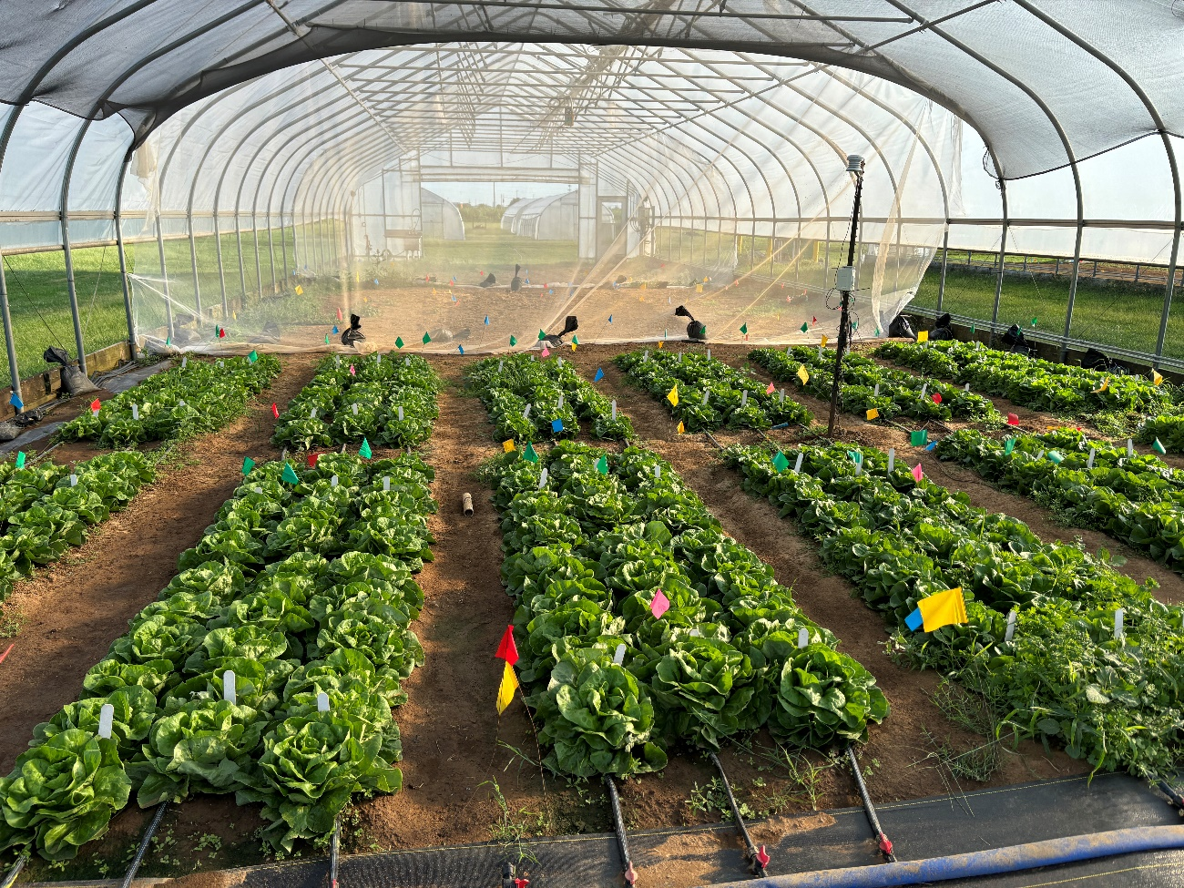
Photo credit: Paula Luize Lessmann.

Figure 12. Marketable lettuce yield after soil solarization in a closed high tunnel in Spring, Summer, and Fall 2024 in Lexington, KY and Knoxville, TN. While this experiment evaluated weeds, this yield is from subplots that were maintained weed-free.
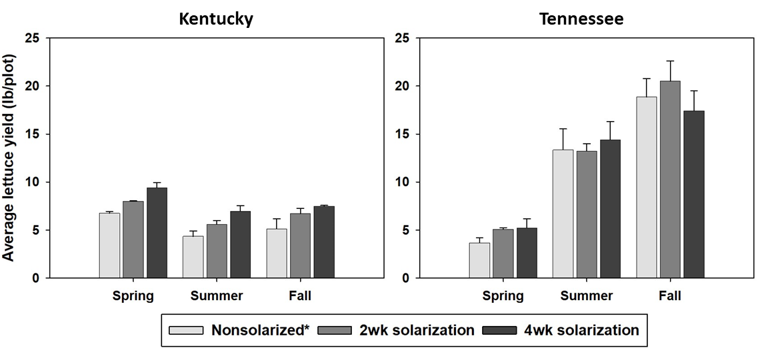
*Nonsolarized: plots were not solarized.
2wk solarization: plots solarized for 2 weeks.
4wk solarization: plots were solarized for 4 weeks.

Figure 13. Marketable tomato fruit yield harvested from tomato plants grown after soil solarization in high tunnels in Spring 2022 in Mercer and Woodford Counties, KY. The high tunnels were naturally infested with southern root-knot nematode (Meloidogyne incognita).
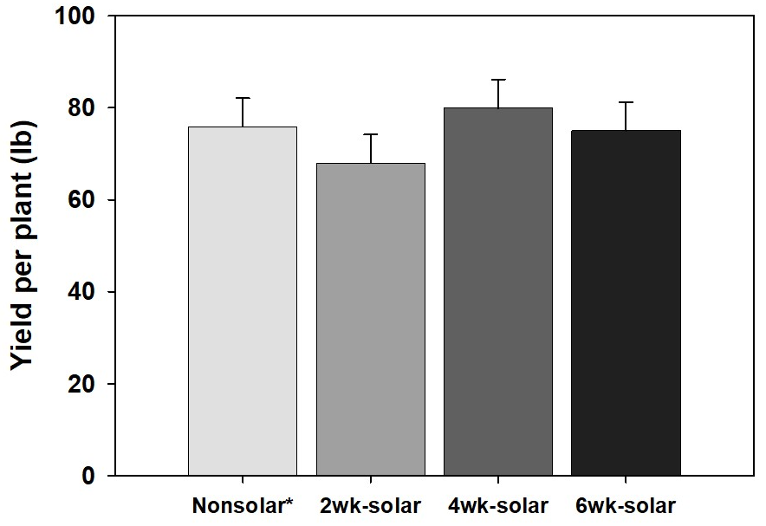
*Nonsolar: plots were not solarized.
2wk-solar: plots solarized for 2 weeks.
4wk-solar: plots were solarized for 4 weeks.
6wk-solar: plots were solarized for 6 weeks.

References
Elmore C, Stapleton J, Bell C, DeVay J. 1997. Soil solarization: a nonpesticidal method for controlling diseases, nematodes, and weeds. Publication, 21377, 1-13.

