Preparing Production Structures for Extreme Weather Conditions
Qinglu Ying and Rachel Rudolph
- Design consideration before setting up a structure
1.1 Site selection and orientation
Choosing the right location is critical for minimizing the impact of extreme weather. High tunnel or greenhouse structures should be placed in elevated areas to reduce the risk of flooding. In regions prone to high winds or storms, the orientation of the structure should be optimized to reduce exposure to prevailing winds and extreme weather patterns. The end walls, rather than the side walls, should face prevailing winds when possible. Selecting a site with natural windbreaks, such as hills or trees, can also help mitigate potential wind damage.
  - Foundation and frame
It is important to select galvanized steel frames that meet Kentucky’s structural design requirements. A minimal snow load of 15 pounds per square foot (psf) should be considered in Kentucky, while higher elevation and eastern counties may require up to 20 psf. Frames should also be designed to withstand a nominal wind speed of approximately 90 mph. Posts should be embedded at least 3 ft deep and secured with concrete or screw anchors to resist uplift and overturning forces. To help withstand wind and snow loads, high tunnel bow spacing should be 4 ft apart.
  - Roof design
Roof shape plays a critical role in how a structure withstands wind, snow, and heavy rainfall. The gothic-style arch roof is the most popular roof structure in Kentucky, as the design creates smoother airflow and reduces turbulence, providing excellent wind resistance. Additionally, the gothic roof also encourages snow to slide off more quickly than other structures. In regions with heavy snow, selecting a roof pitch of at least 4:12 or higher (Fig. 1) improves shedding and reduces compression forces on bows and purlins.
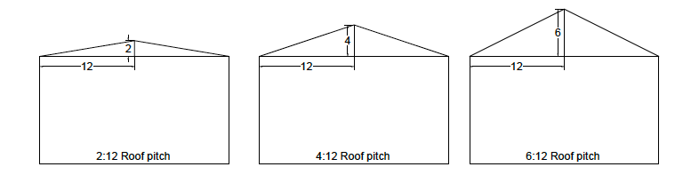
Figure 1. Examples of 2:12, 4:12 and 6:12 roof pitch
  - Covering and ventilation design
Choose UV-stabilized, thick materials like polyethylene film and polycarbonate panels to ensure durability and resistance to weathering. For improved insulation and greater tolerance to snow loads, consider using an inflated double-layer cover, which creates an insulating air gap. At least one inflation fan is needed to inflate the two layers. Ventilation systems should include automated roll-up sides and roof vents to maintain airflow and temperature control, but these should also have manual overrides to ensure operation during power outages or equipment failure.
- Operational Strategies for Weather Resilience
Closely monitoring conditions helps growers anticipate extreme weather conditions and take proactive measures to protect structures and crops. For each extreme weather, have protocols in place for structures that are in production and not in production.
  - High wind and tornadoes
Strong winds can cause severe damage to greenhouse and high tunnel structures if precautions are not taken (Fig. 2). If the structure is in production, ensure plastic covers are fully inflated and tensioned, as loose films can act like sails. Securely close and lock all vents and doors, roll down side walls and end walls for high tunnels, store shade cloths and/or secure them tightly to prevent tearing, and relocate lightweight materials such as pots, trays, and tools to storage. If the structure is not in production, partially removing or rolling up plastic can reduce wind load, and the structure should be anchored using screw anchors or tie-down kits. After a storm, inspect the frame for alignment, check for film tears and connection integrity, and tighten any loose bolts immediately to prevent progressive bending.
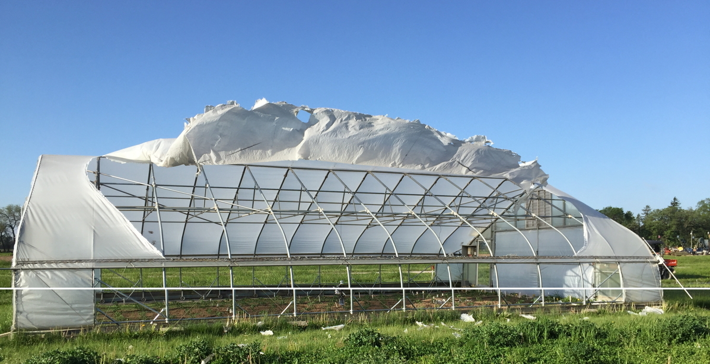
Figure 2. Production structure damaged by the storm (Source: https://undercoverfarmingexpo.com/2024/01/10/storm-damage-greenhouse/)
  - Heavy snow and ice
When greenhouses and high tunnels are not in production during the winter months, the primary goal is to protect the structure itself from damage due to heavy snow and ice. Before the first expected snowfall, inspect the entire frame, tighten any loose bolts, fasteners, or connectors, and check cables and bracing for proper tension. For high tunnels, if they are not specifically designed for heavy snow loads (especially Quonset-style or those with bow spacing wider than 4 ft), the best proactive measure may be to remove the plastic cover entirely, roll it up, and store it safely. For any structure left standing, clear the surrounding area for snow to slide off and make sure gutters and drainage systems are free of debris to prevent water/ice buildup around the foundation. Gutters may be removed in the winter to avoid breakage.
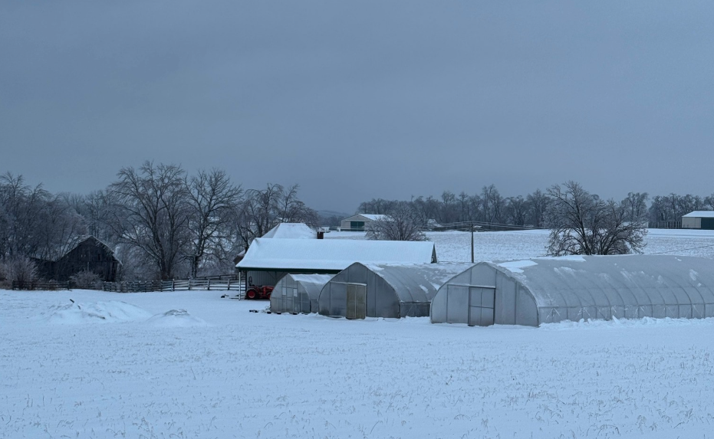
Figure 3. Production structure covered by snow (Photo by UK Center for Crop Diversification)
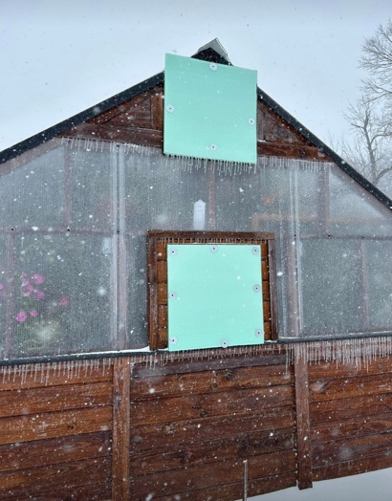
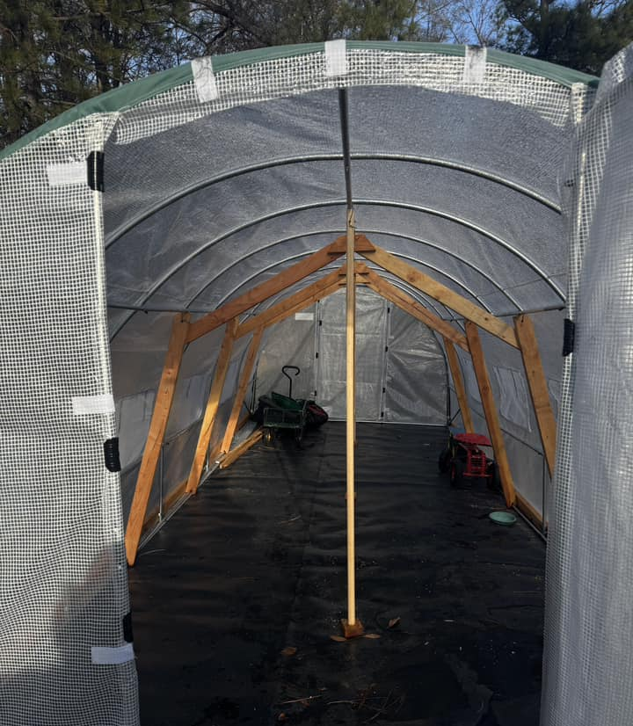
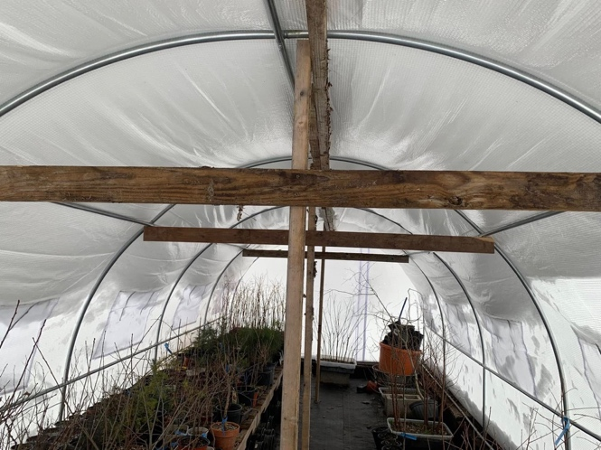
For greenhouses or high tunnels that remain in production, the strategy shifts to balancing structural protection with crop survival. A proven approach is to place one or more layers of row cover directly over the crops—either continuously or only at night—depending on inside temperatures and crop needs. During periods of short, cloudy days, reduce fertigation and, if irrigation is required, apply water earlier through drip, microsprinkler, or sub-irrigation during the day to allow soil to dry before evening. To minimize snow accumulation on the structure, actively heating the space is most effective. As additional, low-cost protection, many growers temporarily seal vents, doors, and automatic shutters with rigid foam board, heavy plastic sheeting, or even duct tape to create a more airtight envelope. Internal bracing can also be added by installing posts or lumber supports under the purlins or ridge beam to increase load-bearing capacity during extreme snow events (Fig. 4). If it is safe to do so, a soft-bristle broom can be used to sweep snow from the structure as it accumulates.
Figure 4. Grower DIY methods for temporarily sealing vents and adding internal bracing under purlins or the ridge beam to support extreme snow loads.
2.3 Heat wave
In general, when air temperatures exceed 95°F (35°C), crops inside protected or controlled structures are at high risk of heat stress. If the structure is in production, a 30–50% shade cloth should be installed and adjusted seasonally to reduce solar radiation and air temperature. The exact percent of shade cloth will depend on the crops being grown and production systems. Too much shade may affect production and yield.
During high temperatures, ventilation needs to be increased by opening the side curtains, end walls, and exhaust fans to allow consistent air exchange. When the structure is not in operation, all vents and doors should remain open to prevent heat buildup. Sensitive materials such as irrigation tubing, sensors, and other plastic materials are susceptible to thermal degradation and should be protected or stored elsewhere.
  - Heavy rainfall and flood events
Heavy rainfall and saturated soils can compromise greenhouse foundations, resulting in significant crop losses. Before flooding, it is essential to make sure drainage channels, drains and sum pumps are functioning properly, and clear out debris and sediment buildup. Raise electrical outlets and control boxes at least 12 inches above the ground. For high tunnels in which crops are grown in-ground, severe rainfall and lack of drainage can cause water to seep underneath the high tunnel, inside the structure, and flood the interior. Selecting a site with soil that drains well is ideal.
Any portable equipment, chemicals, and fertilizers should be moved to higher ground. During flooding, any power running to a structure should be shut off in case water reaches electrical components. After flooding, irrigation water should be tested for quality and EC before use. All surfaces should be thoroughly washed and disinfected, and structural components (base plates and anchors) should be inspected for corrosion. Where drainage can be a problem, it is recommended to install drainage tile below the surface, ideally before constructing the structure (Fig. 5). Gutters can be installed to help divert water away from the structure.
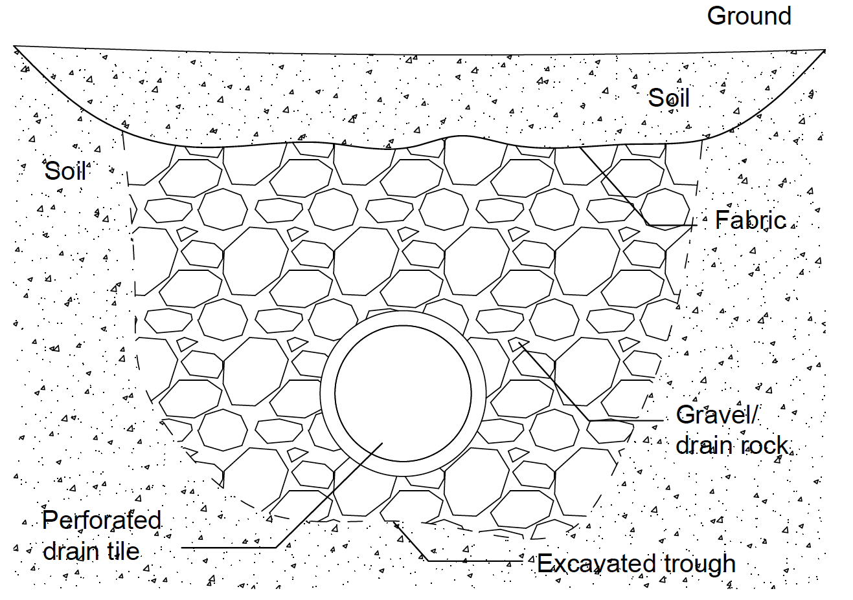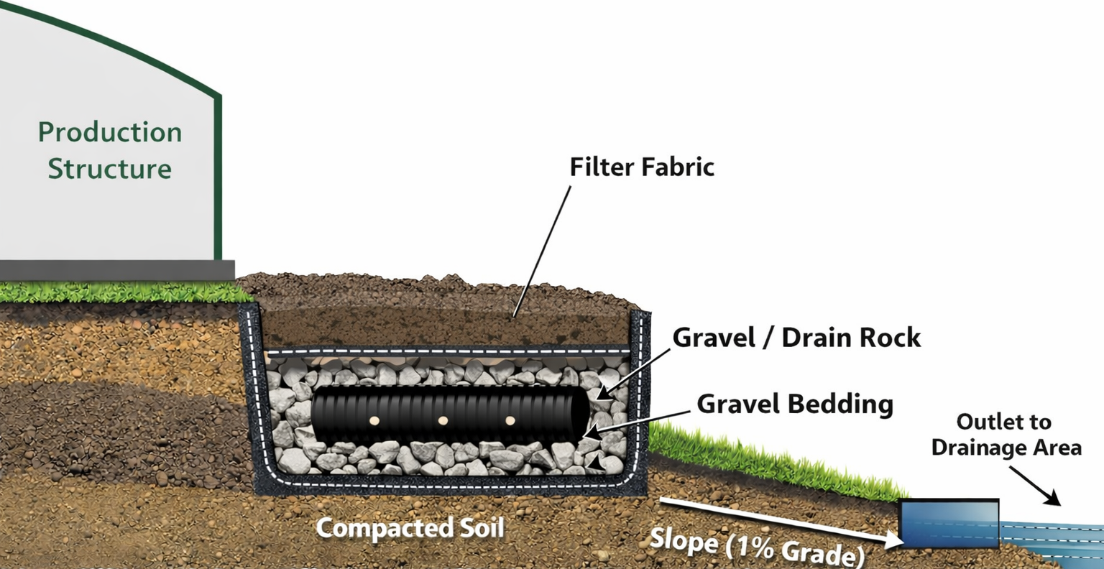
Figure 5. Schematic diagram of a French drain system (left) and its placement relative to a production structure to intercept and redirect excess water (right).

3. Post-storm recovery and assessment
3.1 Safety first
Safety should be the top priority after any severe weather event. Do not re-enter a damaged greenhouse or high tunnel until it has been evaluated for collapse risk or unstable structural components.
3.2 Structural inspection
Once the site is safe, begin with a thorough structural assessment. Check that the foundation remains aligned and that ground posts or anchors have not shifted or loosened. Inspect the frame for bent bows, twisted purlins, or compromised connections. Examine the covering for film tears, loose lock channels, broken fasteners, and damage to doors, vents, or end-wall framing. Electrical and mechanical systems should also be evaluated to ensure they remain operational and safe for continued use.
3.3 Crop and system assessment
Next, evaluate crop health and growing systems. Inspect root zones, substrates, and irrigation lines for signs of contamination, silt, or clogging, which are common issues after flooding or heavy wind-driven rain. Flush fertigation systems thoroughly with clean water before resuming nutrient delivery. If plants are grown in containers and the growing substrate was submerged, replace it or apply proper pasteurization procedures, as floodwater may introduce pathogens or debris that jeopardize future crop cycles.
3.4 Documentation
Record all relevant details following the storm, including weather conditions, the nature and extent of damage, repair actions, and associated costs. Tracking this information helps identify patterns and repeated weak points that should be reinforced before future seasons. Over time, these records form a useful reference for improving structural resilience and informing management and insurance decisions.
4. Insurance and risk management
Insurance is an essential component of risk mitigation for greenhouse and high tunnel production systems. Review your policy to ensure there is coverage for weather events and damage. Many policies do not automatically cover non-permanent structures such as high tunnels, so supplemental coverage may be required. Maintain clear documentation by taking annual photos of the structure and updating them after any modifications or improvements. Keeping a digital inventory of high-value equipment helps streamline claims if damage occurs. For more information on insurance, please refer to Extension Publication on Insuring Horticultural Investments (CCD-FS-33, refer to additional resources).
5. Summary checklist
Weather events | Preparation | During | After
Heat wave | Shade cloth, ventilation | Maintain cooling, monitoring air temperature and rootzone EC | Check for wilt or other stress, adjust irrigation
Heavy rainfall and flood | Check drainage and elevation | Shut power, relocate tools | Disinfect, inspect corrosion
High wind and tornadoes | Tighten film, secure openings | Stay clear | Inspect structure, films
Heavy snow and ice | Ensure adequate support, cover the crops | Maintain warmth, remove snow | Remove snow, inspect structure

Additional resources:
A Guide to Preparing High Tunnels for Extreme Weather. https://blog.uvm.edu/cwcallah/2024/08/13/a-guide-to-preparing-high-tunnels-for-extreme-weather/
Byrd, C. 2025. Insuring Horticultural Investments: Insurance Checklist. https://ccd.uky.edu/sites/default/files/2025-02/ccd-fs-33_insuring-horticultural-investments-insurance-checklist_0.pdf
Department of Housing, Buildings and Construction. 2018. 2018 Kentucky Building Code. https://dhbc.ky.gov/Documents/KHBC_BuildingCode.pdf
Owen, W.G. 2018. Greenhouse Snow Load and Removal. https://greenhousehort.mgcafe.uky.edu/sites/greenhousehort.ca.uky.edu/files/Greenhouse%20Snow%20Load%20and%20Removal.pdf

