Sensors and Tools for Evaluating Controlled Environment (CEA) Production: A Catalog for Extension Agents and Growers
Kelly Bryant , Arundathi Sharma and Qinglu Ying
Season extension is widely adopted in intensive horticultural production across Kentucky, but it often comes with a steep learning curve. Even experienced growers may need to “re-learn” how to manage familiar crops when they are grown under protection. To fully realize the benefits of season extension, covered or protected production systems require management practices that differ substantially from those used in open-field production. Among these, understanding and routinely monitoring the crop and growing environment is one of the most fundamental requirements for success.
This publication serves as an index of portable tools that County Extension Agents and controlled environment agriculture (CEA) growers may find useful for assessing indoor growing environments, including low/caterpillar tunnels, high tunnels, and fully controlled greenhouses. Regardless of the specific production setting, environmental parameters that are particularly useful for Kentucky growers to track include water and substrate pH/EC, temperature, relative humidity and light levels (Fig. 1). The tools in this list can be used for immediate technical assistance at grower sites, short-term equipment loans to growers, as well as for education and demonstrations at County Extension programs.
Please note that this publication does not specifically endorse any products. Instead, the examples provided are intended to highlight key environmental parameters to monitor and the features Extension agents should consider when evaluating portable tools.
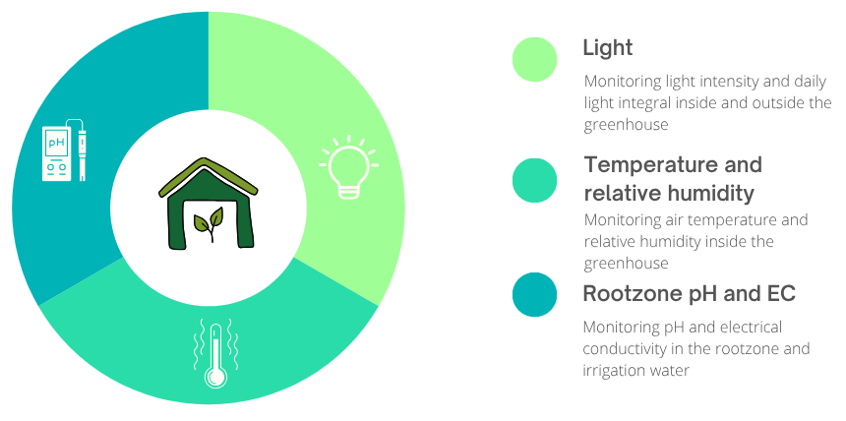
Figure 1. Key environmental parameters to monitor for controlled environment agriculture (CEA) systems
Root-Zone pH and EC Monitoring
Root-zone pH and electrical conductivity (EC) are two of the most critical parameters for managing the root-zone environments of greenhouse crops. They directly affect nutrient availability, uptake efficiency, and overall plant health. Even small deviations can have large impacts on growth and yield.
For instance, if the root-zone pH rises above 6.5, micronutrients such as iron, manganese, and zinc become less available, leading to deficiency symptoms like interveinal chlorosis. Conversely, a pH below 5.5 can interfere with calcium and magnesium uptake and increase the solubility of potentially toxic elements. In Kentucky, irrigation water can have pH above 7.0, and in some areas, it can reach 7.5 or higher due to naturally high bicarbonate alkalinity. This means that without adjustment, the water tends to raise substrate pH over time, affecting nutrient availability and plant performance. Growers using well water or municipal water with high alkalinity may need to acidify their irrigation water using acids (e.g., phosphoric, nitric, or sulfuric acid) to maintain a stable root-zone pH between 5.5 and 6.5. Regularly measuring both fertigation water and leachate pH helps confirm that acid injection or nutrient management strategies are effectively controlling pH at the crop root zone.
EC indicates the total concentration of soluble salts—essentially how much fertilizer is available to the plants. Excessive EC can cause osmotic stress and tip burn, while low EC can result in nutrient deficiencies and reduced growth. Monitoring EC can confirm that fertilizer programs are supplying nutrients at the intended concentration and that salts are not accumulating to harmful levels, preventing over- and under-fertilization before planting and throughout the crop cycle.
pH and EC monitoring meter
A pH/EC/TDS/Temperature portable meter (such as HI9813-51 from Hanna Instruments) can be used to measure pH and EC in water, fertigation solutions and soilless substrates.
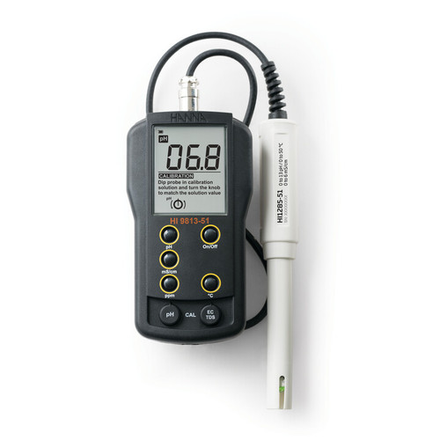

Figure 2. An example pH and electrical conductivity (EC) meter for water and substrate pH and EC monitoring.

General use
The measuring frequency, methods, and expected ranges for pH and EC measurements in water, fertigation solutions and soilless substrates are summarized in Table 1.

Table 1. Recommended pH and EC monitoring methods and target ranges for common controlled environment production inputs
Source/When to Use | Methods | Expected ranges
Irrigation water  (measure before mixing fertilizer or when water sources change) | Collect a water sample in a clean plastic cup or beaker. Insert the pH and EC probes, gently stir, and wait for the readings to stabilize (typically 30–60 seconds). | pH: 6.5-8.0  EC: <0.5 mS/cm
Nutrient solution (measure after mixing fertilizer and before it reaches the plants, and weekly throughout the crop cycle) | Measure the final nutrient solution before it is delivered to the crop. Collect from the injector output or irrigation line or directly measured in the reservoir of float bed or nutrient film technique (NFT) systems, ensuring the sample represents the solution being applied. | pH: 5.5–6.5  EC: 1.5–3.5 mS/cm depending on crops and crop stages
Soilless substrates (measure before and after fertilizer application, and weekly throughout the crop cycle) | Using the pour through method:  - Irrigate the container-grown plant with clear water until the substrate is evenly moist.  - Wait 30–60 minutes.  - Pour a small amount (50–100 mL) of distilled or deionized water onto the substrate surface and collect the leachate from the bottom.  - Measure pH and EC of the leachate using the probes. | pH: 5.5 -6.5  EC: 1.0-5.0 mS/cm depending on crops, crop stages and sampling methods.  Pour through method is expected to have higher EC than 1:2 extraction
Using the 1:2 extraction method:
- Collect a small sample of substrate (about 1 part by volume).
- Mix with two parts distilled water (2:1 water : substrate).
- Stir, let sit for 30 minutes, and then measure the pH and EC by swirling the probe into the solution.

Maintenance (calibration, storage solution)
Proper maintenance is essential for accurate pH and EC measurements and long probe life. Always follow the manufacturer’s manual or calibration, cleaning, and storage procedures. When using a new probe or one that has been unused for a long period, soak it in the recommended storage solution for at least one hour before use to rehydrate the electrode. Regular calibration is critical using standard buffer solutions and standard EC calibration solutions. After each measurement, rinse probes with distilled water to remove residue, gently blot dry, and store the pH probe in a proper storage solution (never in distilled water). Keeping the probes clean, calibrated, and properly stored ensures consistent and reliable readings over time.
Cost and alternatives
Reliable handheld pH and EC combination meters from reputable manufacturers typically cost $150–$300. Cheaper options are available but are generally not recommended due to inconsistent accuracy and shorter lifespan. These handheld meters are ideal tools for county agents, who can use them during site visits to provide growers with quick, preliminary assessments of water and nutrient solution quality.
For large-scale greenhouse operations, continuous monitoring systems with data logging and automatic dosing features are available at higher cost but offer the advantage of real-time control and reduced labor. For smaller operations or educational demonstrations, color-change test strips and simple test kits can provide rough pH estimates but lack the precision needed for management decisions.
Growers are encouraged to work with their local county Extension agents or submit periodic samples to the University of Kentucky Regulatory Services Laboratory to confirm meter readings, assess alkalinity, and evaluate overall nutrient balance. Regular verification helps ensure that pH and EC management strategies remain accurate and effective over time.
Light Monitoring
Light levels are often one of the most important factors contributing to plant growth, development and yield that growers manage actively in the greenhouse. However, light is one of the most capital- and energy- intensive subsystems, posing a particular challenge for greenhouse growers with resource constraints. In this section, we will review a) when and why to measure light and b) how to measure light, including resources suitable for County Agents.
Season extension structures, such as frames, trusses, and glazing materials, naturally reduce the amount of sunlight that reaches the crop, limiting the light available for photosynthesis. This becomes especially important during winter and the shoulder seasons when daylength is short and natural light levels can drop to less than half of summer conditions. Under these low-light periods, growers who are heating their greenhouses may find that their crops become light-limited, slowing growth and reducing overall production efficiency. In high tunnels and basic plastic greenhouses covered with polyethylene film, light transmission can be as high as 90% when the material is brand new. However, exposure to sunlight, age-related deterioration, mechanical wear, and the accumulation of dust or organic matter all contribute to reduced light transmission over time. Growers using these types of structures should routinely assess film condition and schedule periodic cleaning or replacement to maintain optimal light levels for crop growth.
Light levels cannot easily be estimated by perceived “brightness,” because the human eye responds to the different wavelengths of light differently than plants do. Many highly variable factors (e.g., weather, sun-angle, physical obstructions) can affect the exact amount of sunlight reaching a given location at a time, so if growers or agents believe light limitation could be affecting their crop, a light sensor is the best way to know. Light sensors and fixtures can come with many units and abbreviations that may be confusing; detailed information will be provided in another extension publication on light consideration for controlled environment plant production. Table 2 summarizes the key light metrics, units, measurement methods, and relevant conversions that growers should look for when evaluating reputable and reliable horticultural lighting technologies.
Table 2. Common light metrics, units, measurement methods, and relevant conversions.
Metric¹ | PPFD/PAR intensity | DLI | Illuminance | Radiance
Units | µmol/m²/s | mol/m²/day | Lux or footcandle (FC) | W/m² or Joule/cm2/day
Measurements | Quantum sensors |  | Photometric sensors | Radiometric sensors
Conversion | 100 µmol/m²/s with 16 hours photoperiod is 5.76 mol/m²/day |  | 1 FC ≈ 10 Lux ≈ 0.13 to 0.2 µmol/m²/s depending on light sources | 1 W/m² ≈ 1.96 µmol/m²/s  51 Joules/cm²/day ≈ 1 mol/m²/day
¹PAR – Photosynthetically Active Radiation refers to the portion of the light spectrum between 400 and 700/750 nm that plants can use for photosynthesis. PPFD – Photosynthetic Photon Flux Density quantifies the instantaneous intensity of PAR reaching a surface. DLI – Daily Light Integral represents the total amount of PAR received over a 24-hour period.
Light monitoring sensor
A DLI meter (such as Apogee DLI-400 PAR, DLI, and photoperiod meter) can be used by County Agents and growers to get an instant snapshot of light intensity, as well as to track daily light availability.
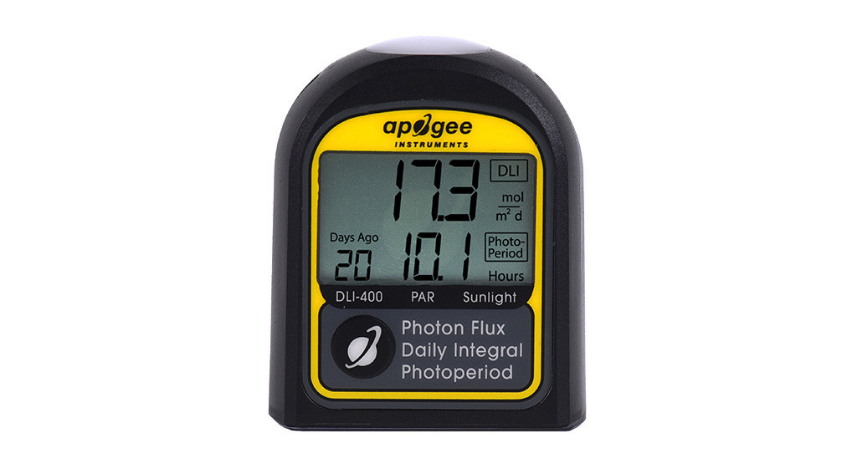
Figure 3. An example light meter for light monitoring

General Use
For aggregated DLI measurements, install the batteries and affix the meter in a location that is at roughly crop-canopy height. This Apogee meter can log for up to 100 days, but we recommend using it only for up to a few days, to get a sense of daily light availability during that season when the measurement takes place. Data can be accessed through a USB port on the meter, and should be cleared periodically.
For snapshot measurements, the meter also enables a live sensor readout that displays the average light intensity from the last 2.5 seconds. This is helpful for assessing light loss through greenhouse plastic, light availability at different heights in the crop canopy, as well as across various locations throughout the greenhouse.
Note: Look at the response curve for the sensor. The DLI-400 meter from Apogee is only accurate under sunlight and broad-spectrum supplemental light sources (e.g., sodium lamps). Agents working with growers who use LED light sources should select an upgraded meter, such as DLI-500, DLI-600, or contact the Extension Greenhouse Specialist.

Maintenance and Calibration
The meter receives light in a domed area at the top; if this area is obstructed (e.g., by physical objects, dust, splashed liquids, or other deposits), measurements will be inaccurate. The product manual provides clear and detailed instructions about how to clean this receiver, and it is important to follow these directions to ensure a long life for the meter. The meter has been professionally calibrated in the factory, and can be returned to the manufacturer for recalibration as and when necessary (approximately every two years). This will generally be the case for PAR meters, but make sure to check the manufacturer’s instructions and guarantee of sensor calibration.
Cost and alternatives
DLI meters that provide appropriate units can cost upwards of $300. However, small-scale growers may be able to make do with lower-cost sensors that measure lux (<$100) – however, the measurements will need to be converted and calculated to get an estimated DLI by 1) converting instantaneous light intensity to appropriate units (PPFD) using a spectral conversion factor, then 2) multiplying by photoperiod to estimate light availability for the whole day. This website provides estimated conversions: https://www.egc.com/lighting-conversion/. Note that these are estimates, and only a DLI meter can give growers the most accurate data.
Climate Monitoring (temperature, humidity, and light)
Climate monitoring within a controlled environment is essential for maintaining plant growth and resource efficiency. Plants respond directly to environmental conditions. Small changes in the climate can significantly impact plant health and yield. Greenhouse climate monitoring includes temperature, relative humidity, CO₂ and light. These factors are the primary drivers of plant photosynthesis, transpiration, and respiration. Temperature in a controlled environment affects the plant’s enzyme activity, growth rate, and the timing of developmental processes such as flowering. When temperatures are within the crop’s optimal range, metabolic reactions proceed efficiently, supporting steady biomass accumulation; when temperatures fall below or exceed this range, growth slows and physiological stress increases. Relative humidity (RH) influences the plants’ transpiration, which is the plant’s primary mechanism for water movement and evaporative cooling, and in turn, nutrient uptake through mass flow. High RH can suppress transpiration and limit calcium and micronutrient transport, whereas low RH increases transpiration demand and may predispose plants to water stress.
Climate Monitoring Sensor
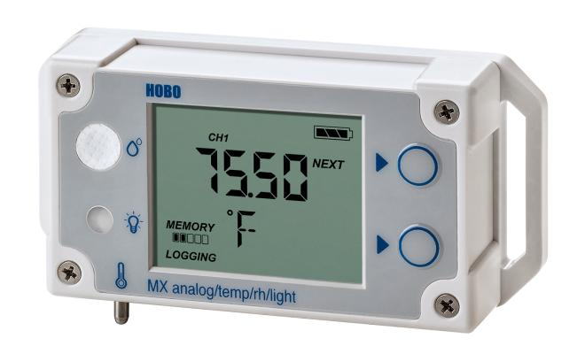A Temp/RH/Light data logger (such as HOBO MX1104, Fig. 4) can be used by county agents and growers to monitor growing environments. This is a compact data logger that is designed to monitor the temperature, RH and light intensity in a controlled environment system. The light intensity is measured as Lux and needs to be converted to µmol/m²/s as explained the previous section (Table 1). The data logger is also available with a solar radiation sensor (such as HOBO MX2309) and a PAR sensor (such as HOBO MX 2308) that measures light intensity in W/ m² and µmol/m²/s, respectively.
Figure 4. An example Temperature/ Relative humidity/ Light data logger for climate monitoring.

General Use
The HOBO MX1104 is valuable for microclimate monitoring, record-keeping, and backup monitoring within controlled environments. There is a screen on the sensor to show current temperature, RH and light intensity. When sensors are placed strategically across multiple zones within the CEA facilities, they provide real-time reading. These spatially distributed readings help growers evaluate environmental uniformity, detects hotspots or humidity gradients and verify whether the climate control system (e.g, heaters, ventilation, fans, sprinklers) is performing as intended. Selecting the right mounting location will depend on the crop, and the growers' goals. For example, placing the sensor at canopy level will capture the climate the plant is currently experiencing, making this location the most common and informative. If the goal is to measure the media temperature and moisture, mounting the sensor at the root-zone may be more beneficial. The sensor also has Bluetooth enabled, wireless logging function that keeps a record of the climate history. The sensor is recommended to be mounted slightly above the plant canopy and shielded from direct radiation to capture environmental conditions most representative of plant growth. Integrating climate data with plant performance and yield information helps guide routine climate-management decisions, such as adjusting ventilation, heating, or shading, allowing growers to make timely corrections that improve crop uniformity and reduce plant stress.
The temperature can be measured from -4 °F to 158 °F (-20 °C to 70 °C) and it measures RH from 0%-100%, although prolonged exposure to high humid and temperature greenhouse conditions can compromise its accuracy over time. It also measures light ranges from 0 up to 167,731 lux (≈3106 µmol/m²/s). The logging interval can be set anywhere between 1 second and 18 hours. For routine commercial production monitoring, a logging interval between 10 to 30 mins is recommended. For Extension agent site visits, the logging interval can be set to 20–60 seconds to quickly assess climate conditions at multiple locations within the greenhouse. Data can be accessed and downloaded using mobile devices through Bluetooth, or computer using a free app, or USB cord provided.
Cost/ Alternatives
The HOBO MX1104 is currently listed for $235 by the manufacturer. Alternative options include simpler standalone sensors, basic thermostats, or more advanced climate stations that enable the integration of multiple sensors. When comparing options, it is important to consider the measured parameters, units, sensor accuracy and range, deployment environment, connectivity and data access, software and data management, future plans and total costs for integrating additional sensors. More advanced integrated climate-management systems are also available; these integrate multiple sensors with fans, vents, heaters, or irrigation systems through a climate computer. While these systems offer automated control and higher precision, they are significantly more expensive and may require professional installation and ongoing maintenance.

Additional resources:
Byrd, C., Ying, Q. and Sharma, A. (2025). Monitoring pH and EC in Greenhouse Production. CCD-ER-01. Lexington, KY: Center for Crop Diversification, University of Kentucky Martin Gatton College of Agriculture, Food and Environment.
Fisher, R.Stephen. (2002). Groundwater Quality in Kentucky: pH. https://kgs.uky.edu/kgsweb/olops/pub/kgs/ic06_12.pdf
Ingram, D.L. (2014). Understanding Soilless Media Test Results and Their Implications on Nursery and Greenhouse Crop Management. Cooperative Extension Service. University of Kentucky Martin Gatton College of Agriculture, Food and Environment. https://publications.mgcafe.uky.edu/sites/publications.ca.uky.edu/files/HO112.pdf
Lopez, R.G., and Runkle, E.S. (2021). Making sense for light sensors. Greenhouse Product New. https://www.canr.msu.edu/floriculture/uploads/files/MakingSenseofLightSensors.pdf

