Farm Food Safety Plans for Urban Farms
Cindy Finneseth, Extension Specialist, Bryan Brady, Senior Extension Associate, and Courtney Bartlett, Extension Associate
Regardless of your farm size or production system, it is a good business practice to have a farm food safety plan. This plan will help you identify, assess, and manage food safety risks on your farm and ensure safe production of fruits and vegetables for your customers. This plan is unique to your farm and is where you outline policies and standard operating procedures (SOPs), as well as keep records to show you are following these policies and procedures. Sample plans are available, but it is critical that you use any template as a guide and write your own plan that describes your farm. There are four primary categories of a farm food safety plan: general farm information, production activities, harvest activities, and post-harvest handling.
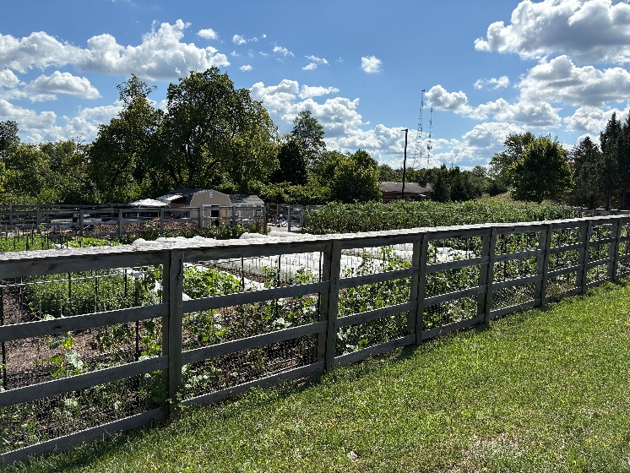
Fig. 1. An urban farm in Covington, KY. Photo credit: Cindy Finneseth

General Information
Management Responsibilities. Someone who manages day-to-day production activities should be responsible for writing and maintaining the food safety plan. For smaller farms, the owner-operator may be doing all the farm work and is completely responsible for all aspects of the farm food safety plan. List contact information for emergency purposes.
Farm Description. Include a description of the location, crops grown, historical land-use, and area under cultivation (sum of the square footage of field plots and/or raised beds). A farm map can be as simple as a hand-drawn map or a more formal labeled satellite image (Fig. 2).
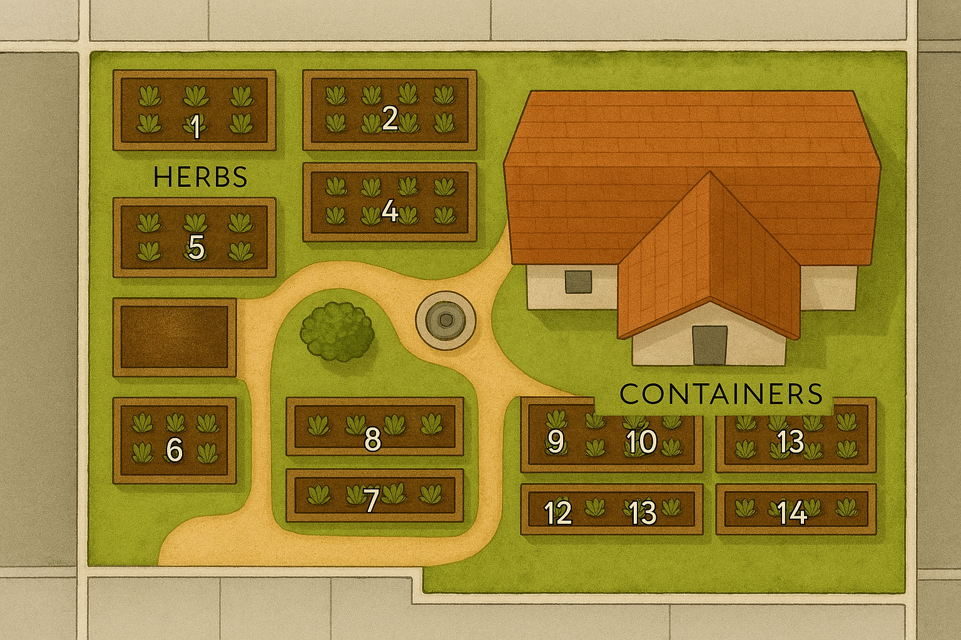
Fig. 2. Urban farm map graphic with production areas labeled. Calculate square footage of area in cultivation by measuring the length and width of each individual section (field plots and/or raised beds) and multiply to get the area of that section. Add all the individual sections together for the total square footage.

Record Keeping. Documentation is key to tracking farm activities and determining production risks. Important records are identified in the accompanying risk assessment document.
Traceability. Growers need to have a system in place to track crops back to the field or bed they were grown in and then traced forward to the buyer. In the rare event of a product recall, having this information will allow you to quickly communicate to consumers.
Corrective Actions. Outline procedures to address and correct any problems and how you prevent potentially contaminated crops from reaching consumers. It is important to identify the root cause to prevent the problem from happening again. Document corrective actions, including the issue, what actions were taken, and any newly implemented prevention steps.

Production Activities
Site Assessment. Perform a visual inspection and note the site history - including crops previously grown and products applied - to identify potential risks. This is important in urban areas where sites may have been used for industrial purposes. Soil tests can identify risks of contaminated soil. Production areas should be viewed after a heavy rain to observe flooding potential and runoff patterns. Include a description of how adjacent land is being used and note animal traffic patterns.
Worker Health & Hygiene. Employees should not handle produce if sick. Access to a toilet and handwashing facilities is important to prevent the spread of microorganisms that can cause illnesses. Simple handwashing stations can be inexpensive to build (Fig. 3).
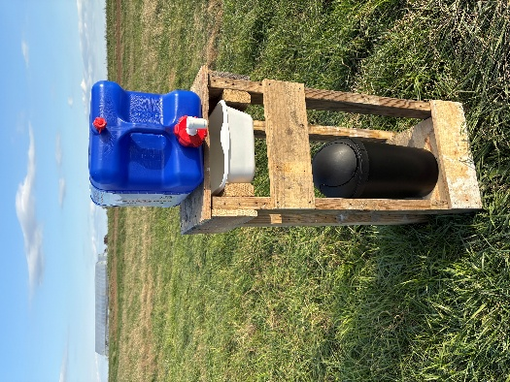
Fig. 3. A simple handwashing station made from a discarded pallet to ensure personal hygiene on an urban farm. Photo credit: Cindy Finneseth
Agricultural Products. Keep an updated list of all inputs used on the farm, including where purchased and when products were applied. A private applicator pesticide license may be required to buy and apply certain agricultural products.
Agricultural Water. Many urban growers use city or municipal water to irrigate crops. Water companies are required to issue and annual quality report, which can often be found on their website. Print the report and keep it with your records. Water collection systems (rain barrels, for example) are common on urban farms. This is considered surface water and poses a higher risk than municipal water. Note in your plan water sources in use, how applied, and how water quality is being monitored.
Animal Control. Pets and wild animals are frequent visitors on urban farms. Describe how you exclude, monitor, and handle evidence of animals in the production areas of your farm. Avoid harvesting from areas where animals have been.
Vehicles, Equipment, Tools, and Utensils. List the different mechanical and manual tools used on the farm. For shared-use equipment borrowed from off the farm, list the equipment, cleaning and maintenance performed, and notes about the place from which it was borrowed. All hand tools should be thoroughly cleaned and sanitized regularly.

Harvest Activities
Preharvest Assessment. Before harvest, visually inspect the production area to identify potential contamination sources. Mark spots of concern to prevent harvest from those areas (Fig. 4).
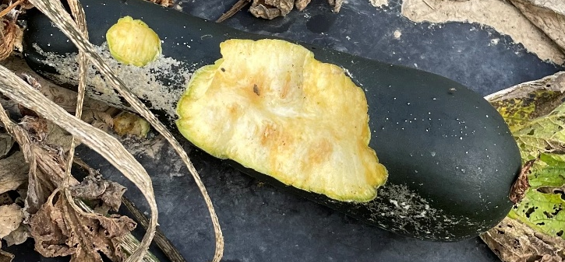
Fig. 4. Animal feeding damage on zucchini. This area should be flagged area to prevent harvest. Photo credit: Cindy Finneseth
Containers and Bins. Containers and bins used to harvest and transport produce should be easy to clean and sanitize (Fig. 5). Prevent containers and bins from being placed directly on the ground and clean well after each use.
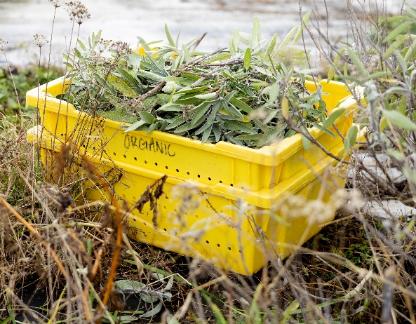
Fig. 5. Plastic bins are easy to clean and sanitize. Use a second bin or another method to keep bins off the ground. Photo credit: UK MG CAFE.

Postharvest Handling
Cooling and Packing. Rapid cooling of produce will preserve crop quality. When using water or ice to remove field heat, the water must be potable. Produce is often transferred from harvest bins to boxes or other containers for storage (Fig. 6).
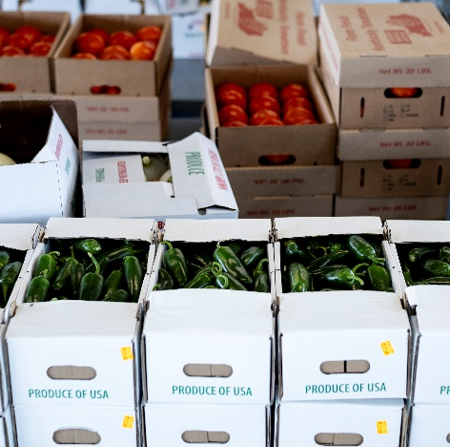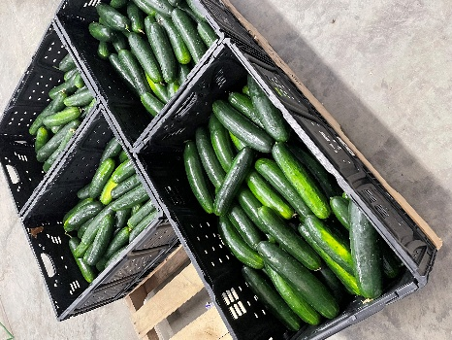
Fig. 6. Single use waxed boxes are commonly used to store and transport produce crops. Wooden pallets can be used to keep boxes off the floor. Photo credits: UK MG CAFE (left); Cindy Finneseth (right).
Storage. Describe how and where produce is stored. Temperature should be monitored if using cold storage. Produce containers or boxes should be elevated and never placed on the floor. Control of pests in storage is a critical part of maintaining product safety.
Transportation. Note how crops are being transported to markets and strategies to avoid risk of contamination during movement.

Understanding Audits. Each year you should perform a self-audit where you review your farm food safety plan to be sure it still describes your operation. Audits are a tool to assess on-farm food safety activities, facilities, and to confirm practices and procedures are in place to minimize contamination of fresh produce crops. These can be performed by the operator or someone from off the farm to confirm compliance with buyer requirements. Your urban farm – particularly in the early days – may be exempt from certain regulatory requirements, like the Food Safety Modernization Act (FSMA). As you scale up and expand your markets, buyers may require third party GAP audits.

Food Safety Resources for Urban Farms
Cultivate Kentucky is a program through the University of Kentucky that has templates, checklists and logs available free to produce growers. Program personnel will also provide technical assistance in writing farm food safety plans and advising on food safety upgrades.
Your local Cooperative Extension Service Office is another resource available to help you with producing food crops in urban areas. Find your local county office here.
Produce Best Practices Training (PBPT) is a Kentucky-specific food safety training offered through local county extension offices that. The training is voluntary and required for sampling certificates.
All Kentucky produce growers are required to complete the Kentucky Department of Agriculture’s Produce Farm Inventory Survey. This survey will help determine if your farming operation is required to comply with the Food Safety Modernization Act Produce Safety Rule (FSMA PSR) or if it is exempt.

References:
Kentucky Department of Agriculture (KDA). 2024. Kentucky Produce Safety Program. KDA Office of Agricultural Marketing, Frankfort, KY.
Kubat, N., C. Newcomb, D. Satterwhite, M. Reed, and P.P. Vijayakumar. 2021. Kentucky Produce Food Safety Program. CCD-PFS-6. Center for Crop Diversification, University of Kentucky College of Agriculture, Food and Environment, Lexington, KY.
US Food & Drug Administration. 2024. Food Safety Modernization Act (FSMA). FDA, Washington, DC.
US Food & Drug Administration. 2024. FSMA Final Rule on Produce Safety Standards for the Growing, Harvesting, Packing, and Holding of Produce for Human Consumption. FDA, Washington, DC.
Vijayakumar, P.P., B.V. Jagannathan and M. Schroeder. 2019. Understanding the U.S. Food Safety Regulatory System. CCD-PFS-5. Center for Crop Diversification, University of Kentucky College of Agriculture, Food and Environment, Lexington, KY.

