Hydroponic lettuce production in controlled environments
Arundathi Sharma, Kim Leonberger, Nicole Gauthier and Qinglu Ying
Introduction
Lettuce (Lactuca sativa) is one of the most common vegetables of hydroponic systems. Hydroponics is a method of growing plants without soil. Plants can be grown with soilless medium (drip or ebb-and-flow benches), or in nutrient solution with or without the support of an inert medium (deep water culture and nutrient film technique). In all hydroponic systems, all plant nutritional needs are supplied through the irrigation water.
Hydroponics is a highly exacting and demanding system that requires a greater amount of production knowledge, experience, technical skill, and financial investment than many other production systems. A grower must be committed to meeting the daily demands of production to be successful.
While there are a number of different hydroponic systems that have been commercially successful for lettuce production, this guide will focus on the nutrient film technique (NFT), deep water culture (DWC) and drip irrigation system. Prospective growers should obtain as much information as they can about hydroponic production before starting this type of enterprise.
Marketing consideration
Hydroponic production costs require growers to either identify consistent markets willing to pay a premium price or produce at a great enough scale to realize cost economies while shipping large amounts of produce. Such market niches may take some time to develop to maximize returns. Growers with superior crops and off-season or year-round availability will have a marketing edge. Potential hydroponic growers should talk to local grocers or specialty food retailers interested in locally grown produce.
The quantity and variety of leafy greens and herbs demanded by Americans has increased as consumers desire more health and diversity in their diets. Per capita consumption of fresh lettuce (romaine and leaf) has increased over the years, reaching 31.5 pounds in 2023. In 2022, lettuce contributed nearly 20% of the $21.8 billion in cash receipts earned by U.S. growers from the sale of vegetables and melons. Greens and herbs may be grown and marketed on a variety of scales for different markets, from farmers markets to large-scale commercial wholesale accounts. Wholesale lettuce production is dominated by large scale growers in the western US. While Kentucky producers could investigate smaller-scale wholesale production, opportunities for hydroponic greens will most likely come from direct marketing to consumers. Proper handling practices and other food safety considerations are crucial components for successfully marketing lettuce and other greens and herbs.
Production consideration
Facility requirement
Hydroponic lettuce production requires well-ventilated greenhouses or similar structures, oriented to optimize environmental conditions. The structure should provide shading or cooling during the summer months, while maximizing light and heat capture in the winter. Consistent access to water is essential and water quality is critical for hydroponic production, as plants rely entirely on water for nutrient delivery and root health. Well or municipal water is recommended due to its stability and lower pathogen risk, while surface water from ponds or rivers may increase the likelihood of introducing plant pathogens. In addition, the facility should have reliable access to electricity, which is necessary to operate water and air pumps and irrigation controllers.
Growing environment
Lettuce is a cool season crop and the air temperature for hydroponic lettuce production should not exceed 75° F (24° C) during the day and 65°F (18°C) at night, with an optimal daily light integral (DLI) of 12-17 mol/m²/day. Lettuce becomes prone to bolting when exposed to prolonged heat and/or high temperature fluctuations. When active cooling is not feasible in production systems, fluctuating temperatures can be more detrimental to lettuce growth and quality than sustained high temperatures. Bolting is a process in which the plant prematurely produces a flower stalk and seeds, leading to a shorter harvest window, bitter taste, and an unmarketable crop. Selecting heat-resistant cultivars and implementing shading, evaporative cooling, and ventilation are strategies to alleviate heat stress.
As a cool-season crop, lettuce can be cultivated under suboptimal conditions when growers face resource limitations, such as restricted heating or lack of supplemental lighting. Lettuce can tolerate nighttime temperatures as low as 50°F (10°C) and daytime temperatures of 59°F (15°C), particularly during the winter months when ambient light levels are low. The minimum DLI requirement for lettuce ranges from approximately 6.5 to 9.7 mol·m⁻²·day⁻¹. However, growing lettuce under low light and temperature conditions will extend the time from planting to harvest. Contact your Extension Agent for instantaneous light measurements in your production area and estimate the resultant DLI; Figure 1 offers an idea of how much light you may have to supplement, should you choose to do so. See Additional Resources for more information about light measurement units.
Figure 1. Daily light integral (DLI) of ambient (outside) and inside the greenhouse in Kentucky, based on average ambient measurements from 2021 to 2024 across Mesonet climate stations in 80 counties. Greenhouse DLI was estimated assuming a 50% light transmission rate. Minimum and optimal DLI for lettuce production are indicated – for many Kentucky farms, winter lettuce production is possible with little to no supplemental lighting
Relative humidity should be maintained at 50 to 70%. Lettuce also requires consistent airflow to maintain transpiration and nutrient uptake, particularly calcium. Calcium is essential for cell wall development in rapidly growing tissues, and calcium deficiency can result in a physiological disorder known as tip burn. Tip burn is characterized by necrosis at the edges of the growing tip and young growing leaves (Fig 2). Tip burn can be mitigated by reducing growing light and/or temperature, shortening the production cycle, improving air flow and transpiration rate, and applying foliar calcium.
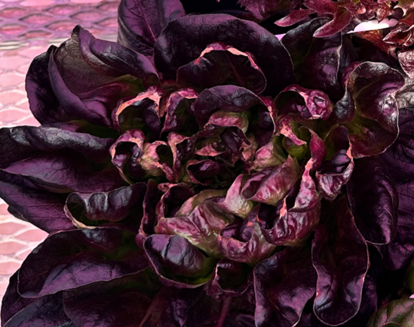
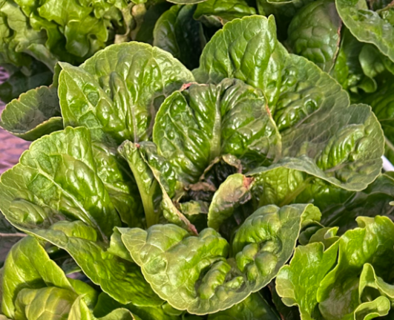

Figure 2 Tip burn of green leaf (left) and red leaf (right) lettuce.
Fertigation
Regardless of the type of hydroponic systems used, a complete fertilizer solution containing all 14 essential mineral elements required for plant growth is necessary. Prior to developing a nutrient management plan, it is strongly recommended that growers submit a water sample to a reputable analytical laboratory for a comprehensive analysis. This analysis should assess pH, electrical conductivity (EC), alkalinity, hardness, macronutrients and micronutrients, and the presence of potentially harmful ions. In Kentucky, source water is typically alkaline and exhibits a high pH over 7.0, which can interfere with nutrient availability. Therefore, acidification, most commonly with phosphoric, nitric, or sulfuric acid, is often necessary to lower the pH of the irrigation water to the optimal range of 5.5 to 6.0 for nutrient uptake in hydroponic systems for lettuce. EC of the fertilizer solution is controlled by the dilution rate of fertilizers.
Fertigation recipes should be adjusted based on crop varieties and cultivars, growth stages, environmental conditions, and the availability of fertilizer sources. Table 1 provides an example of a balanced fertilizer formulation. Custom nutrient solutions are often prepared using more than 10 individual fertilizer salts, typically dissolved into two or three concentrated stock tanks (commonly labeled Tank A, B, and occasionally C). While this “made-from-scratch” approach offers precision, it can be complex and labor-intensive, particularly for small-scale or beginning hydroponic growers.
As a simpler alternative, growers can use either a single complete fertilizer (e.g., 17-5-17) or a two-part system. A common two-part method involves dissolving calcium nitrate (e.g., 15.5-0-0) in Tank A and a complete fertilizer (e.g., 5-11-26 Hydroponic Special) in Tank B. An acid (e.g., sulfuric acid, phosphoric acid) is often added to Tank B to reduce the pH of alkaline source water and improve nutrient availability.
An exact fertilizer recipe must be developed based on the specific test results of the source water – contact your County Extension Agent or Greenhouse Specialist for help formulating customized recipes.
Table 1. An example fertigation recipe for hydroponic lettuce production. Growers may submit a treated (fertilizer-amended) water sample to Regulatory Services to confirm what nutrients their crop is receiving
Nutrient | N | P | K | Ca | Mg | Fe | Mn | Zn | B | Cu | Mo
ppm | 150 | 39 | 162 | 139 | 47 | 1.3 | 0.38 | 0.11 | 0.38 | 0.11 | 0.08

Varieties and Cultivars
Butterhead, romaine, and leaf types are varieties of lettuce that are commonly grown in hydroponic systems, with seed companies offering a wide catalog of cultivars bred specifically for controlled environments and/or hydroponic systems. Generally, romaine type lettuce is more challenging to produce in controlled environments compared with leaf and butterhead types. Growers should consider factors including growth rate, head size, and disease resistance when choosing a cultivar to grow. Additionally, selecting for seasonal conditions—such as heat-tolerance for summer or faster growth for low-light winter months—can optimize yield and quality year-round.
Production timeline and practices
The greenhouse lettuce production timeline (Fig. 3) begins with planting and germination, which typically lasts about 3 days. This is followed by a seedling growth phase of approximately 10 days. Once the seedlings are robust enough, they are transplanted into the main hydroponic system. After transplant, lettuce enters a growth-to-harvest phase lasting approximately 30 to 40 days, depending on species and growing environments.
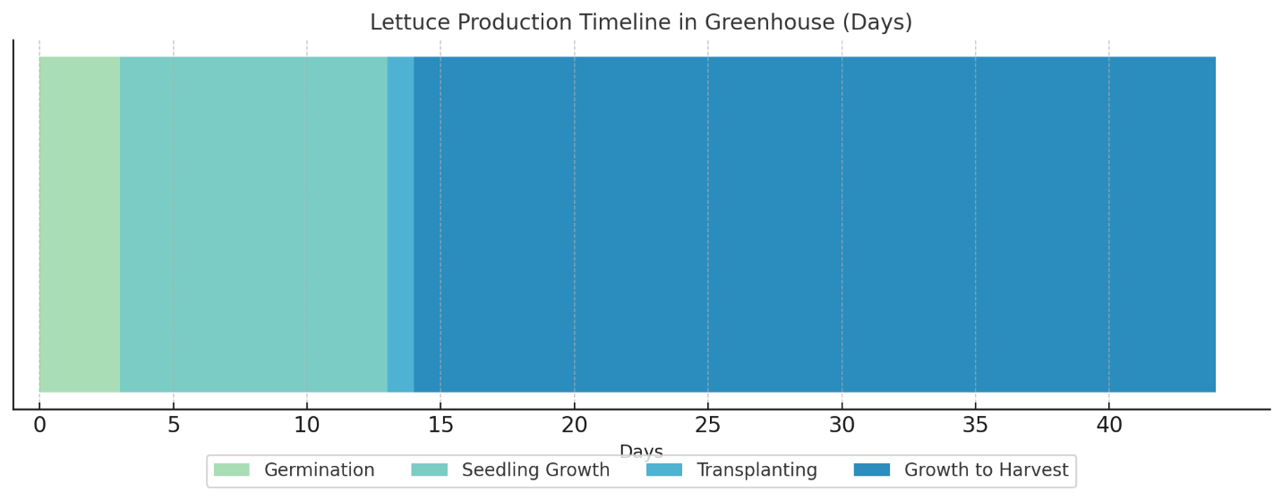
Figure 3. Lettuce production timeline in Greenhouses
Propagation
Lettuce can be propagated using a variety of soilless substrates, including bonded plugs such as Rockwool, coco coir-based, or peat-based plugs, as well as loose substrates filled in high density seedling trays (e.g., 128-cell tray). The choice of propagation substrate should align with the specific hydroponic production system being used. For water-based systems like deep water culture (DWC) or nutrient film technique (NFT), bonded 1-inch plugs are strongly recommended. These plugs are designed to retain their structure and will not fall apart when submerged in water, providing better stability, uniform moisture retention, and ease of transplanting into these systems.
Substrates—particularly rockwool—should be pre-charged with a nutrient solution using a balanced complete fertilizer with an EC of 1.0 mS/cm and a pH of 5.5-6.0 before seeding. Place one seed per plug/cell. Lettuce seeds germinate best at a temperature of 68°F (20°C). If ambient air temperatures are below optimal, a heat mat can be used to maintain consistent warmth and promote uniform germination. A germination dome can also be used to maintain high relative humidity during this stage but should be removed as soon as the seeds have emerged, about two days after seeding. Seedlings should be watered 2 to 4 times per day with a nutrient solution using a balanced complete fertilizer with an EC of 1.0 mS/cm and a pH of 5.5-6.0, depending on plant sizes and growing environments.
Transplant
Seedlings are typically ready for transplanting into the final production system once they have developed 3 to 4 true leaves and roots have visibly emerged from the bottom of the propagation substrate, usually 14 to 21 days after seeding. Table 2 describes common hydroponic systems, their key components, considerations, advantages, and disadvantages. To ensure successful transplanting, thoroughly water the seedlings beforehand. This helps prevent root desiccation and keeps the substrate intact during handling. In liquid-based hydroponic systems such as deep water culture (DWC) or nutrient film technique (NFT), it is essential to ensure that seedling roots are in contact with the nutrient solution at the time of transplanting. Because the substrate volume is minimal, seedlings can quickly dry out if their roots are not touching the water. For substrate-based systems like drip irrigation or ebb-and-flow, it is important to determine irrigation volume and frequency based on substrate properties and crop stages.
Table 2. Overview of main hydroponic systems for lettuce production
 | Deep Water Culture (DWC)/ Float Bed | Nutrient Film Technique (NFT) | Drip Irrigation | Ebb-and-Flow (“Flood and Drain”)
System description | Floating rafts on nutrient solution contained in a framed bed lined with waterproof liner | Sloped troughs or channels with shallow nutrient flow driven by a pump in the reservoir | Plant containers/trays filled with media; drip lines and emitters deliver water and nutrients through main irrigation line | Shallow flood tables on a bench; water and nutrients are delivered to flood and may or may not drain back to the reservoir
Key components | Frame (wood or metal) at least 12in depth, liner (EPDM or HDPE), foam rafts, air pump, air stones | Troughs/channels (PVC or food-safe plastic), pump, reservoir, return lines | Containers, drip emitters, dripper stakes and tubing, main irrigation lines, timer, switch/solenoid valve, reservoir, fertilizer injector | Flood trays, timer, switch/solenoid valve, drain system, reservoir, fertilizer injector
Substrates | Bonded plugs (generally 1x1 in) inserted in raft holes | Bonded plugs (generally 1x1 in) inserted in NFT channels | Loose media (like peat based substrates) | Loose media (like peat based substrates)
Oxygenation | Need air pump and air stones, 6-8 ppm dissolved oxygen | None – continuous thin film provides oxygen | None - rely on air space in substrates | None - rely on air space in substrates
Water use | High volume (>4 L/plant) (>1 gal/plant) | Low volume with the thin film | Moderate | Moderate
Planting density¹ | 3 to 4 plants/sqft or 35 to 40 plants/m² | ~2 plants/sqft or  30 plants/m² | 1 to 2 plants/sqft or  20 to 25 plants/m² | ~2 plants/sqft or 25 plants/m²
Nutrient delivery | Constant – roots submerged in nutrient-rich water. Single, complete fertilizer required | Constant – thin stream of nutrient water flows past roots. Single, complete fertilizer required. | Periodic – nutrient solution delivered on timed intervals. Precise, multi-part fertilizer recipes possible | Periodic – nutrient solution delivered on timed intervals. Precise, multi-part fertilizer recipes possible
Advantages | Simple system set up, low labor needs, low risk of plants drying out, possibility of plant spacing to maximize space use efficiency | Low water and nutrient consumption, possibility of plant spacing to maximize space use efficiency | Precise water and nutrient delivery to individual plants, may sell containerized live plant | Flexible layout, Works for plants of all sizes, simple automation; more uniform growth, may sell containerized live plant
Disadvantages | Large volume of water, waterborne pathogens can spread through shared solution | System failure will cause rapid dry out; waterborne pathogens can spread through shared solution | Doesn’t work for propagation, emitter clogging, labor intensive for installation | Regular maintenance to ensure proper drainage; root disease can be spread
¹Planting density recommendation for full size crops; higher density can be used for smaller plants and shorter production period.
Post-transplant production
In liquid-based hydroponic systems such as DWC and NFT, it is important to continuously monitor the pH and EC of the nutrient solution in the reservoir, as plants are constantly absorbing water and nutrients, which can cause fluctuations in solution balance over time. To maintain optimal nutrient balance in liquid-based systems, fertilizers, acid, and water should be added as needed to replenish the solution and correct any fluctuations in pH or EC caused by plant uptake. Respacing strategies, i.e., gradually increasing the distance between plants as they grow, can also be applied by liquid-based systems to optimize space use efficiency and improve airflow while improving overall yield. Growers should plan to align respacing schedules with available labor and anticipated market demand.
In substrate-based systems, leachate can be collected by placing a saucer beneath pots in a drip irrigation setup, or by using the pour-through method in an ebb-and-flow system. Analyzing the leachate's pH and EC provides a snapshot of the root zone environment and helps guide nutrient and irrigation adjustments.
Plants can typically be harvested 21 to 35 days after transplanting and a fully grown lettuce can be 100 to 210g/head, depending on the species, cultivar, and growing environment. In summer, earlier harvests may help prevent tip burn, while in winter, slower growth due to suboptimal light and temperature may necessitate later harvests.
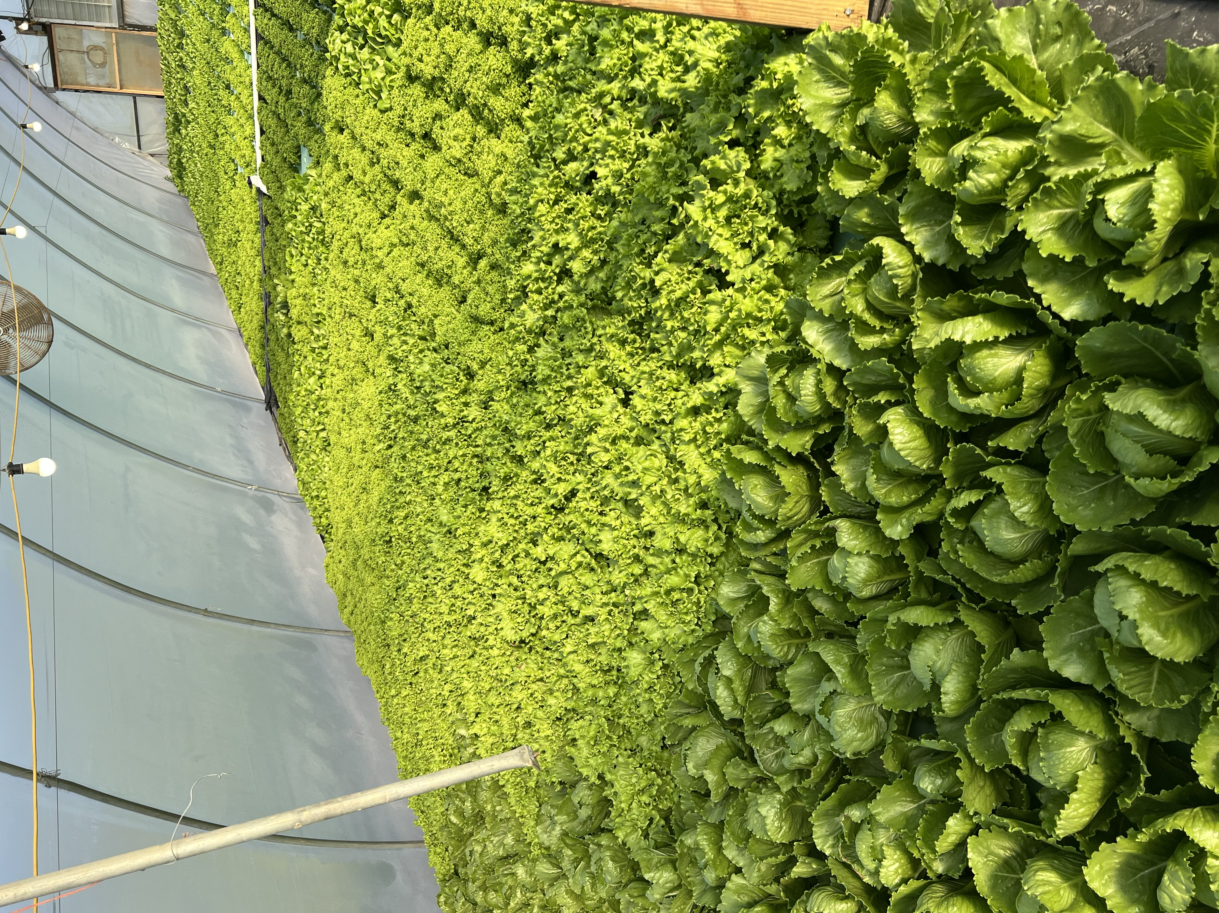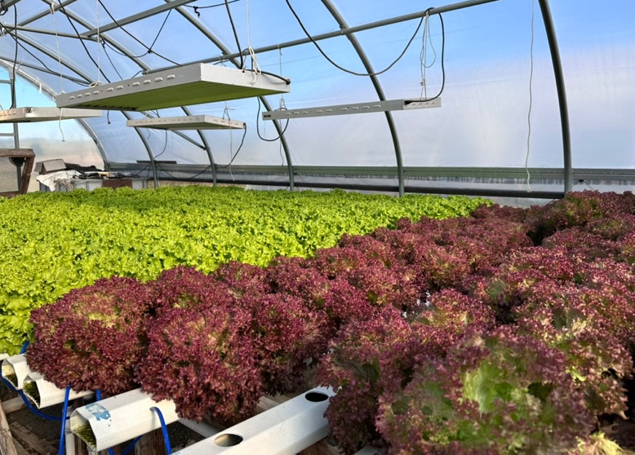
Figure 3. Float bed (left) and nutrient film technique (right) lettuce production at commercial farms in Kentucky.
Disease management
Lettuce is susceptible to several diseases that can result in reduced yield. The most common diseases are included here, but growers may encounter additional diseases not included in this publication. Contact a county Extension agent for assistance with disease confirmation.
Major diseases | Management
Botrytis gray mold (Botrytis cinerea) is a fungal disease that begins as a soft rot of lower leaves. Symptoms appear brownish-gray to orange. Infection occurs as leaves age or become damaged. Fuzzy, gray fungal growth is often visible as disease becomes severe. Infection can spread to surrounding, healthy leaves and crowns. Botrytis sp. proliferates when humidity reaches 85% and senescent tissue or debris is readily available. Gray mold usually occurs under cool conditions (65 to 75°F or 18 to 24°C) such as in shaded areas or within dense canopies. | - Remove dead, dying, and diseased leaves as soon as they appear.  - Maintain humidity below 85% by exchanging indoor air.  - Preventative fungicides are effective when conditions are conducive for disease.
Pythium root rot (Pythium spp., Phytopythium spp., Globosporangium spp.) is caused by a group of soilborne, fungus-like pathogens known as water molds. Symptoms include overall stunting or wilting, with marginal leaf scorch or yellowing of outer leaves that becomes more severe as root rot progresses. Roots become soft, mushy, and grayish-brown, and the cortex sloughs off leaving the stele intact (known as “rat tails”). These pathogens can also cause damping off in which seeds are infected before or after emergence. These water mold species favor wet conditions, and optimal temperatures are dependent upon species. Water mold pathogens can also become established in irrigation lines and hydroponic systems. Fungus gnats are known to transmit Pythium spp. | - Do not introduce diseased plugs into production systems.  - Remove dead, dying, and diseased plants as soon as they appear.  - Fallow and sanitize greenhouses and hydroponic systems between crops.  - Fungicides can help suppress disease or prevent new infections.
Minor diseases | Management
Bacterial soft rot (Pectobacterium carotovorum [formerly Erwinia carotovora], other secondary bacteria) is caused by secondary infections of vascular tissue that often lead to slimy decay. Infections begin as wilting with pinkish brown discoloration of lower leaves. As infections spread, leaf and crown tissue becomes water-soaked and slimy (known as “jelly butt”). Plants eventually collapse. Vascular discoloration can be observed in cut stems. Lettuce is most susceptible as it matures. Bacterial soft rot is most common as a postharvest disease. Pectobacterium sp. favors wet conditions and warm temperatures (above 77°F or 25°C). | - Remove dead, dying, and diseased plants as soon as they appear.  - Clean harvest tools regularly.  - Avoid wounding or bruising leaves during harvest.  - Bactericides such as copper can help suppress disease or prevent new infections.
Bottom rot (Rhizoctonia solani) is a soilborne, fungal disease that causes rot on lower leaves. Initial symptoms include brown to orange lesions on lower leaves, expanding to midribs. If disease becomes severe, rot expands to inner leaves and heads. The crown is often the last part of the plant to decay. Bottom rot occurs under warm (77 to 95°F or 25 to 35°C), wet conditions. The fungus can infect healthy leaves or colonize dead or dying tissue. | - Fallow and sanitize greenhouses between crops.  - Fungicides can help prevent or reduce disease.  - Mildly affected lettuce heads can often be marketed by removing infected lower leaves.
Powdery mildew (Golovinomyces spp.) is a fungal disease that causes powdery growth on all lettuce tissue. Early infections appear as small patches of white fungal growth on upper and lower sides of older leaves. The causal fungus has a wide host range, including other vegetable crops, weeds, and ornamentals. Disease can establish under a wide range of conditions, but it is most severe at moderate temperatures (65 to 70°F or 18 to 21°C). | - Increase air circulation and exchanging humid air.  - Preventative fungicides are effective when conditions are conducive for disease.

Additional Resources
Gauthier, N. and Leonberger, K. Common lettuce diseases in Kentucky (https://plantpathology.mgcafe.uky.edu/sites/plantpathology.ca.uky.edu/files/PPFS-VG-53.pdf).
Mattson. N.S. (2015). Tipburn of hydroponic lettuce. E-Gro Alert.
Paz, M., Fisher, P. R., & Gómez, C. (2019). Minimum light requirements for indoor gardening of lettuce. Urban Agriculture & Regional Food Systems, 4(1), 1-10.
Sharma, A., and Knight, J. (2023). Irrigation in hydroponic systems: An illustrated overview. (https://ccd.uky.edu/sites/default/files/2024-12/ccd-sp-20-irrigation-in-hydroponic-systems.pdf)

