**Grafting transplants for greenhouse production**

**By Arundathi Sharma and Qinglu Ying**

Grafting is an important horticultural technique used to combine the desirable traits of two different plants, typically a disease-resistant rootstock and a high-yielding or high fruit quality scion. In greenhouse vegetable production (especially for tomatoes, peppers, and eggplants), grafting has gained popularity as a sustainable method to manage soilborne diseases, improve stress tolerance, and extend production cycles without relying on chemical inputs. Specifically, greenhouse tomato accounts for over 90% of grafted seedling production in North America.

During the grafting process, the rootstock refers to the lower portion of the plant that includes the root system (Fig 1). It is typically selected for traits such as disease resistance, vigor, and tolerance to abiotic stress, depending on the production systems and specific grower needs. The scion is the upper portion of the plant that produces stems, leaves, and fruits, and it is chosen for its desirable characteristics, such as high yield, fruit quality, or variety preference. For grafting to be successful, both the rootstock and scion should have similar stem diameters, usually when the seedlings are at the two to four true leaf stage. In addition, they must be compatible in terms of species or genus. Rootstock varieties can be broadly classified as generative or vegetative. The selection should complement the growth habit of the scion. Generative rootstocks are often used with scion varieties that exhibit strong vegetative growth or are intended for short production cycles, as they help balance plant vigor and promote early fruiting. In contrast, vegetative rootstocks are preferred for more generative scion types or for long crop cycles, as they provide enhanced vigor and sustained productivity. While Fig 2 demonstrates different types of graft techniques for horticultural crops, top grafting is particularly useful in longer-cycle greenhouse crops like tomatoes.

**Scion**

**Rootstock**

Figure 1. Tomato scion and rootstock seedlings during grafting

*Figure 2. Different types of grafting techniques for horticultural crops from Rasool et al., 2020*

**Seeding**

Seedling production should begin at least six weeks prior to the anticipated transplant date into the final production system. This timeline may need to be extended under suboptimal lighting or temperature conditions. Typically, seedling development takes approximately three to four weeks. After grafting, seedlings require an additional one to two weeks for healing before they are ready to be transplanted. The full timeline for grafting and transplanting, using tomato as an example, is illustrated in Fig 3*.A close-up of a plant
*

*Figure 3. Timeline of seedling production, grafting, healing, and transplant using tomato as an example.*

To ensure a high grafting success rate and healthy union between the scion and rootstock, it is important to closely match the stem diameters of both seedlings. Different varieties germinate and grow at varying rates. For example, Figure 4 illustrates the stem diameter growth over time for four greenhouse tomato varieties: the rootstock variety ‘Maxifort’, tomato-on-the-vine (TOV) variety ‘Estiva’, beefsteak variety ‘Marnero’, and cherry tomato ‘Favorita’. Due to these differences, growers are encouraged to conduct small-scale trials or sow multiple successions to ensure uniform development. Because rootstock seedlings are typically more vigorous, they should be sown one to two days after the scion seedlings to help synchronize stem diameter at the time of grafting. Incorporating approximately 25% overseeding can also improve the likelihood of obtaining well-matched rootstock and scion pairs at the optimal grafting stage.

*Figure 4. Stem diameter at 16, 18 and 22 days after sowing of four greenhouse tomato varieties*

Tomato seeds should be sown in rockwool cubes or 72-cell trays filled with a soilless substrate that has been pre-charged with a balanced nutrient solution. During germination, maintain a temperature of approximately 75°F. A germination dome can be used to preserve high relative humidity levels between 90% and 100%, but it should be removed promptly once seedlings begin to emerge. After germination, the night temperature can be reduced to around 65°F. Providing sufficient light is essential for vigorous seedling development. An optimal daily light integral (DLI) for tomato seedlings is approximately 15 mol/m2/day. A complete nutrient solution with a pH between 5.5 and 6.2 and an electrical conductivity (EC) of 1.5 to 2.5 mS/cm should be provided at least once daily.

**Grafting**

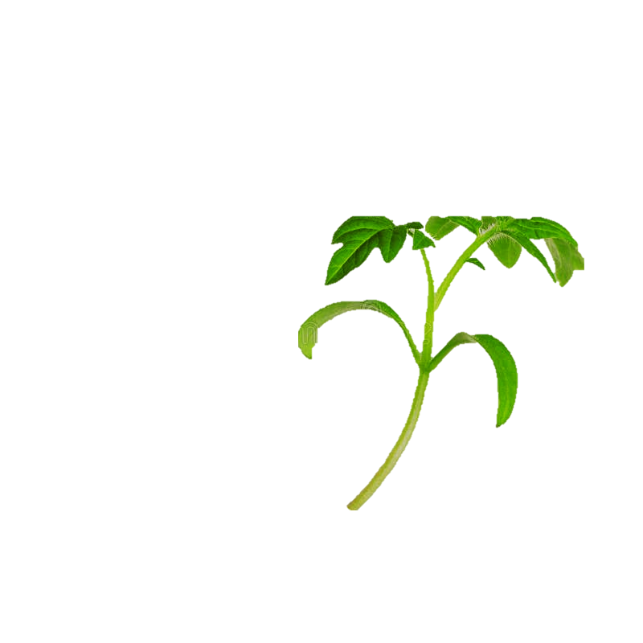Plants are ready for grafting when the stem diameter reaches approximately 2 mm, measured just below the cotyledons. This typically occurs 3 to 4 weeks after sowing. To ensure successful grafting, it is important to work in a clean, shaded environment and maintain sanitary conditions throughout the process. Plants should be thoroughly watered about 12 hours before grafting. Select rootstock and scion seedlings with closely matched stem diameters. Using a sharp, sterile razor blade or knife, make a diagonal cut at a 60° -70° angle just below the cotyledons to create enough surface area on both the rootstock and scion. Carefully align the cut surfaces of the rootstock and scion, then secure the graft using a similar sized grafting clip along with a supporting stake for stability. Using an appropriately-sized clip will improve the graft union. To reduce the weight and transpiration load during healing, 80% to 95% of the leaves could be removed from the scion. This practice can improve graft success but may slightly extend the healing duration.

◄ Cotyledons ►

◄ True leaves ►

Figure 5 Cotyledons and true leaves of tomato seedlings.

**Healing**

A climate-controlled growth chamber or a customized healing chamber should be used during the healing process. Newly grafted plants require high humidity and low light conditions after grafting. As healing progresses, light and airflow should be gradually introduced to acclimate the plants. A healing timeline with required environmental adjustments is outlined in Table 1.

Table 1. Healing timeline for greenhouse tomato seedlings

|  |  |
| --- | --- |
| **Day** | **Growing requirement** |
| **Day 1-2** | |  | | --- | | Keep seedlings in complete darkness with the germination dome fully closed. Maintain high relative humidity (>90%) and a steady temperature around 75°F. Mist frequently and inspect plants every 1–2 hours. | |  | | |
| **Day 3-5** | Gradually open the germination dome to lower humidity. Begin introducing low light levels. Reduce misting frequency and continue monitoring plants at least twice daily. |
| **Day 5-7** | Continue decreasing misting and relative humidity while steadily increasing light intensity. |
| **Day 8-10** | Remove the germination dome completely. Transition plants to greenhouse conditions with appropriate light, temperature, air flow and humidity. |

**Troubleshoot**

After grafting, several physiological and environmental factors can affect plant recovery and grafting success. Understanding common issues that arise during the healing process allows growers to take corrective actions quickly and effectively. Table 2 below outlines frequently observed problems and practical troubleshooting strategies to improve success rates and reduce transplant losses.

Table 2. Common grafting issues and how they may be addressed

|  |  |  |
| --- | --- | --- |
| **Issues** | **Description** | **Troubleshooting strategies** |
| **Wilting** | Scions appear limp, fall over or fail to stand upright, could happen on days 4-5 or earlier | - Check the healing chamber humidity and temperature.  - Substrates too dry or too saturated  - Avoid direct light too early. |
| **Graft union fails to heal** | The scion and rootstock don’t join, or the connection is too weak and break easily | - Ensure matching stem diameter and cut.  - Confirm compatibility of rootstock and scion varieties. |
| **Adventitious rooting** | Roots form above the graft union, often from the scion. | - Ensure graft union is kept above the substrate during transplanting.  - Ensure plants are not under high humidity for too long. - Graft below cotyledons to minimize rooting potential. - Remove adventitious roots if detected. |
| **Rotting at the grafting point** | Softening, discoloration, or mold around the grafting area. | - Sanitize tools before use. - Prevent excessive moisture. - Reduce misting if condensation is heavy. - Avoid overcrowding in the healing chamber. |
| **Stretching stems or folding leaves** | Plants become leggy, thin-stemmed, or leaves curl inward. | -Make sure plants are not in darkness for too long.  - Introduce light on day 3 by gradually removing shade cloth.  - If plants are healing well, move to greenhouse on day 7–10. |

**Additional resources**

Gagne, C., Kurosaki, M. and Mattson, N. 2020. A guide to grafting tomatoes: Cornell’s tips for success.

Kubota, C., McClure, M.A., Kokalis-Burelle, N., Bausher, M.G. and Rosskopf, E.N., 2008. Vegetable grafting: History, use, and current technology status in North America. HortScience, 43(6), pp.1664-1669.

Loewen, D., Meyer, L., and Rivard, C. An Introduction to tomato grafting. A how-to guide for propagating your own grafted transplants. Kansas State University.

Rasool, A., Mansoor, S., Bhat, K.M., Hassan, G.I., Baba, T.R., Alyemeni, M.N., Alsahli, A.A., El-Serehy, H.A., Paray, B.A. and Ahmad, P., 2020. Mechanisms underlying graft union formation and rootstock scion interaction in horticultural plants. Frontiers in plant science, 11, p.590847.

**Instructor modules**

These educational modules are presented in partnership with the Appalachian Regional Commission (ARC). The modules are intended to provide inspiration for hands-on activities that supplement greenhouse technician/management curricula.

**Learning objectives:**

- Explain the benefits and purpose of grafting in controlled environment agriculture (CEA).

- Monitor and assess greenhouse seedling and transplant development for grafting

- Demonstrate basic grafting techniques.

- Select and prepare tools and materials needed for successful grafting.

- Evaluate graft success and troubleshoot common issues in the healing process.

**Tools required:**

* Trays and substrates
* Grafting knife
* Grafting clips
* Digital caliper
* Supporting tubes
* Germination domes
* Clean water and disinfectant (e.g., bleach)
* Plant materials: healthy rootstock and scion seedlings

**Activities:**

* Tracking and Projecting Scion and Rootstock Seedling Development
* Grafting practices and healing monitoring

**Activity 1: Tracking and Projecting Scion and Rootstock Seedling Development**  
  
Objective:  
Conduct a small-scale trial to determine how quickly scion and rootstock varieties reach a suitable diameter for grafting.   
  
Instructions:

1. Sow seeds for equal numbers of scion and rootstock varieties, starting with the rootstock varieties up to 2 days earlier – note the dates that each batch of seeds is started.

*Instructor notes:*

* + - *Consider up to two different rootstock varieties and three scion varieties and ensure careful labeling; remember that the number of seeds sown is more than double the number of transplants, so plan according to both class size and space limitations for seed germination and grafted transplant healing (see Activity 2)*
    - *Tomato seeds should be sown in rockwool cubes or cell trays filled with a soilless substrate that has been pre-charged with a balanced nutrient solution. After germination, a complete nutrient solution with a pH of 5.5-6.2 and an electrical conductivity (EC) of 1.5 to 2.5 mS/cm should be provided at least once daily.*
    - *During germination, maintain a temperature of approximately 75°F and high relative humidity of 90-100%. A germination dome can be used, but it should be removed promptly once seedlings begin to emerge. After germination, the night temperature can be reduced to around 65°F.*
    - *Providing sufficient light is essential for vigorous seedling development. An optimal daily light integral (DLI) for tomato seedlings is approximately 15 mol/m2/day.*

1. After the stem diameter is at least 1 mm (approximately two weeks after seeding), use calipers to measure the stem diameter of rootstock and scion seedlings just below the cotyledon.
   * Proper use of calipers: first calibrate (if using a digital tool), then gently close the jaws of the outside measurement tool around the stem, holding it perpendicular to the growth. See the images below for examples of good (left) and bad (right) alignment. Be careful not to damage the delicate stems.

Source: Bantam Tools <https://support.bantamtools.com/hc/en-us/articles/115001656313-Proper-Use-of-Digital-Calipers>

1. Repeat and record the measurements in a data logbook every day for about one week, or until the seedlings have been grafted (see Activity 2). Use the template below to name the columns in your data log:

|  |  |  |  |  |
| --- | --- | --- | --- | --- |
| Observation Date | Planting Date | Days After Sowing | Variety | Stem Diameter |
|  |  |  |  |  |
|  |  |  |  |  |
|  |  |  |  |  |
|  |  |  |  |  |
|  |  |  |  |  |
|  |  |  |  |  |
|  |  |  |  |  |

1. For each variety, plot the average seedling diameter versus the days since seeding. Were there differences in development rates between rootstock versus scion varieties?
2. Select two combinations of rootstock and scion that you would like to graft. How many days apart would you sow each combination?

**Activity 2: Grafting Practices and Healing Monitoring**

Objective:

Graft scion varieties to rootstock varieties and compare healing and transplant development across different scion/rootstock combinations, different healing conditions, or different stem diameters.

Instructions:

SETUP (the day before graft)

1. Start with graft-ready seedlings (~2 mm, measured just below the cotyledons).
2. 12 hours before the planned grafting, water the seedlings thoroughly.
3. Select a work area that is cool and well-shaded.
4. Sanitize the work area - use diluted bleach or hydrogen peroxide spray to wipe down the work surface and all implements.

GRAFT

1. Set a tray of scion seedlings on one side of the work area, and rootstock seedlings on the other side of the work area. Establish a separate waste area nearby for all grafting waste. Keep your data log sheet nearby. You may use the attached template for an example of how to label the columns in the sheet – note especially the groups you want to compare. You will need this sheet for the next 2 weeks of data collection.
2. Select one each of rootstock and scion seedlings with closely matched stem diameters (can estimate visually). Do not remove them from the trays, and note which variety of rootstock and scion you have selected, as well as their stem diameters in the log sheet.
3. Using a sharp, sterile razor blade or specialized grafting knife, make a diagonal cut at a 60° -70° angle just below the cotyledons on the selected rootstock seedling – this cut angle ensures enough surface area for the two parts to heal together. Dispose of the top part of this plant.
4. Wipe down the blade, then make another diagonal cut at 60° -70° angle just below the cotyledons on the selected scion seedling. Keep the top part of this plant.
5. Ensuring that no stray particles of loose substrate are near the cut areas, carefully align the cut surfaces of the scion seedling top with the rootstock seedling bottom, then secure them together using a transparent grafting clip.
6. Examine the graft through the clip to confirm the cut surfaces are flush to each other
7. Insert a supporting stake into the clip for stability.
8. Repeat this for all the seedlings. To start with, it is best to perform a small group of grafts individually, rather than cutting all the seedlings at once.
9. After all the seedlings have been grafted, replace the germination dome on top and move the tray of grafted plants into the healing chamber.

*Instructor notes:*

* + - *To reduce the weight and transpiration load during healing, 80% to 95% of the leaves may be removed from the scion. This practice can improve graft success but may slightly extend the healing duration.*

1. The healing chamber should be completely closed, maintaining a steady temperature (approximately 75°F) and high humidity (>90%). The chamber should keep the seedlings in complete darkness, and the inside of the germination dome may be sprayed or the plants misted frequently.

*Instructor notes:*

* + - *A healing chamber may be constructed using a well-insulated container (e.g., cooler box, empty fridge) and a germination mat with temperature setpoints. A small light may be placed inside to use in later stages of healing.*

1. Inspect the plants after 1-2 hours and note any observations. Then, return the plants to the healing chamber.

HEALING AND MONITORING (1-2 weeks following the graft)

1. 1-2 days after grafting: Continue misting plants regularly. Inspect the plants twice a day and note any observations about the healing process.

*Instructor notes:*

* + - *Use the troubleshooting table to offer students the right technical vocabulary to describe indicators of healing or symptoms of stress*

1. 3-4 days after grafting: Gradually open the germination dome to reduce humidity. Begin introducing low light levels. Reduce misting frequency and continue monitoring plants at least twice daily.
2. 5-7 days after grafting: Continue decreasing misting and relative humidity while steadily increasing light intensity. Continue monitoring plants daily
3. 8-10 days after grafting: Remove the germination dome completely. Transition plants to greenhouse conditions with appropriates light, temperature, air flow and humidity for tomato seedlings
4. Compare the healing process and grafting success of the two comparison groups (scion/rootstock combination, stem diameter at grafting time, or healing chamber environment) – what percent of plants in each group had a successful outcome?

**Grafting Log Sheet**

**Name:** _________________________ **Date of Grafting:** ____________________

|  |  |  |  |  |  |  |  |
| --- | --- | --- | --- | --- | --- | --- | --- |
| Entry # | Rootstock Variety | Scion Variety | Rootstock stem diameter | Scion stem diameter | Graft Clip Size | Healing Environment | Healing Status (Day 3/5/7/10) |
| 1 |  |  |  |  |  |  |  |
| 2 |  |  |  |  |  |  |  |
| 3 |  |  |  |  |  |  |  |
| 4 |  |  |  |  |  |  |  |
| 5 |  |  |  |  |  |  |  |

Additional Observations: